Motivation

It is plain to see that economic decision-making is a fundamental aspect of modern human existence. Even before sitting down at their desk, a commuter must integrate multiple decision variables to calculate which mode of transport to take, is bombarded with advertisement for consumer goods, and faces a choice of breakfast options that would be unimaginable even a millennium ago. The brain has the unenviable duty to gather required information, incorporate it into a common framework, and decide between alternatives for each of these tasks.

Over the last 500 years, economics has found success in explaining what people decide when they are deciding. Utility has emerged as the fundamental variable of interest which is maximised along economic choices. These subjective values present in any choice are generated internally to the individual faced with alternatives and must be elicited via careful study of behaviour. Over the past 50 years, auction theory has proved successful in developing mechanisms which incentivise participants to declare the utilities of offered goods on a single trial basis.

Theories of utility have proved successful both prescriptively, in setting axioms for how a hyper-rational decision maker should act, and descriptively when studying how and when humans break these ‘rules’ (Luce & von Winterfeldt, 1994). As impressive as the economics literature is, it cannot tell us how the brain manages to navigate these choices every single day of our lives.

More recently, neuroscience has identified the activity of dopaminergic cells in the midbrain as a putative substrate for utility. These neurons have been shown to encode and integrate multiple variables crucial to this function such as the magnitude, probability, and temporal delay of rewards. By combining these parameters into a common signal, dopaminergic neurons facilitate the direct comparison of and selection from choices that encompass a vast decision space. By reinforcing choices that maximise utility, these neurons serve a crucial role in balancing an organism’s motivations and disturbances to this system have been implicated in severe neuropsychiatric disorders such as Parkinson’s disease and schizophrenia.

Central to research into the function of midbrain dopaminergic neurons are electrophysiological recording methods which allow researchers to study the behaviour of these cells with unparalleled temporal and spatial resolution. Such recordings require direct access to nuclei nested deep within the brain and so are unsuitable for studies of human decision making. Instead, most cellular studies of economic decision-making have relied on rodent or non-human primate models, limiting the sophistication of the choice tasks that can be employed.

The motivation for this thesis is to overcome these limitations so that we might gain a greater understanding of the dopaminergic utility signal. We aim to investigate the activity of midbrain dopaminergic neurons in rhesus macaques trained on a task inspired by auction theory to provide a real time readout of utility while observing changes in neuronal activity.

Organisation of the Thesis

The remainder of this chapter is spent reviewing the fields of economics and neuroscience. We chronicle the development of theories of utility before examining the evidence that the brain, and especially the dopaminergic midbrain circuitry, encodes utility. We also discuss the experimental task paradigms that animal research into utility has employed.

In chapter 2, we compare these paradigms to a second-price auction developed by Becker et al., 1964 and explore the theory behind what makes these ‘Becker-DeGroot-Marshak’ (BDM) auctions appealing to behavioural economists. We conclude the chapter by looking at the growing neuroscientific literature of human economic decision-making using auction tasks and why we consider the BDM an appealing choice for investigating the function of neuronal circuits of reward.

In chapter 3 we detail a BDM auction task we developed and trained two rhesus macaques on. The behaviour of the primates on the task is explored and is compared to more traditional choice

Chapter 4 concerns the electrophysiological recording of midbrain dopaminergic cells from two trained rhesus macaques. It begins with the single-cell recording procedure and the confirmation of the dopaminergic nature of recording cells. We then analyse the dataset produced to

In the final results chapter we take our findings from

Finally, we conclude by discussing

Organisms as utility maximisers
The choice of all possible actions in the world is potentially infinite, yet each organism only has a limited amount of time, effort, and (in the case of humans) money they can expend. As such, a key function of the brain is to accumulate the evidence needed to whittle down choices and eventually decide on the single course of action that will benefit the organism most over the duration of its remaining lifespan. On the simplest level, organisms are compelled to travel or grow towards increasing gradients of the chemicals they require to survive and propagate their genes. In evolutionary biological terms, they maximise their ‘reproductive fitness’.
In C. elegans, the decision to move forwards or backwards is simply an integration of the evidence for or against a chemical in its vicinity (Tanimoto et al., 2017). Such decisions are perceptual in that they deal with some external, observable quantity in the outside world. Regardless of whether the worm makes the decision to move away (in the case of this study) from a noxious chemical, there exists a unidimensional scale of the decision variable (i.e. strength of concentration gradient) which behaviour can be regressed against.
Rhesus macaques and human participants in neuropsychological studies are able to produce similar perceptual decisions when presented with an array of randomly moving dots and the chance to win a reward (juice or money) if they can guess the correct aggregate direction (Shadlen & Newsome, 2001). A competent programmer can define exactly the coherence of the dots movement without having to know a single thing about the organism participating in the task.
In economic tasks, there is no such external dimension which dictates a correct choice between alternatives and the difficulty of that choice. Even in token economies developed by humans, people frequently make choices which do not maximise monetary value. For example, it is not uncommon for individuals to both seek risk and buy lottery tickets and avoid risk by paying insurance premiums, despite both having a negative expected value in units of currency (Friedman & Savage, 1948). Even for certain goods, it is plain to see that a cheeseburger has more benefit to a starving man than a piece of jewellery which may be many times its value. Instead of comparing items against cost, people instead factor the monetary cost into some utility function which they use to maximise their own internal subjective value for goods.
This tendency for individuals to seek actions that maximise a utility function, rather than value, was first described by Daniel Bernoulli in the 18th century as an answer to the St. Petersburg 'paradox' (Bernoulli, 1738). In this thought experiment, a player is offered the chance to buy into a lottery where a coin will be flipped $n$ times until it lands on heads. At that point, the player will be paid out $2^{n}$ dollars. The first five terms of the expected value ($EV$) of this game are equal to the chance of each outcome ($p(x_{n}$)) multiplied by the magnitude of that outcome ($x_{n}$), and are as follows:
Equation 1.1
$${EV}_{n}= p(x_{n})⋅x_{n}$$
$$EV = \sum_{n = 1}^{∞}{{\left(\frac{1}{2}\right)}^{n}⋅2^{n}}$$
$$EV = \left(\frac{1}{2}⋅2\right) + \left(\frac{1}{4}⋅4\right) + \left(\frac{1}{8}⋅8\right) + \left(\frac{1}{16}⋅16\right) + \left(\frac{1}{32}⋅32\right)... = 1 + 1 + 1 + 1 + 1 +....$$
For instance, if a player bought into the lottery for $10 and the coin landed on heads on the third flip, the player would win $8 and make a total loss of $2. However, as the summation term in equation 1.1 is infinitely long, the expected value of the lottery becomes infinite. That is, a ‘rational’ player should be willing to spend an infinite amount to play this game. Clearly this defies common sense; it seems clear to an observer that any person who gambled away their life savings buying into the game would likely end up disappointed. In reality, Bernoulli remarks, ‘any fairly reasonable man would sell his chance, with great pleasure, for twenty ducats’. Instead of judging the expected value of the lottery, he supposed that ‘people with common sense evaluate money in proportion to the utility they can obtain from it’.
This formulation of utility stipulates that the subjective value of the possible winnings is different from person to person. For instance, though a $10 bill lying on the sidewalk is a net profit for any person who comes across it, it is likely to elicit much greater joy in a poor man that one who is already rich. If the expected value of the St Petersburg Lottery is given in Equation 1.1, the expected utility ($EU$) for a given individual $i$ is given in Equation 1.2:
Equation 1.2
$${EU}_{i,n}= p(x_{n})⋅{υ_{i}(x}_{n})$$
$${EU}_{i} = \sum_{n = 1}^{∞}{{\left(\frac{1}{2}\right)}^{n}⋅{υ_{i}(2}^{n})}$$
Where $υ$ is a function which transforms the objective payout $x_{n}$ to a subjective utility for an individual $i$ studied. Bernoulli’s insight to ‘solve’ the St Petersburg paradox was to imagine a concave utility function: that as an individual’s wealth increases, the marginal utility of winning an extra $x_{n}$ dollars is decreases until it eventually plateaus. A rich individual who could afford to pay $10,000 would gain comparatively little by increasing their wealth by (e.g.) $6,000 (winning on the 14th flip), which has a proportionally tiny chance of occurring. Bernoulli imagines this utility function to be logarithmic, i.e. that expected utility is proportional to the log of the expected value, however, as the exact shape of the utility curve is unique, the utility of the St Petersburg lottery (or any good, for that matter) varies from individual to individual.
Economists in the 19th century dreamed of directly measuring utility using a ‘hedonimeter’ (Edgeworth, 1881) and developed tasks to study the revealed preference of individuals. By presenting subjects with ‘bundles’ comprised of amounts two goods $A$ and $B$ and studying the choices made between, they were able to measure ordinal utility. For instance in figure 1c, a subject is indifferent, i.e. has no preference, between a bundle $X$ (which is comprised of 4 units of good $A$ and 1 unit of good $B$) and a bundle $Y$ (which is comprised of 1 unit of good $A$ and 5 units of good $B$). If such a choice were presented an infinite number of times to this individual, we would expect them to choose at random and pick each bundle an equal number of times. Non-intersecting indifference curves can be built up representing a monotonic increase in utility as preferential and indifferent choices are made.
To generate these ‘indifference curves’, only two axioms are required. The first axiom of completeness is described by:
Equation 1.3
$$∀X,Y: X≺Y, Y≺X, or X\sim Y$$
For any bundles $X$ and $Y$, either a bundle $X$ is preferred to a bundle $Y$, $Y$ is preferred to $X$, or bundles $X$ and $Y$ are valued equally. The second axiom is that of transitivity, namely:
Equation 1.4
$$if X and Y≺Z ⇒ X≺Z$$
If a bundle $X$ is preferred to a bundle $Y$, and a bundle $Y$ is preferred to a bundle $Z$, then bundle $X$ is preferred to bundle $Z$. A third implication is that we ignore goods that might have disutility and assume that a greater magnitude of a good(s) in a bundle is always preferential (as illustrated in figure 1b).
However, this ordinal revealed preference theory of utility can only explain choices made between certain (riskless) choices. It was not until 1944 that von Neumann and Morgenstern showed that a cardinal utility function could be sampled from a subjects choices between risky gambles in their seminal work (von Neumann, J Morgenstern, 1944). The authors proposed four axioms (a further two plus those above in equations 1.3 and 1.4) which any decision maker must satisfy if they can be said to be behaving as if they are maximising their expected utility (as defined in equation 1.2). These final two axioms are the axioms of continuity and independence, and are shown in equations 1.5 and 1.6:
Equation 1.5
$$∀X≾ Y≾ Z, ∃p∈[0,1]:pX+(1-p)Y\sim Z$$
For all choices where $X$ is preferred to $Y$, which itself is preferred to $Z$ (and so, by transitivity, $X$ is preferred to $Z$), there must exist some probability $p$ for which the composite of $p⋅X$ and $(1-p)⋅Z$ which is equal in preference to the second option $Y$.The continuity axiom dictates that the ordered choices of revealed preference theory can be compared on a continuous scale of utility where probability and magnitude of outcome are integrated.
Equation 1.6
$$∀X≾Y, ⇒∀Z and ∀p∈[0,1]: pX + (1-p)Z≾pY + (1-p)Z$$
In all cases where $X$ is at least as preferable as $Y$, then for any possible third option $Z$ and any possible probability $p$, the bundling of either the probability $p$ or the third option $Z$ to both sides of the original choice should have no effect on the preference of the first option over the second. If the first three axioms of this Expected Utility Theory (completeness, transitivity, and continuity) describe the shape of a utility function, the independence axiom states that preferences should be static. The order choices are presented in, or the addition of decoys to the presented choice should have no effect on which is chosen.
Any economic decision-maker that satisfies these four axioms can be said to be making choices as if they are trying to maximise their utility. Thus, the formalisation by von Neumann and Morgenstern allowed for measurement of an organisms utility from the binary choices they make between bundles of goods with given probabilities, and underpins the last half of a century of research into both human (Mosteller & Nogee, 1951) and animal (Ferrari-Toniolo et al., 2020; Genest et al., 2016; Pastor-Bernier et al., 2017) studies of economic decision-making. Even as many violations of the four axioms have been discovered during this time (see Allais, 1953 and Ellsberg, 1961 for two high profile violations, and Machina, 1987 for a more general review), Expected Utility Theory remains a cornerstone of research into economic decision-making and has been the driving theory behind the experimental paradigms employed in the literature. For a more in-depth view of its limitations and the development of more descriptive models in the past 50 years, see appendix 1.1.
Hedonimetry and the brain
If behavioural science tells us that animals act as if they are maximising the utility they receive, it is not unreasonable to suggest that a function of the brain is to track the utility of offered choices. If such a collection (or collections) of cells that encoded a common currency of utility across choice domains could be identified and their activity deciphered, it might prove possible to realise Edgeworth’s dream of a hedonimeter to fully measure the utility function of any decision. With full measurement and knowledge of the utility signal in the brain, the behavioural science fantasy of predicting any subject’s choices from any offered sets of options would be achieved.
The first evidence that such a population might exist came from studies of rats that would repeatedly self-stimulate via a lever connected to an electrode implanted in the basal forebrain (Olds & Milner, 1954). There is nothing intrinsic to any physical object that is ‘rewarding’; the concept of an object’s rewarding value comes from the reinforcement it produces to collect/do/eat more of it (Salamone et al., 2009). These implanted rats which will indefatigably press a lever to continue self-stimulating show the extreme positive reinforcement generated by stimulation of the basal forebrain, implying that activity of cells in the vicinity are conveying reward.
Later studies of intracranial self-stimulation (ICS) revealed the ipsilateral pharmacological oxidopamine (6-OHDA) lesions of the ascending dopaminergic fibres reduced the compulsion of rats to self-stimulate (Fibiger et al., 1987; Phillips & Fibiger, 1976). This implication of midbrain dopaminergic neurons which project to the striatum and frontal cortices in the reinforcing activity of ICS was further strengthened by studies which showed that levels of ICS were correlated with the presence of dopamine metabolites (Fibiger et al., 1987) and that animals were most reinforced to self-stimulate when electrode tips were placed within the ventral tegmental area (VTA) or substantia nigra pars compacta (SNc) with the volume of ICS correlating with the density of dopaminergic neuron cell bodies at this point (Corbett & Wise, 1980).
In addition to self-stimulating for current, rats will also press a lever to administer drugs of abuse intravenously. Injection of pimozide, a dopamine receptor antagonist, greatly increases the self-administration of amphetamines by animals in an effort to compensate for the reduced efficacy per volume of drug (Yokel & Wise, 1975). Similarly, 6-OHDA lesions to dopaminergic projections to the nucleus accumbens in the ventral striatum have also been shown to extinguish the self-administration of amphetamines and cocaine in rats (Lyness et al., 1979; Roberts et al., 1980) further implying dopamine’s role in the reinforcement of ‘rewarding’ behaviours. The incentive-sensitisation theory builds from these findings to posit that the mesolimbic dopamine pathway plays a central role in generating the craving for addictive drugs (Robinson & Berridge, 1993); maladaptive or not, the dopaminergic pathways robustly generate motivations which lead to choices, and thus have an important role in any measurement of inferred utility.
Physiologically, disorders of dopamine in humans have a marked effect on a patient’s motivations. Parkinson’s disease, which involves the destruction of dopaminergic neurons in the substantia nigra, is well known to induce apathy (a motivational deficit) in sufferers (den Brok et al., 2015), which can be lifted in many patients by the application of the dopamine precursor L-Dopa (Czernecki et al., 2002). In many patients, attempts to address the reduction in dopaminergic activity can lead to the opposite outcome of compulsive behaviour such as excessive gambling (Grosset et al., 2006) and hypersexuality (Romito et al., 2002). Dopaminergic dysfunction is also implicated in schizophrenia, a condition in which sufferers also regularly suffer from apathy. In such patients, ventral striatal responses to reward cues are dampened (Juckel et al., 2006).
As previously mentioned, choices and actions are only ‘rewarding’ insofar as they can reinforce said behaviour. Therefore, there is a crucial link between reward and learning. One influential model of learning dictates that the rate of learning depends on the association between a cause and effect, i.e. is as strong as the prediction of the effect from the cause (Rescorla & Wagner, 1972). The update in the association between such a cause (the conditioned stimulus) and effect (unconditioned stimulus) can be written as:
Equation 1.7
$$∆V_{x}^{n}=αβ\left(λ-\sum{V_{all}}\right)$$
$$V_{x}^{n+1} = V_{x}^{n}+∆V_{x}^{n}$$
$$x ∈ all$$
Where $V_{x}^{n}$ represents the strength of association between a cause and effect $x$ at a time, or trial $n$. This is updated for trial $n+1$ by taking the strength of association at time $n$ and adding the change ($Δ$) in strength of association that occurs during trial $n$. This change is determined by the salience of the conditioned stimulus in $x$ (a red sky in the morning might predict future rain as well as the distant rumble of thunder and lightning, but it is much less noticeable), specified by a parameter $α$, and the learning rate of the subject for the unconditioned stimulus $β$. These parameters then scale the prediction error term inside the brackets; the difference between the maximum associative strength $λ$ and the combined sum of associative strength for all stimuli present $\sum{V_{all}}$. I.e., the change in associative strength on trial $n$ is proportional to the difference between what is expected, $λ$, and what actually happens, $\sum{V_{all}}$.
The success of the Rescorla-Wagner model in predicting empirical learning findings such as overshadowing (the stronger conditioning to the most salient of group of conditioned stimuli) and blocking (the deficit in conditioning to a second conditioned stimuli when paired with an already perfectly conditioned stimulus; Miller et al., 1995).
This model was the foundation of later ‘temporal-difference’ (TD) models which made two important contributions relevant for the neuroscientific study of utility (Ludvig et al., 2012; Sutton & Barto, 1981). First, the Rescorla-Wagner model treats the trial as the unit of time, which is unsuitable for physiological learning which must happen continuously in real-time. It is conceivable that something learnt in the first half of a trial might be vital in the later half, or even on some later trial. Secondly, TD models employ a Markov approach to updating predictions where the difference in predictions at each time step are compared to each other and then to the unconditioned stimulus, also referred to as ‘second order conditioning’ (Sutton & Barto, 1990). For an intuitive example, consider an American Football team moving the ball down the pitch in separate plays (time-step) where the end result of each play carries a different future prediction of the unconditioned reward points (Daw & Tobler, 2013).
These theoretical models had a profound effect on the search for a neural substrate of reward when reconciled with electrophysiological recordings of non-human primate midbrain dopaminergic neurons (Schultz et al., 1997). Such dopaminergic neurons typically have stereotyped responses to unpredicted rewards showing phasic activity with a duration of less than 200ms and a latency of <100ms (Ljungberg et al., 1992). This activity scales with the magnitude (typically measured in ml of a pleasurable sugary juice) of reward, and with the reward's unpredictability (Bayer & Glimcher, 2005); these neurons show the greatest increase in stimulus-related firing rate when the organism receives the most surprising, most preferred kind (e.g. flavour), and largest reward. Such responses of a single dopaminergic neuron to an unpredictable reward of juice recorded from the midbrain of a rhesus macaque over multiple trials are shown in figure 2a).
Crucially, this 'quantitative encoding' (Bayer & Glimcher, 2005) of the desirability extends to cues which predict a future reward (Mirenowicz & Schultz, 1994). Indeed, as a conditioned stimuli for reward becomes established, dopaminergic neurons gradually increase the stimulus-related phasic activity corresponding to the presentation of the conditioned stimuli, and decrease stimulus-related phasic activity at the time of the reward delivery. For a perfectly temporally predictive cue-reward relationship, the only change in dopaminergic firing rate is seen when the conditioned stimulus is presented and there is no change in reward-related dopaminergic firing rate (W. Schultz et al., 1997). The changes in firing rate of a single dopaminergic neuron evoked by a fully conditioned stimulus and reward are shown in figure 2b).
This change in firing rates to these two stimuli presentations can be explained using the prediction error paradigm described above. A subject to whom it has been signalled that a reward will occur with 100% reliability in exactly n seconds will have no prediction error at the actual receipt of reward. This temporal-difference 'reward-prediction error' (RPE) is what the dopaminergic neurons are signalling with their change in activity (D’Ardenne et al., 2008; W. Schultz et al., 1997). The compatibility of this signal with temporal-difference (rather than the foundational Rescorla-Wagner) models is supported by a study by Montague et al., who showed that rewards could be predicted from sequences of conditioned stimuli. Such sequences are only compatible with the higher-order prediction errors of temporal-difference learning.
If the change in firing rate of these neurons is correlated to the reward-prediction error of a pair of conditioned and unconditioned stimuli, it should hold for when this error is negate, i.e. when a reward is predicted, but does not arrive. Such a relationship is observed (Schultz et al., 1997) and an illustrative example is presented in figure 2c). In addition, punishments, and conditioned stimuli for future punishments, have been shown to also inhibit dopaminergic firing rate (Mirenowicz & Schultz, 1994).
A Dopaminergic Neural Substrate of Utility
That the change in dopaminergic neuron firing rate encodes a reward-prediction error, with responses correlated with the physical components of expected value, i.e. reward magnitude and probability (Fiorillo et al., 2003; Tobler et al., 2005). However, as discussed, physical components alone cannot account for an organism’s level of utility received. Instead, expected utility theory formalises the calculation of the utility present in any choice by observing the behaviours of a choosing subject.
Recent behavioural experiments in mice (Kim et al., 2012), rats (C. Y. Chang et al., 2015; Steinberg et al., 2013), and monkeys (Stauffer et al., 2016) have shown that optical stimulation of 'mimic' dopaminergic RPE activity is sufficient to drive learning and choice behaviour (Stauffer et al., 2016). Conversely, disruption of the ability of dopaminergic neurons to produce burst firing by genetic inactivation of NMDA receptors led to mutant mice that had attenuated performance on a bandit choice task (Zweifel et al., 2009), implicating these cells as a neuronal substrate of utility.
Lak et al., 2014 furthered this by studied the dopaminergic activity of midbrain neurons in rhesus macaques making choices that differed by magnitude, probability, and type of consumable good (either flavour of juice, or juice versus mashed banana). Monkeys showed complete and transitive choices, i.e. choosing as if satisfying some integrated quantity (utility) rather than separate reward dimensions. The RPE activity of single neurons recorded in this study reflected this unitary scale, rather than the separate attributes of the goods, suggesting that the prediction error of dopaminergic cells is, in fact, a utility prediction error.
Aside from the physical components, another important dimension rewards can vary along is the effort and time taken to receive said good, i.e. “a bird in the hand is worth two in the bush”. If dopamine signalling is incorporating all of the dimensions of a possible reward into a unitary scale, these two should be encoded. Day et al., 2007 used voltammetry to study dopamine released by midbrain projections to the nucleus accumbens in rats. In forced choice trials, significantly less dopamine was released (with the implication that therefore this is also less neuronal spiking activity from the upstream dopaminergic neurons, but see) when the obligated good was either delayed, or required repeated lever presses (had a high effort cost). Single cells dopaminergic activity in macaques have since been shown to reduce in a hyperbolic manner as rewards are time discounted (Kobayashi & Schultz, 2008), and a recent study has extended the idea of folding effort into the unitary scale of utility encoding in macaque dopaminergic neurons (Burrell, 2019).
Finally, employing an experimental paradigm using gambles to construct the utility function (the 'fractal method'; Machina, 1987), Stauffer et al. found that the normalised dopaminergic phasic activity associated with reward increased in a non-linear manner as the expected value of a gamble increased linearly. Such non-linearities in utility-versus-value are the foundational theoretical finding from Bernoulli’s work on the St. Petersburg paradox. That the increase in dopaminergic cell firing mirrors this asymmetry is more evidence that the activity of these dopaminergic projections are signalling a utility-prediction error.
Though we have focused on the dopaminergic midbrain in this introduction (and throughout the rest of this thesis), it should be noted that other areas of the brain have also been proposed as encoding economic value. Given the fundamental importance of economic decision-making to the survival and well-being of humans, and other animals, it is hardly surprising that these decisions might involve the integration of multiple regions of the brain (Grabenhorst et al., 2012; Padoa-Schioppa & Assad, 2006). For greater detail on the anatomy of the brain circuits thought to underpin reward processing, and the evidence for other regions of the brain’s involvement in these circuits, see appendix 1.3.
As a putative neural substrate for utility in the brain, we spend the remainder of this thesis discussing and analysing the behaviour of non-human primates on a task that elicits utility from choices on a trial by trial basis. This behavioural utility is then used to investigate the activity of recorded midbrain dopaminergic neurons in these animals.
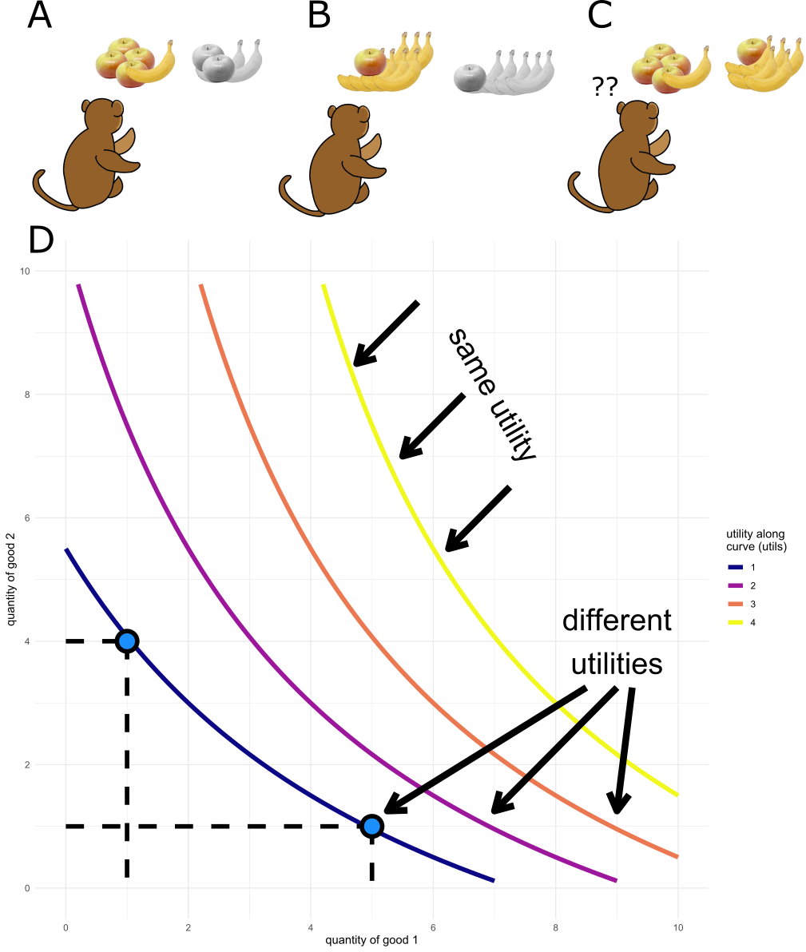
Figure 1a-d) Observations of an organism’s binary choices between bundles of goods allows for the construction of utility curves under revealed preference theory. In a-c) an organism chooses between bundles of goods (in this example, between amounts of apples $A$ and bananas $B$). In a) the offered bundle of 4 apples and 1 banana is more desirable than an offer of 2 of each fruit, and so the first bundle is chosen. In b) an offer of 7 bananas and a single apple is dominant over an offer of 5 bananas and a 1 apple and so the former is chosen. In c) the two offers (4 apples and 1 banana vs. 5 bananas and a single apple) are both preferred equally and will be chosen between as if at random. The organism is said to be indifferent between these two choices and they lie on the same utility curve. In d) an example indifference map is generated assuming the choices in 1a-c). Each point along a curve is a potential choice which carries the same utility to the organism. For instance, the choice offered in c) is highlighted on the lowest curve. As curves are drawn away from the origin, the utility they represent to the organism increases; the points along a curve offer more utility to the organism than any possible point below the curve. Each distinct curve is referred to as an ‘indifference curve’. All choices and values in this figure are hypothetical and are used for illustrative purposes only. Adapted from Pastor-Bernier et al. 2017.
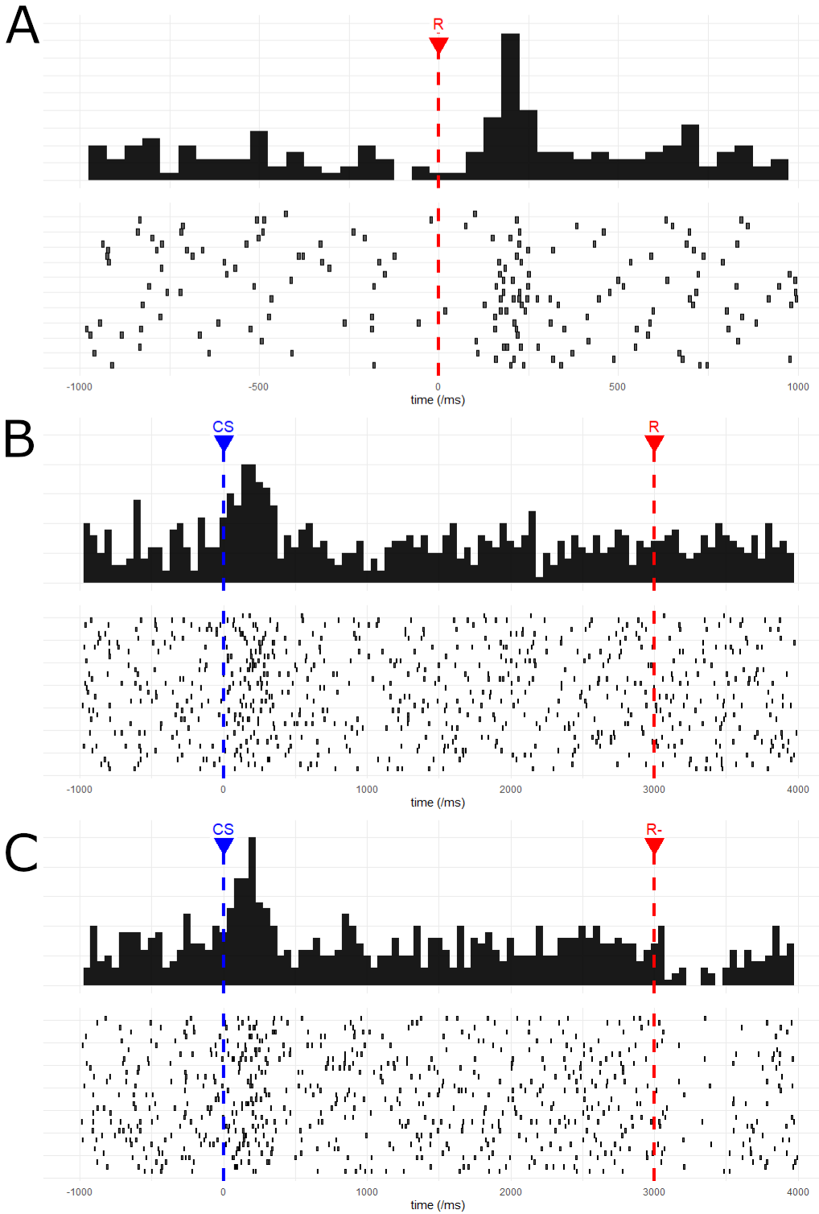
Figure 2a-c) Single dopaminergic cell responses to rewards and conditioned stimuli. In a), the responses of a single non-human primate dopamine cell recorded during this project to an unexpected juice reward are shown. Reward was delivered at time 0 and the responses of the cell are shown as a post-stimulus time histogram (top) and as a raster plot (bottom) of single spikes from this cell. The phasic response of the cell can be seen starting at 100ms and continuing for a further 200ms. As our task contains many epochs where stimuli are presented, and as we never withhold a predicted reward during our task, for panels b) and c) we use wholly simulated data to illustrate the widely reproduced change in activities of dopamine neurons upon conditioning of stimulus (b) and when a predicted reward is not forthcoming (c). For biological data, see Schultz et al., 1997. In b) a conditioned stimulus (CS) cue is presented at time point 0, predicting a reward at 3000ms. The firing rate of the simulated dopaminergic neuron increases at time 0 with the CS presentation rather than at time 3000 with the delivery of the reward. In c) the same CS cue is shown at time 0 but in these trials a predicted reward is never delivered. The simulated neurons maintains phasic activity at time 0 but shows a decrease in firing rate upon the omission of the predicted reward.
Appendix 1.1 – Modern Advances in Behavioural Economics and Auction Theory
This thesis considers the behaviour and neuronal responses of trained macaques in an auction task (BDM) hitherto only used in human studies of economic decision-making. As such, we feel that any interested reader only need be introduced to three behavioural-economic concepts in the introductory chapters of the thesis:
- The idea that utility and not value is the variable by which economic decisions are made. I.e. people and other organisms maximise their utility by consulting a utility function when choosing between distinct options. Compare equations 1.1 and 1.2 when discussing the St Petersburg paradox in the first chapter.
- That in order to make these decisions some areas of the brain must have access to these internal representations of utility. For instance, we discuss Lak et al., 2014, which shows how dopaminergic neurons of the macaque midbrain integrate information across different dimensions. In Chapter 1 of the thesis we focus on dopaminergic circuits, branching out to discuss the evidence for other components of ‘the reward circuit’ (Haber & Knutson, 2010) in appendix 2.
- Finally, we discuss the incentive-compatible nature of the BDM, a mechanism by which subjects report their cardinal utility for a good on a single trial. Chapter 2 walks through the theory of the BDM and what makes it such a potentially attractive task for the cognitive sciences.
However, there has been much interesting progress in the fields of micro- and behavioural economics over the past half a century which goes beyond the requirements of this thesis. We use this appendix to briefly discuss three examples we find most interesting.
Prospect Theory
We close discussions of economic utility theory in the first chapter by mentioning violations of the four axioms of Von Neumann and Morgernstern’s utility model. Of particular note is the ‘Allais paradox’, first described in the literature by Allais, 1953 and adapted in figure 1 from Kahneman & Tversky, 1979. A participant is asked to make two choices, between options A and B, in gambles 1 and 2:
Gamble 1:
Choose between option A where there is a 33% chance of winning $2,500, a 66% chance of winning $2,400, and 1 % chance of winning nothing, OR option B which represents a certain $2,400.
Gamble 2:
Choose between option A where there is a 33% chance of winning $2,500 and a 67% chance of winning $0, OR option B where there is a 34% of winning $2,400 and a 66% chance of winning $0
In their experimental reproduction of Allais, 1953, Kahneman & Tversky found that 82% of 72 participants chose option B in gamble 1 and 83% chose option A in gamble 2. However, this is a violation of the independence axiom (equation 1.5) as options A and B in gamble 1 and 2 are identical except for addition of independent extra alternative choice of $2,400 with a constant probability (66%). A graphical explanation of this paradox is shown in figure 1.
In chapter 1 we define the utility function of a set of choices in equation 1.2 as
Equation A1.1
$${EU}_{i,n}= p(x_{n})⋅{υ_{i}(x}_{n})$$

Where the probability term ($p(x_{n})$) is separate from the subjective, utility term $υ_{i}(x_{n})$. That is, probability is treated objectively whereas other components of value (e.g. magnitude) are treated subjectively. This idea was further extended by a later paper by Tversky & Kahneman in which subjects were asked to choose between three responses to a hypothetical deadly, novel disease:
Imagine that the U.S. is preparing for the outbreak of an unusual Asian disease, which is expected to kill 600 people. Two alternative programs to combat the disease have been proposed. Assume that the exact scientific estimate of the consequences of the programs are as follows:
Choice 1:
If Program A is adopted, 200 people will be saved. If Program B is adopted, there is 1/3 probability that 600 people will be saved, and 2/3 probability that no people will be saved. Which of the two programs would you favor?
Choice 2:
If Program C is adopted 400 people will die. If Program D is adopted there is 1/3 probability that nobody will die, and 2/3 probability that 600 people will die. Which of the two programs would you favor?
(taken directly from Tversky & Kahneman, 1981)
For any choice, the expected number of deaths is equal. Either 400 people will certainly die (A and C), or 400 people will be expected to die (B and D). Participants are choosing between a sure thing and a risky choice with equivalent values. We would assume subjects would show consistent risk preferences between the 2 choices: either they go for the risky option in both choice or the ‘safe’ option. However, the framing of the choice as either losses or gains (‘200 people will be saved’ vs. ‘400 people will die’), has a distinct impact upon participants choices; they are risk averse and choose option A in choice 1, but are risk-seeking and choose option D in choice 2.
These violations of Von Neumann/Morgernstern utility theory were codified by Kahneman and Tversky into a descriptive model of decision making known as ‘Prospect theory’ (Kahneman & Tversky, 1979). The key insight made was that probability should be treated subjectively, that is
$${EU}_{i,n}= ω_{i}(p(x_{n}))⋅{υ_{i}(x}_{n})$$
Where $ω$ is some distortion a subject $i$ places upon the probability of outcome $x_{n}$. This leads to a further two appreciations of how an individual’s utility function is shaped. Firstly, that this $ω$ parameter creates as S-shaped distortion where people overweight low probabilities and underweight high probabilities (figure 2a). Secondly, the idea that “losses hurt more than gains”, i.e. if an organism loses something of value, to return to net zero utility for the time period, they must gain something of greater value than that which was lost. This is formally described as ‘loss aversion’ and depends on the framing (see the above experiment using a potential novel disease) of any transaction and gives rise to the ‘endowment effect’ discussed in chapter 2. This ‘kink’ in the utility function is shown in figure 2b.
While newer models have arisen to account for some failings of Prospect theory (and especially to incorporate ‘heuristics’ into descriptive models of economic decision-making; Tversky & Kahneman, 1992), the theory still represents a step forward in combining insights from psychology and ‘experimental’ economics into the previously much more theoretical economic framework. Though undoubtedly not perfect, has proved its worth in empirical studies of humans (Abdellaoui et al., 2008; Scholten & Read, 2014) and macaques (Stauffer et al., 2015). In 2002, Daniel Kahneman won the Nobel Prize in economics for "for having integrated insights from psychological research into economic science, especially concerning human judgment and decision-making under uncertainty”.
Stochastic Choice and Random Utility
Within this thesis we present a task which allows us to study the cardinal utility of a good to a monkey on individual trials (chapter 2). We compare this task to the discrete-choice tasks that have traditionally been used in this field. In such ‘binary choice’ tasks, subjects choose been options A and B, with the implication being that the good with the higher utility will be chosen.
For a hyper-rational decision-maker, we might expect that these choices are black and white- after all, the participant should always choose the better option! However, when studying the choices made by both humans (Mosteller & Nogee, 1951) and monkeys (Ferrari-Toniolo et al., 2020; Pastor-Bernier et al., 2017), many choices instead show a curve or preferences (see figure 2.1 for a simulated example or figure 2.7 for a figure redrawn from Mosteller and Nogee, 1951). In the introduction to this thesis we touch upon the differences between ‘perceptual’ decisions (e.g. sensory discrimination tasks) and ‘economic’ decisions. The indifference curves in figures 2.1 and 2.7 bear a striking resemblance to the psychometric curves found in the perceptual literature (Klein, 2001; Rieskamp et al., 2006); instead of always choosing an offer with higher utility, subjects make ‘stochastic’ (or ‘discrete’) choices.
There are two reconciliatory theories of these empirical observations of choice reversal. Fixed utility theories assume that the utilities present in a choice are fixed and subjects choose options in proportion to the value of the offered choices (Luce, 1959; Tversky, 1972).
Equation A1.2
$$p(x_{i})=\frac{υ_{i}(x)}{\sum_{j=1}^{n}{υ_{i}(x_{j})}}$$
The probability of a subject $i$ choosing an offer $x$ is equal to the utility of that choice to the subject, divided by the sum of the utilities of all other offers.
In contrast to fixed utility theories, random utility theories assume that the utility placed on a choice by a subject is sampled from a distribution at each evaluation and is inherently noisy (Becker, Gordon M. DeGroot, Morris H. Marschak, 1963; Marschak, 1960; McFadden, 1982). 1 millilitre of orange juice might have greater mean utility to a monkey than 1 millilitre of blackcurrant juice and over infinite trials might be chosen more often. However, if both utility distributions have significant variance, both options might be chosen with a similar rate over a countable number of choice actions. Daniel McFadden showed that the Luce equation (equation A1.2) could be reinterpreted in terms of logistic regression. Namely that the choice $p(x_{i})$ can be estimated using a multinomial logit model (McFadden & Train, 2000)
Equation A1.3
$$p(x_{i})=\frac{e^{υ_{i}(x)}}{\sum_{j=1}^{n}{e^{υ_{i}(x_{j})}}}$$
The slope of this model is proportion to the noise in a subjects choices; a rectangular step function shows hyper-rational choices of always the offer with the most utility, with the curve flattening as a subject’s choices become noisier. Daniel McFadden won the 2000 Nobel Prize in economics for these contributions to discrete choice modelling and we use this model in chapter 3 to estimate the utility of binary choices, in line with previous studies from the lab (Ferrari-Toniolo et al., 2020; Pastor-Bernier et al., 2017).
Figure 3 shows the random utility model in graphical form where choices red, blue, green, and purple sit along a concave utility function (panel 1). We model the noise in each choice as a Gaussian (here with equal variance (noise) per choice which may or may not be the case in the real world), where the proportion of choices corresponds to the proportion of samples where each has a higher utility plus noise (panel 3). The choice between the red and blue offers (representing 2 or 3 units of an offered good) sits on a steeper section of the utility function and so, for the same amount of noise in each choice, has a greater discrepancy in observed choices than for the green and purple (7 and 8 units) goods.
Modern Auction Theory – From Wives to Wireless
This project uses a relatively simple auction design in which a monkey makes bids which are compared to a randomly drawn computer bid. We discuss a history and analysis of the BDM auction paradigm in chapter 2 of this thesis (Becker paper, milgrom paper). While this is not a pure economics thesis, we consider it important to situate our work somewhat within the more general field of auction theory. Neuroeconomics as a discipline is in its infancy (Camerer et al., 2005) and we would expect that some day, possibly even soon, an understanding of the economics literature will be an important asset to any neuroscientist who goes in search of value signals in the brain. Here we give a whirlwind tour starting with the history of auctions and progressing onto modern auction theory.
The somewhat chequered history of auctions is generally agreed to have begun with Herodotus' description of the sale of Babylonian wives in his Histories published circa. 500 (Rawlinson, 1885).
"All the girls of marriageable age were assembled together in one place, and a crowd of men would form a circle around them while and auctioneer had the women stand up one by one and sold them, beginning with the most beautiful. When this young woman was sold for a large amount of gold, he would then put up for sale the second most beautiful... All the wealthier Babylonian men of marriage-able age would try to outbid each other for the prettiest girls. The more humble among them did not seek beauty in the women they bid for, because the homelier ones came with a monetary reward as an incentive for someone to marry them... And when the auctioneer finished selling the most beautiful of the young women, he had the most unattractive stand up, or a crippled girl, if there was any among them, and these would be offered for sale with the announcement that they would go to whoever would accept the smallest amount of gold and marry them... The gold for these arrangements came from the sale of the beautiful girls, and thus the attractive provided the dowries to help marry of the unattractive and crippled."
Each potential suitor is assumed to have utility for both a beautiful wife and the potential monetary compensation offered. The rich outbid each other to maximise their utility for the 'prettiest girls' and the poorer men to maximise the monetary incentive for marrying a more 'humble' bride.
Perhaps a more famous early example of auctions is also it's most disastrous. In 193AD the Praetorian guard murdered the Roman emperor Pertinax and auctioned off the chance to succeed him. Pertinax's father-in-law Sulpicianus offer of 5000drachmas was outbid by Didius Julianus who offered 6000drachmas (Gibbon, 1776). While auctions are an efficient mechanism to discover an individual’s utility for an offer, they are a poor apparatus to aggregate many people's preferences; the purchase rather than earning of the title made Julianus an unpopular emperor who was executed by the same guards less than 3 months later (Dio, n.d.).
The Romans had greater success staging auctions for more common goods in order to trade and raise money, most commonly to pay off debts to creditors (Morcillo, 2008). For the last few centuries, particular industries especially for rare items (such as diamonds), fresh items (such as fish and fresh flowers) and durable items (such as used cars) have, and continue to sell their goods in auctions, however, it is only with the advent of the modern world that the use of auctions has exploded.
The United States introduced auctions for treasury bills in 1929 (Garbade, 2008), a mechanism of government financing that has since been taken up by many countries and is now worth tens of trillions of dollars worldwide. In addition, certain natural monopolies where the opportunity to exploit a resource can only be sold to one bidder have proven amenable to auctions. For instance, when selling the rights to extract oil from a potential field, the utilities of petroleum companies will vary by their estimate of the magnitude of that oil reserve, and any regulator is incentivised to find the highest estimate among any set of bidders.
With the rise of telecommunications, frequency spectra became a crucial and inherently limited natural monopoly and by the new millennium auctions of spectra raised tens to hundreds of billions of euros per country (Klemperer, 2002). The internet allowed monopolisitic startups the opportunity to auction limited advertising space (Google, 2017) as well as connecting traders with an near infinite supply of potential buyers on platforms such as eBay.
It's therefore not surprising that auction theory has proved a fertile ground for applied economic thought over the last half a century providing insights that have raised billions of units of currency for governments around the world, and many prestigious prizes for economists. The modern analysis of auctions is traditionally traced back to John Forbes Nash's 1950 dissertation on non-cooperative games (Nash, 1951). Extending the work of von Neumann and Morgenstern beyond zero-sum games (von Neumann, J Morgenstern, 1944), Nash introduced the concept of a 'Nash equilibrium', an optimal strategy for any player given full knowledge of every other player's strategy, which must exist for any finite game (that is, any game with a bounded set of strategies such as the limited bidding budget in our BDM task).
Nash shared the 1994 Nobel prize in economics that he won for his work on non-cooperative games with John Harsanyi for the latter's work on 'Bayesian games', when players have incomplete information about the game being played (Harsanyi, 1967, 1968a, 1968b). For example, if a PhD student knows that their examiners are diligent the Nash equilibrium should land on the student putting a fair bit of work even into the appendix of their thesis to produce a comprehensive piece of work to be examined upon. However, any student has incomplete information about their thesis committee and does not know if their examiners will be diligent or lazy (and not read the appendices), or perhaps just not interested in auction theory. In auctions, a bidder only has complete knowledge of their own value and range of bids for any offered good, and so any analysis of auctions must take place within the Bayes-Nash framework.
The extension of game theory to incomplete information settings becomes crucial when considering the phenomena that has come to be known as “the winner's curse”. In 1971, Capen, Clapp, and Campbell published their reports that oil giants bidding for the rights to extract from offshore locations under a first-price auction mechanism were making less profit from these sites than expected (Capen, E. C. Clapp, 1973). All else being equal, by definition, the company which won the rights to drill an oil field had the greatest expected value of the oil located within that field. That is, after all, why they submitted the highest bid and won the auction for those rights. For any bidders lacking introspection, the greatest bid for a given good will tend to be the greatest overestimation in that goods worth, with the overestimation of value correlated with the numbers of bidders in the auction.
Robert Wilson solved the amount each bidder should optimally reduce their bid in such auctions by an analysis of auctions within the Bayesian games framework (Wilson, 1967). This work was expanded upon by Wilson and his former student Paul Milgrom in two seminal papers (Milgrom & Weber, 1982) with two key results for auction theory. Firstly, that it is possible to rank the expected income from an auction on a good based on the type of auction that is used. For instance, the English (the traditional mechanism used at auction houses where bids are open and gradually increase) auction and sealed second-price auctions (i.e. Vickrey auctions; the BDM mechanism but against conscious opponents) are functionally equivalent, but the open nature of the English auction mechanism reveals greater information about bidders valuation of goods. Therefore, any ignorant bidder can gather more information about the value of the auctioned good mitigating the winner's curse and leading bidders to bid more aggressively. English auctions typically raise more revenue than sealed second-price auctions, and both of these raise more than Dutch (descending price) auctions.
This feeds into the second main finding that it is in the interest of sellers to reveal as much information of their valuation of a good as possible. For instance, when selling a used car, auctioneers should provide proof that the car can run safely so that bidders can be more sure they will not fall victim to the winner's curse and will be incentivised to bid higher. Milgrom and Wilson termed these findings the 'linkage principle'.
Wilson and Milgrom's theoretical work in turn led to greater empiricism in auction theory. Throughout the 1950s and 1960s Vernon Smith had carried out experimental auctions on classes of economics students (Smith, 1991). These experiments grew more sophisticated and two papers published in 1980 and 1982 found similar empirical violations to revenue equivalence for 'identical' auctions to Milgrom's theoretical papers (Coppinger et al., 1980; Cox et al., 1982). Vernon Smith shared the Nobel prize in economics for his work on experimental auctions with Kahneman in 2002. In 1986, Kagel and Levin also carried out experimental work into the winner's curse, confirming both the real-world behavioural findings of Capen, Clapp, and Campbell, and the theory laid out by Milgrom (Kagel & Levin, 1986).
These theoretical and experimental results are interesting by themselves, but perhaps the single area where auction theory has distinguished itself over the last thirty years is in its successful application to real-world auctions. Mobile phone spectrum is inherently limited by the range of frequencies usable, and thus, is extremely valuable to telecommunications companies. Prior to 1993, the United States allocated spectrum via lottery and belief in free market mechanisms to encourage spectrum trading, leading to inefficiencies and zero revenue for the federal government. Among others, Milgrom and Wilson were invited to design auctions for the selling of spectrum in 1994 settling on the Simultaneous Multiple-Round Auction (SMRA) mechanism (McMillan, 1994). Similar spectrum auctions since then have raised over $60billion in revenue for the government and the efficient sorting of the natural monopoly has allowed wireless communication technology to flourish. Milgrom and Wilson were awarded the 2020 Nobel prize in economics for both their theoretical treatment of auctions and this successful application of the theory.
In the United Kingdom, similar auctions have also been used to great success. In 2000, Britain sold third generation spectrum licenses, raising £22.5billion in a single auction, described as the 'biggest auction ever' (Binmore & Klemperer, 2002). Not all spectrum licenses have been such a success, with many European auctions at around the same time failing to raise anywhere near that amount (Klemperer, 2002), highlighting the crucial role of continual research into auction theory and behaviour to allocate scare resources.
As Binmore and Klemperer note in their introduction, “Twenty-two and a half billion is a great deal of money to raise for selling air, but that is what the British government raised in an auction for five telecom licences“. This quote neatly summarises the power of gradual advancements in microeconomic theory over the past century. We have progressed from the failures of the Praetorian guard and Johann Wolfgang von Goethe, to the mathematical study of games ,and finally to governments worldwide “putting auction theory to work” (Milgrom, 2003).
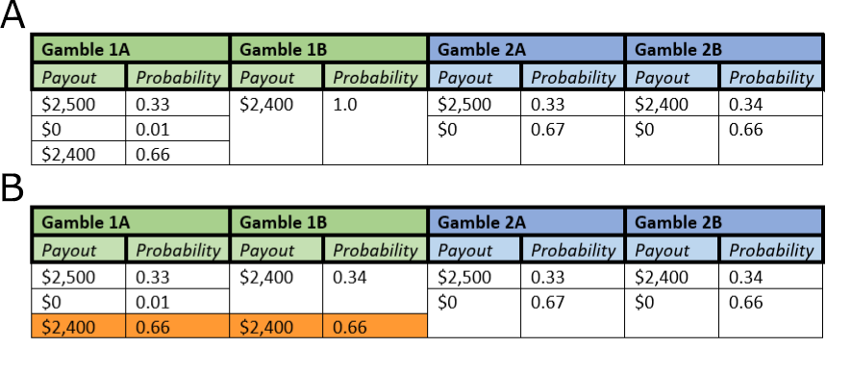
Figure 1a-b) The Allais paradox highlights a violation of the independence axiom. Participants are asked to choose between two options (A and B) in sequential gambles (1, green, and 2, blue). In a) participants are asked to choose which option from gamble 1 and gamble two they would choose. In Kahneman & Tversky, 1979, 82% of 72 subjects choose gamble 1B and gamble 2A. However, in b) it can be shown that gamble 1 and gamble 2 should have the same relative desirability of options. Gamble 1 is derived from gamble with the addition of a 0.66 chance of $2,400 added to each option (orange). Thus, the switching behaviour between options A and B originally found by Allais, and also Kahneman & Tversky, represents a violation of the independence axiom.

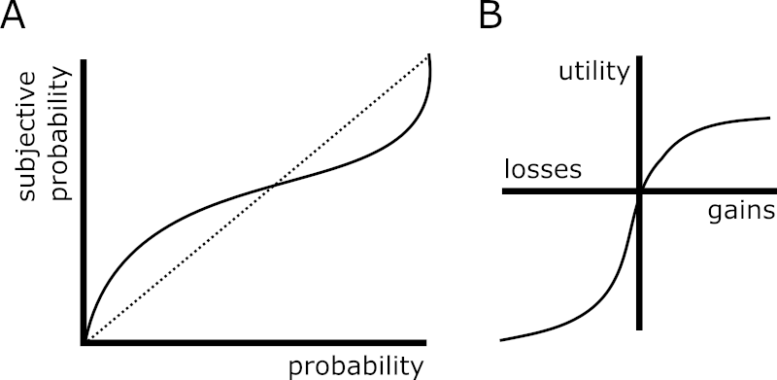
Figure 2a-b) Prospect theory incorporates evidence that probabilities are experienced subjectively by individuals. In a) the S-shaped curve of the probability distortion is shown. Low probabilities are subjectively overweighted (and seem to occur more often than they actually do) whereas objectively high probabilities are underweighted. In b) the ‘kink’ of the utility curve is shown where the convex function for losses is steeper than the concave curve for gains. I.e. “losses hurt more than gains”.

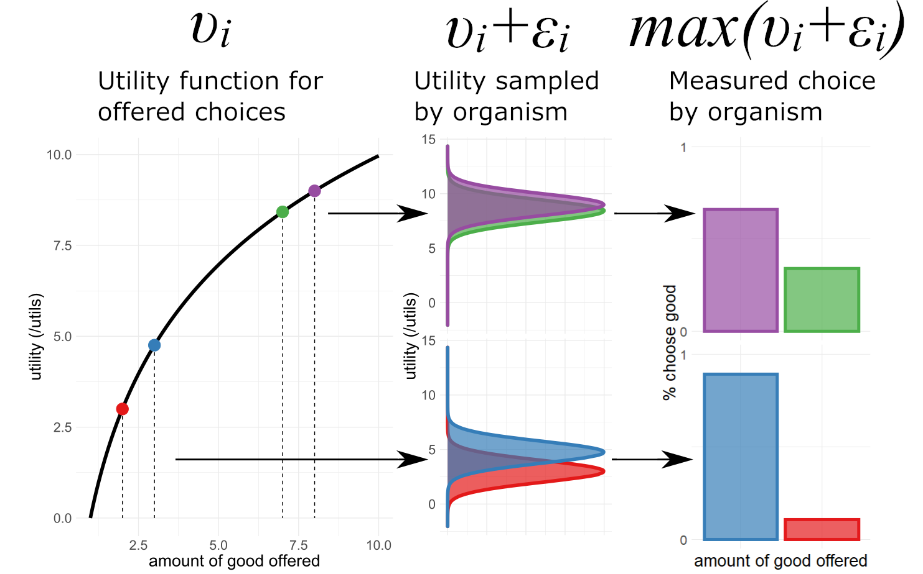
Figure 3) Random Utility Models assume that the organisms sampling of the utility of an offered choice incorporates and error term. For given choices (e.g. between 2 and 3 units, red and blue, of a good, or 7 and 8 units, green and purple, of a good) and organism samples a utility function (black curve for utility given offer in first panel). This utility function takes the form $υ_{i}$ and is internal to the organism. We expect the organism to preferentially choose the option with the higher internal, subjective utility. Random Utility Models posit that the choice the organism makes is between this utility for the good plus an error term $ε_{i}$ which in this figure takes a Gaussian function in panel 2. In panel 3 the sampled utilities are compared and in each simulation the choice with the higher sampled utility $υ_{i}+ε_{i}$ is chosen. The fraction of choices the organism would be expected to make is then shown. For a given error term, the choices are expected to be made in proportion to their utility as derived from the utility function $υ_{i}$. Data here is simulated and for illustrative purposes only.

Appendix 1.3 – The Wider Primate Reward Circuit
In the introduction to this thesis we provide a brief history of the development of the idea that a representation of utility can be found in the dopaminergic neurons of the midbrain. We focus solely on this subcircuit (and restrict the supporting evidence to rodents, primates, and human studies) in the introduction for the sake of brevity, and because the neuronal data presented in chapter 4 of this thesis is recorded from these projections. However, economic decisions are universal and complex; it would be outrageous to suggest that such a small population of neurons represent the whole of the neuronal reward circuit. In this appendix we consider other brain regions of interest to researchers searching for neuronal correlates of reward, focusing on the cortical-basal ganglia circuit.
The Prefrontal Cortices and Reward
During the early 1990s, Edmund Rolls showed that single neurons in the orbitofrontal cortex (OFC) of macaques responded to flavour (Rolls et al., 1990) and that, crucially for reward encoding, these responses depended on the satiation of the animal in question (Rolls et al., 1989). O’Doherty et al., 2001 replicated this finding in human studies using functional magnetic resonance imaging (fMRI), showing separate regions on the orbitofrontal cortex in humans showed blood-oxygen-level-dependent (BOLD) activity mediated by pleasant and aversive taste stimuli which was expanded upon by Anderson et al., 2003 who showed that the OFC fMRI activity was associated with an increase in the valence, but not the intensity, of an odour stimulus.
In two later fMRI studies of humans performing monetary tasks, Brian Knutson showed that the medial prefrontal cortex (mPFC) shows an increase in BOLD signal upon the receipt of an award, but a decrease upon an expected monetary reward that is withheld (Knutson et al., 2003, 2005). Moreover, the BOLD signal incorporated both the magnitude and probability of the monetary rewards, and thus seemed to be computing the expected value on an economic stimulus (see equation 1.1; Knutson et al., 2005). That single cells in these prefrontal cortices encode economic value was later shown by Padoa-Schioppa & Assad, 2006 in a task where macaques made choices between amounts of liquid rewards. This study also dissociated the different activity of different single neurons, showing that some responded to the ‘offer value’ (how much juice or water was offered on a trial), whereas other responded to the ‘chosen value’ (the amount of the chosen liquid that had higher utility and was picked by the animal). This multiplexing of value signal including magnitude, probability and cost was replicated in the macaque prefrontal cortices by Kennerley et al., 2009.
In a similar task in which macaques had to choose between two pictures representing a magnitude of a juice reward, neuronal ensemble recordings from the OFC could be decoded to show the oscillation of value encoding between the two choice offers with response times on a single trial correlating with the time spent by the ensemble in the ‘unchosen state’ (Rich & Wallis, 2016). Furthermore, low current (25-50μA0 stimulation of macaque OFC cells was sufficient to bias choices in a similar task, whereas high current (≥100μA) did not bias choices but did increase the variability of choices (Ballesta et al., 2020).
The rich, heterogeneous responses of frontal lobe neurons to tasks was interesting to us and we strongly considered recording from this region when developing the project due to the increased sophistication of the BDM when compared to traditional choice paradigms. For example, instead of choosing discretely between two offers, a monkey must instead choose between continuous values of a bid. As a monkey then makes their choice, they pass through the other choices which must be continually considered and find an optimal stopping value to place their bid at.
The Amygdala and Reward
Many of the pioneering human fMRI studies discussed in the last section also found significant changes in the BOLD signal in the human amygdala during economic value tasks (Breiter et al., 2001; O’Doherty et al., 2001). The amygdala are a collection of nuclei located in the medial temporal lobe of mammals most commonly implicated in fear processing (LeDoux, 2007). Once the amygdala was implicated in economic decisions, studies found this fear processing could be extended to uncertainty of a potential loss (Hsu et al., 2005; Kahn et al., 2002), an idea extended by findings that humans with bilateral amygdala lesions show markedly reduced loss aversion (see appendix 1.1 for a discussion of Prospect theory; De Martino et al., 2009).
As with the prefrontal cortices, single cell recordings from non-human primates have supported the idea that neurons in the amygdala encode economic value. Bermudez & Schultz, 2010 used a Pavlovian task where the display of a stimuli predicted a juice reward with three possible magnitudes finding that the activity of a population of amygdala neurons increased their activity after the delivery of the juice, and that one third of these had changes in activity that correlated with the magnitude of the juice received. In a replication of Padoa-Schioppa & Assad, 2006, Jezzini & Padoa-Schioppa, 2020 found that basolateral amygdala (BLA) neurons also showed heterogenous responses in a choice task, though with many more neurons coding the chosen value than in the OFC.
In appendix 1.2, we discuss the idea that value arises from progress towards a goal (Juechems & Summerfield, 2019). Interestingly, studies of humans and macaques have implicated the amygdala in progression to some internal stopping point on a ‘spend-save’ task (Grabenhorst et al., 2016; Zangemeister et al., 2016). Both humans and monkeys could choose to either ‘save’ (and accumulate liquid rewards with interest) over trials or ‘spend’ (and consume the saved liquid). In humans, BOLD activation in the amygdala encoded the length and value of save sequences and single BLA neurons in macaques showed ramping phasic activity as a sequences of save trials progressed towards the monkey’s choice to consume their reward.
Perhaps most intriguing for studies involving auction theory is that the amygdala seems to be involved in processing economic and social stimuli (see Rutishauser et al., 2015 for a review). In appendix 1.1 we discuss the ‘winner’s curse’ in auction theory- the idea that on auction the winner is likely to have overpaid for a good (Capen, E. C. Clapp, 1973). The auctions presented in this thesis use a random computer bid as is typical for the BDM paradigm, however, it is possible to imagine future studies which involve multiple organisms bidding to receive one reward per trial. BLA neurons have been shown to respond to the value of rewards for oneself and to those given to another monkey in a donation game, but not to rewards donated by a computer (termed ‘value-mirroring’ neurons by the authors; Chang et al., 2015). Moreover, in a learning task, amygdala neurons track value learnt from a primates own choices as well as those made by another monkey in view (Grabenhorst et al., 2019). These neurons are then able to simulate the choices made by a different animal, a strikingly similar paradigm to how human’s can optimally bid on auctions by simulating the discounting of other actor’s bids (Wilson, 1967).
Other Structures Implicated in the Reward Circuit
We focus on the prefrontal cortices and amygdala here as we find the evidence for value encoding in these areas the most striking. The entire reward circuitry of primates is known to be more complex (Haber & Knutson, 2010) and involves the striatum (Samejima et al., 2005; Strait et al., 2015), lateral habenula (Matsumoto & Hikosaka, 2009), anterior cingulate cortex (Azab & Hayden, 2018), and lateral hypothalamus (Harris et al., 2005) amongst others.
Dopamine neurons from the ventral tergmental area (VTA) or the substantia nigra pars compacta (SNc) provide input to most of these implicated areas via the mesolimbic-mesocortical and nigrostriatal projections (figure 1) and are hypothesised to form a ‘reward retina’ conveying a signal of how a reward deviates from expectation to downstream regions of the brain which integrate additional information (Wolfram Schultz, 2009). These two populations receive distinct inputs from a wide range brain areas, with the dopaminergic neurons of the VTA receiving most input back from the ventral striatum and lateral orbitofrontal cortex, as well as inhibitory input from the lateral habenula (Matsumoto & Hikosaka, 2009). By contrast, the SNc receives most of its input from the somatosensory and mortor cortices, as well as the aubthalamic nucleus, the dorsal striatum and nucleus accumbens (Watabe-Uchida et al., 2012).

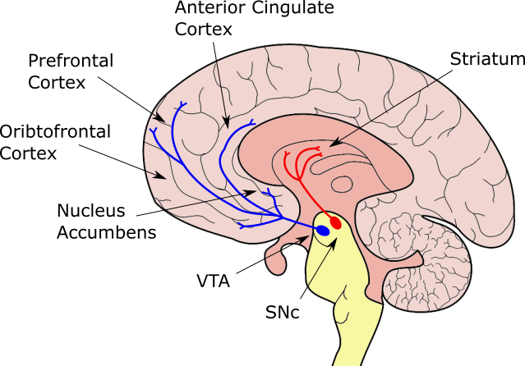
Figure 1) The dopaminergic pathways of the ventral tegmental area (VTA) and substantia nigra pars compacta (SNc) project to most regions implicated in economic decision making. Dopaminergic nuclei located in the midbrain have wide ranging projections. The nigrostriatal projections from the substantia nigra pars compacta reach to the striatum (red). The mesolimbic-mesocortical projections originate in the ventral tegmental area are reach to the prefrontal cortices as well as the nucleus accumbens and the anterior cingulate cortex.

Chapter 2 – Auction Theory as a Neuroscientific Tool

One problem that studies of economic decision-making face is that utility is an internally generated value and must be reported by any animal or human subject to an external observer. The context a subject finds themselves in is a key constraint on how easily and accurately an experimenter can measure a participant’s utility. Therefore, choosing an adequate task for any animal or human is of the utmost importance.

Making invasive recordings from a model organism is both time consuming and requires the sacrifice of animals. It is vital that experiments are designed to generate the most pertinent and robust findings possible given these costs. As expressed by Niv, 2020, “arguably, the most interesting findings from neural recordings or perturbations are […]coupled with incisive, hypothesis-driven behavioural experimental designs.” The key differentiating aspect of this thesis is its choice of behavioural paradigm for electrophysiological recording. Instead of using repeated binary choices made by an animal, we record from non-human primates performing an auction task. The focus of this chapter is to describe the importance of this difference, and the nuances of the task.

What makes a good economic task?

When using an economic task as an experimental paradigm, it is crucial that the task should reveal the mechanisms used by the subject to make economic decisions. For instance, a game of roulette using a fair (random) wheel where the subject can pick one number on which to place a bet cannot reveal anything about how the subject makes economic decisions. Each possible choice the subject can make has the same expected payoff and so no choice exists that has any more value than another.

If we then allow the roulette player to pick how to spread their bets, the task presented is still inherently random (there is no ‘winning strategy’ to roulette), but we have allowed the subject to alter the expected utility of a trial. A player who routinely spread bets thinly is risk averse, preferring a higher chance of small wins, compared to one who places it all on one number, seeking large (risky) gains. This task is now suitable for use in understanding a subject’s risk preferences, and how and why these change as they complete multiple rounds of the task.

In contrast, if there are too many potential strategies for a task, it is also difficult to glean any understanding of how a subject makes decisions. For instance, in a round of poker any player who bets high may hold a hand they subjectively value, or be bluffing on a poor hand. There is no incentive for the player to truthfully reveal the value of their hand, as doing so would allow opposing players to exploit them. As there is no rule that a poker player must state which strategy they are using, there is no way for would-be economists to know exactly the subjective value placed upon the cards drawn.

It is crucial that any task used to reveal a subject’s valuation of a chosen option is incentive compatible. I.e. it is always in the best, selfish, interests of any participant in the task to truthfully reveal exactly their preferences, or valuation, of the presented options. This is doubly important in any animal models of economic decision making where the strategies available to an animal cannot be verbally explained and must be learnt via reinforcement. The strategy the animal settles on should always converge to the one which yields the maximum rate of subjective value returned.

Any task suitable for research into economic behaviour therefore should have a single, obvious strategy which is incentive compatible. A self-interested participant in the task should always follow this utility-maximising strategy, which is referred to as the dominant strategy. This should override any internal desire for (e.g.) a nefarious human participant to deceive the experimenter about their valuation of a presented option allowing us to be confident that a choice truthfully reveals their preference.

In traditional ‘binary choice’ paradigms outlined in the previous chapter (see figure 1.1 and also Mosteller & Nogee, 1951), choices are obviously incentive compatible as any participant should always choose the one which presents the greatest expected utility. For a simple riskless choice between two quantities of the same desired good ($A$), a subject should always have more utility for the option that contains more of the good, and thus preferentially choose that option.

However, a single trial of a binary choice task never reveals exactly the value of one option in terms of the other. A subject can only choose between options, and not in terms of them. A simple experiment that offered a participant an amount $X$ of good $A$, and an amount $Y$ of good $B$ only reveals which has the higher valuation, and not the values of $X$ and $Y$ for which $X×A == Y×B$.

To calculate the numeraire- the quantity $X$ for which $Y$ is equal to 1- repeated choices between amounts of goods $A$ and $B$ are required. As valuation decisions (like all types of decisions) are noisy and even sometimes erroneous, a binomial function can be fitted to the choices. The midpoint of this logistic function can be taken as the indifference point, the values of $X$ and $Y$ for goods $A$ and $B$ where a subject is indifferent between the choices. I.e. both choices represent the same utility. Therefore, the equation $X×A == Y×B$ is satisfied, and the values of $X$ and $Y$ can be derived and rearranged to calculate the value of good $A$ in terms of a numeraire $B$.

However, the nature of such a repeated measures task has three obvious limitations:
- As the indifference point is interpolated, it is not uncommon for there not to be any choices made at the point where $X×A == Y×B$. The indifference point is an estimate, not a truly observed equality. In addition, any errors in calculating the logistic fit over the observed points will lead to errors on this estimate.
- To minimise this error, binary choice tasks require many trials to reduce the noise on any one repeated measure. Given a subject will only complete so many trials, in any binary choice experiment, the experimenter must trade-off the resolution of the probability of choices for any offer, and the number of different options to present.
- As the experimenter increases the number of trials required from a subject, they also increase the time taken by a subject to complete a session. Holding the rewards for completing any single trial constant, this means that the subject may become more ‘sated’ with the payment from the task over time and the marginal utility of later trials will be lower than on identical earlier trials. Even if they do not, participants bidding may chance as the novelty of the task wears off. In order to calculate utility, the average choices over a range of trials must be used and it must be assumed that the probability of choice between any two options remains constant over this range.

Examples of these 3 limitations are shown in figures 2.1a-c. For a real-life example, consider figure 2.7 which is redrawn from Mosteller & Nogee’s attempt to measure the utility of monetary bets (Mosteller & Nogee, 1951).

Ideally, we would use a task in which on every trial the subject states their exact subjective value of $X$ for a given offer of $Y×B$, that is, a subject would state their willingness-to-pay in terms of $X$ for an amount $Y$ of good $B$. Such tasks exist using auctions such as the Becker-DeGroot-Marshak (BDM) auction task which has been extensively studied by experimental economists researching human decision making.

A single trial method to measure utility

The concept of the BDM was first defined in a 1961 theoretical paper by William Vickrey (Vickrey, 1961), but takes its name from the authors of a 1964 paper in which human subjects were given wagers with the chance to win $\$W$ in the case of an event $p$, and $\$L$ otherwise $(1-p)$ where $\$W$ is greater than $\$L$ (Becker et al., 1964).

For each of these wagers, the subjects were asked to give a price $\$X$ which is the lowest amount of money they would accept to sell the wager. This price is the subject’s willingness to accept (WTA) and is clearly a function of the value the subject places upon the wager given to them. After, a random number representing a buyer’s bid $\$Y$ is drawn, and if this number is greater than the participant’s WTA $\$X$, the subject receives $\$Y$ dollars, otherwise the wager is resolved and the subject wins either $\$W$ or $\$L$ depending on the outcome.

This WTA value can also be described as the subject’s certainty equivalent. It is the amount (in this example the monetary selling price) of a good they are content to receive with complete certainty. For a utility maximiser, they should only be satisfied so long as the utility of the CE is equal to the utility of all possible outcomes ($O$) of a trial multiplied by their probability.

Equation 2.1
$$υ_{i}(CE) = p_{1}⋅υ_{i}\left(O_{1}\right) + p_{2}⋅υ_{i}\left(O_{2}\right) + p_{3}⋅υ_{i}\left(O_{3}\right) + ...p_{n}⋅υ_{i}\left(O_{n}\right) =υ_{i}(\$X)$$

Where $υ_{i}$ is the utility a single subject places upon each outcome. In the wager selling task with two potential outcomes (win the bet with probability $p$, or lose with probability $1-p$) this resolves to

Equation 2.2
$$υ_{i}(CE) = p_{w}⋅υ_{i}\left(W\right) + {(1 - p}_{w})⋅υ_{i}\left(L\right) =υ_{i}(\$X)$$

In a reversed task where participants bid for an auctioned good, it should be clear that the certainty equivalent, in this case a willingness to pay, should remain the same for each participant as on each trial the participant can either win or lose the auction with a probability $p$ or $1-p$. The reverse of selling a wager for at least as much as a price $\$X$, is the same as buying entry to that wager with at most a price $\$X$. The randomly drawn buyer’s offer $\$Y$ is in this case a randomly drawn second buyer’s price $\$Y$ which the subject pays.

This is equivalent to a sealed second price auction, in which the participant who bids highest for a good, wins the auction and pays the second highest bid to obtain their reward. All other participants neither pay nor win anything.

In such a sealed second price auction, the weakly-dominant strategy is always to bid exactly the value of the good being auctioned. A participant who follows this strategy will never have any ‘regret’ about their bid; there exists no bid that could yield more utility from the trial. In contrast, all other potential bids have the potential for such regret by either yielding negative utility (overpaying for the reward), or net zero utility where the possibility of positive utility was present. This is a counterintuitive finding but is explained in figure 2.2 and in the paragraph below:

Imagine a subject $S_{1}$ bidding against $S_{2...n}$ other participants. The true exact utility of a good to be auctioned to subject $S_{1}$ is $G_{1}$ and the maximum utility of $n$ other participants for the good is ${\hat{G}}_{n}$.

Across trials, a rational participant may win or lose auctions depending on whether $G_{1}>{\hat{G}}_{n}$ or $G_{1}<{\hat{G}}_{n}$ (we assume utilities are continuous and never exactly equal to each other). When $G_{1}>{\hat{G}}_{n}$, the subject wins the auction and pays ${\hat{G}}_{n}$. By definition, $G_{1}>{\hat{G}}_{n}$, so the subject makes a profit of $G_{1}- {\hat{G}}_{n}$.

When${ G}_{1}<{\hat{G}}_{n}$, the participant neither wins nor pays any money, and so makes no profit or loss (except perhaps a small waste of time).

Having failed to win in multiple trials and becoming bored of losing, let us assume that the subject decides to raise their bid to $H_{1}$, where $H_{1}> G_{1}$.

On trials where $H_{1}<{\hat{G}}_{n}$, they lose the trial and make neither a profit nor a loss. Given that ${G_{1}<H}_{1}<{\hat{G}}_{n}$, they would have lost this trial in any case had they bid their true value.

However, in the case where $H_{1}>{\hat{G}}_{n}$, they still pay ${\hat{G}}_{n}$ but may make a profit or a loss:

If ${\hat{G}}_{n}<G_{1}<H_{1}$, they make the same profit as with their previous strategy:$G_{1}- {\hat{G}}_{n}$.

However, where $G_{1}<{\hat{G}}_{n}<H_{1}$, the change in utility to the subject is still measured as $G_{1}- {\hat{G}}_{n}$, but this will be negative; $S_{1}$ makes a loss on the trial.

Having been burned with the strategy the increase bids, the subject instead tries to underbid for the reward. They bid $I_{1}$ where $I_{1}< G_{1}$.

Now they may still win any single trial where $I_{1}>{\hat{G}}_{n}$, but given that
${\hat{G}}_{n}<I_{1}<G_{1}$, they still only make a profit of $G_{1}- {\hat{G}}_{n}$.

But, as $I_{1}< G_{1}$, on any trial where $I_{1}< {\hat{G}}_{n}$, they lose the trial and miss out on the chance to make a profit of $G_{1}- {\hat{G}}_{n}$ in the case that $I_{1}<{\hat{G}}_{n}<G_{1}$.

In summary, we are forced to conclude that subject S₁ will never regret bidding their true utility of a reward ($G$), but if they do not bid their true utility they may sometimes regret overpaying or missing out on the opportunity for profit.

Each of these eventualities are shown in figures 2.2a-h) where bids and values are represented as bars across a continuous number line and a higher position indicates a higher bid/value. It should be mentioned that in experimental trials of the BDM, the subject is generally given a budget to spend or keep so the utility of losing a trial is not exactly zero as it might be for BDM auctions ‘in the wild’. For sake of simplicity however, losing an auction and receiving the budget is treated as the neutral outcome.

Bidding one’s true value is therefore weakly-dominant- a participant cannot do better than bidding their true value. We would therefore expect any rational utility-maximiser with a full understanding of the task to bid as close to their true value as possible for any good in a BDM auction. That is, it is in the best interests of any subject to aid the experiment by declaring their true utility for an offered good in any trial. A more comprehensive proof of this is presented in appendix 2.1, adapted from Milgrom & Weber, 1982.

The BDM as an economic tool

The first documented use of a BDM style auction predates the Becker experiment by 150 years. In 1797 the famous German poet Wolfang von Goethe wished to sell a newly penned epic poem Hermann and Dorothea. In 18th century Germany, authors sold the whole rights to a piece directly to publishers, rather than receiving payment per unit sold; the rights to the poem are equivalent to a good sold in an auction.

Already rich and declaring himself to be uninterested in purely maximising profit, Goethe instead wished to get as good an approximation of the true value of his work. He decided on a minimum acceptable price (his WTA, $\$X$ to compare with Becker et al. 1964) which was given to a legal counsel, Herr Boettiger. He then wrote to his publisher with the contents of the poem and the terms of the auction: if they offered a price ($\$Y$) which exceeded this reserve then he would accept their offer and receive $\$Y$ in exchange for the poem. If, however, $\$Y$ was less than the $\$X$ reserve price, then the negotiation was deemed a failure and Goethe kept the rights to the poem to be sold elsewhere (Moldovanu & Tietzel, 1998).
As we have previously shown the WTA to be the inverse of WTP, the publisher’s best strategy is to set their bid to exactly their assessment of the value of the poem. Unfortunately for Goethe he fell victim to one of the primary assumptions of sealed second price auctions- that each bidder only has knowledge of their own values and bids. Realising his unique situation, Herr Boettiger used his knowledge of the reserve price to strike a deal with the publisher. The lawyer was paid in exchange for the letter containing the reserve price using the savings from the auction where the publisher bid exactly the reserve price.

Similar questions over how incentive-compatible the BDM auction task is in practice have been a fixture of the microeconomics literature over the last 50 years. As accurate reports of value via the BDM require participants to be utility-maximising individuals, they must follow the axioms of expected utility theory as defined in the first chapter of this thesis. Mentioned in the first chapter and discussed in greater detail in appendix 1.1, a well-known violation of expected utility theory’s independence axiom occurs in Allais’ paradox (Allais, 1953), where subjects overweight small probabilities presented in otherwise comparable lotteries. Becker et al. present lotteries with probabilities of ¼, ½, or ¾ to minimise this effect but it cannot be completely ruled out in lottery-based auction tasks.

In our task design we offer riskless rewards with a constant, certain, probability of payout upon winning an auction. This has the dual benefit of overcoming this potential limitation in the BDM and simplifying the task to aid the monkey’s understanding of the link between their bids and the payout of a trial.

It has been proposed that even for non-random goods the BDM may not be truly incentive compatible (Horowitz, 2006). This is because the level of bid the subject makes controls the probability of winning the auction. For instance, a subject who always submits a bid of 0 will never win the auctioned good, whereas one who submits the maximum possible bid will always win the auction. The participant can therefore alter their own bid, with respect to a known distribution of opponent bids, to maximise the utility of both the reward and currency but also the chance of winning.

In the descriptive proof of the BDM as an incentive compatible task, we have assumed that a participant who bids truthfully (i.e. bids exactly their utility for a good) and loses the auction to neither lose nor gain any utility from the trial. The small expected profit from each trial of the BDM only comes in cases where the participant wins the auction. Therefore, in the lose case the participant does actually suffer some small reward prediction error: they have lost out on some expected profit. The introduction to this thesis discusses Prospect theory and how losing out on some expected reward can hurt more than receiving that reward (Kahneman et al., 1979). A hypothetical subject might well be willing to sacrifice some of their budget currency to reduce the chance of losing the auction and suffering this disappointment.

As a subject performing successive trials will have some estimation of the probability of opponent bids. They can therefore calculate the change in probability of winning for any extra increase in their bid. Assuming some disutility (‘disappointment’) for any reduction in chance of winning, a rational bidder should then alter their bid such that
Equation 2.3
$$δ{Bid}_{subject}= max\left(p_{win}⋅G - \left(1 - p_{win}\right)⋅disappointment\right)$$

Where $G$ represents the true utility of the good to a subject as in the verbal proof of the incentive-compatibility of the BDM in this chapter. Therefore, the distribution of opponent bids affects a participant’s bid. If we follow the assumptions of the BDM’s incentive compatibility, this means the distribution of opponent bids has some effect on the internal subjective valuation of the good, which cannot be true. We must accept that the BDM is not necessarily incentive compatible.
To minimise the effects of this bias, we draw from a uniform distribution for a single opponent bid, so any bias added to the monkey’s bid should be constant across the range of possible bids. A potential rebuke of the ideas presented in Horowitz, 2006 and how they relate to this project is presented in appendix 2.2.

Findings from Prospect theory also underpin another potential concern over the incentive-compatible nature of the BDM concerns: the endowment effect. The endowment effects states that individuals place a higher value on goods they own compared to goods they do not. For instance, participants in an economic decision making task given a lottery of known value would rather keep hold of this lottery than trade it for the cash equivalent (Kahneman et al., 1991).

In the BDM context, this predicts that participants in an auction should place a greater value on the budget they begin each trial with, compared to an equivalent good being auctioned. Therefore, participants should lower their bids compared to their true valuation of an auction good. This can be seen in experimental tests of the BDM, where the WTP for a good is systematically lower than its inverse, the WTA (Yechiam & Ashby, 2017).

It has been argued that the endowment effect in the BDM paradigm is simply an effect of participants not sufficiently understanding the BDM task (Plott & Zeiler, 2005). These findings remain contentious (Isoni et al., 2011, Plott & Zeiler, 2011), especially as a meta-analysis by Tunçel & Hammitt showed that the WTA-WTP disparity is greater in simpler, non-incentive-compatible methods. This meta-analysis also found that when subjects had the ability to perform multiple trials to gain familiarity with the results of a BDM study, the WTP-WTA gap shrank.

If it is the case that a greater understanding, or at least greater experience with, the task can reduce the disparity between elicited willingness-to-pay and willingness-to-accept values, then experiments using animal participants trained on many thousands of trials should be resistant to the endowment effect. Additionally, we hypothesise that the utility signal measured neuronally in this thesis is downstream of such effects and is already ‘priced in’ to our measurements of utility.

Perhaps the fundamental irony in studies of the incentive-compatible nature of the BDM is that the original 1964 paper rejects the idea of the BDM as an incentive-compatible paradigm. This is hypothesised to be due to the subject’s lack of familiarity and understanding of the task (see also Cason & Plott, 2014). As the original paper concludes:
“The inconsistency of the responses of two subjects led to the rejection of the model. However, as the subjects became more familiar with the task their experience appeared to lead to more consistent behaviour and less deviation from the results specified by the utility model. Thus, despite the rejection of the model in the strict sense, it is felt that it does, at least, approximate the observed behaviour.”

Getting a monkey to do your bidding

The incentive compatible nature of the BDM means that there is no cost and (for instance, in overcoming the endowment effect) some benefits to fully explaining the task and optimal strategies to human participants of economic research. Irwin et al. studied the effect of this explanation upon WTP values elicited from the BDM by providing one set of participants with ‘full information’ about the task, including the value of the good they were bidding for, the distribution of the randomly drawn computer bid, and the results of each trial (the computer bid, whether they won or lost, and the total payoff for that trial). Full information subjects start with bids around half a dollar (from a range of $6) from optimal and over 13 rounds of bidding steadily improve their bidding until within $0.25 of the optimal bid. In contrast, a second group of ‘minimal information’ subjects receiving only the payoff from each trial (even excluding information signalling whether they won or lost the auction) were unable to produce optimal bidding.

The project presented in this thesis required the recording of deep brain structures, and therefore the use of non-human primates as subjects, precluding the possibility of a verbal explanation of strategies. Instead, we were forced to rely on reinforcement learning to guide the monkeys to the optimal strategy for the BDM. Decision policies that yield positive utility per trial should be reinforced and used on subsequent trials by the animal whereas those that yield a less than desirable outcome should be penalised. Our monkeys face conditions much more analogous to a separate experiment conducted by Shogren et al. Subjects were kept in the ‘minimal information’ paradigm and asked to bid for tokens of an induced value of cash but also were given information about the result of each trial (the second price and thus whether they won or lost the auction). In this setting, participants quickly approached the optimal strategy, and within 15 trials mean bids shaded the induced value of the auctioned good by $0.2 in a bidding range of $12. So long as the monkey has equivalent information about the setup (the good being auctioned and the budget range) and the outcome (the result of the auction and experience of the payoffs), they should similarly be able to learn the optimal BDM strategy.

When learning an economic task by reinforcement, our monkeys also have the advantage of being trained over many thousands of trials. Humans have a much greater choice when choosing to participate in decision making research and generally must be tempted with (expensive) monetary rewards. In human studies of the BDM, therefore, task design is a trade of between maximising the number of trials for greater sample size or maximising the incentive for participants to pay attention to the task at hand. This has traditionally been resolved by producing trials with hypothetically large incentives for truthful bidding, of which, one is randomly selected to be resolved at the end of the experiment (Jutta et al., 2010). However, this decouples the decision made by a subject from the reinforcing reward signal, as the payoff only comes at the end of each session. Using liquid-controlled monkeys bidding for juice rewards spending a (taste neutral) water budget allows us to circumvent this limitation; trained primates will regularly complete hundreds of trials for small amounts of liquid payment (Gray et al., 2016).

Despite the promising findings of Shogren et al. and Irwin et al., we might still expect to require training the primates across many hundreds, if not thousands, of trials due to the shallow payoff gradient present in the BDM. Figure 2.3 shows the expected payoff for subjects making bids on a range of 0-10 for goods in the same range (0-8.75 in steps of 1.25) against 3 different strategies of randomly drawn computer bids. The units for the bids, good and (therefore) expected payoff are in unitless ‘utils’ in this graph, but for comprehension’s sake, it may be easier to imagine dollar amounts.

Regardless of the computer bid distribution, the optimal bid is always bidding one’s true utility. This can be seen with the red dots which indicate the maximum expected payoff for each good falling exactly on the breaks of the graph equal to the utility level of the auctioned good. However, the distribution of the computer bids does alter the maximum expected payoff as the computer bid determines the payoff for the win condition. Namely:
Equation 2.4
$$\overline{P}=p_{win}⋅\left(G+\left(B_{max}-{\overline{B}}_{computer}\right)\right)$$

Where $G$ is the utility of a good being auctioned in terms of the currency of the budget used to bid for it (i.e. the numeraire). $B_{max}$ is the maximum possible bid a subject can make (assuming the lowest bid is zero, this is equal to the range of the budget). $B_{computer}$ is the computer bid, as the subject will pay this second price from their total budget in the win condition. To calculate the expected payoff, $\overline{P}$, in this equation we use the expected computer bid (${\overline{B}}_{computer}$). This expected payoff is then equal to the expected magnitude of the payoff to be won multiplied by a probability, $p_{win}$.

When the computer bid is drawn from a uniform distribution across the bidding range, this chance of winning is equal to the percentage of maximum possible bid that the subject bids, and the expected payment is exactly equal to half of the subjects bid. For any rational bidder who seeks to maximise the payoff for any trial, the greatest possible expected payoff occurs when the good, $G$, being auctioned has a utility $υ_{i}(G)$ = B_{max}, and the smallest possible expected payoff occurs when the good has a utility $υ_{i}$(G) = 0. Such a bidder therefore has an expected payoff on any trial of

Equation 2.5
$$\overline{P}= \left\{\begin{aligned}\frac{3}{2} B_{max}, if υ_{i}(G)= B_{subject} ≥ B_{max} \\ B_{max}, if υ_{i}(G)= B_{subject} = 0 \\ \frac{{B_{subject}}^{2}}{{2B}_{max}} +B_{max}, otherwise\end{aligned}\right.$$

The derivation for these formulae can be found in appendix 2.3.

For an unvalued good, any participant on a BDM trial can simply bid the minimum possible amount to keep the budget and maximise their earnings. If the same bidder later faces the best possible trial (for a good which is valued at the maximum possible bid) they can expect to make a profit of one and a half times the bidding range. Therefore, any hyper-rational participant in the BDM task knows that before any trial the maximum possible amount that a good can change the expected payoff is by half the bidding range- a relatively small incentive given the attention and cognition demanded by the BDM paradigm.

This payoff gradient can also be expressed in an inverse manner as the expected ‘cost of misbehaviour’ for a participant deviating from an optimal bid on a BDM trial. As a comparison to figure 2.3, the cost of misbehaviour of a bid, given the utility of a good and the same distributions of computer bids, is shown in figure 2.4. On the BDM task the expected cost of misbehaviour is obviously zero when a participant bids exactly their internal utility of a good (red circles) and rises as bids deviate from this point.

As figure 2.4 points out, only under very poor bidding does this cost of misbehaviour rise to a significant proportion of initial endowment of 10 utils. Thus, the reinforcing regret signal a monkey might receive when overpaying for a good, or missing out on a potential profit, is weak. There are two implications of this. Firstly, when learning to perform the BDM, monkeys might require intensive training to become reinforced on the optimal strategy. Secondly, that even once trained we might expect both human and non-human bids contain a degree of stochasticity around a true utility for any good.

As the expected payoff and the expected cost of misbehaviour in the BDM task depends upon the computer bid faced by a participant, the selection of an appropriate distribution of opposing bids is important. Figures 2.5a and 2.5b show the expected payoff and cost of misbehaviour for a distribution of possible participant and computer bids for a good of a chosen value (6.25 utils), showing how the shape of these functions are dependent upon the distribution of computer bids. Distributions of computer bid which follow a normal distribution with a mean either at the midpoint of the budget (‘normal’, sky blue) or the utility of a good (‘matched normal’, green), have a sharper cost of misbehaviour as the participant deviates slightly from their optimal bid, though the ‘uniform’ distribution of computer bids (purple) has a greater cost of misbehaviour at extreme outlier bids.

As this difference in cost of misbehaviour is slight between the uniform and normal distributions of computer bid, we decided to use a uniform distribution of computer bids as it provides a greater expected payoff to incentivise the primate per trial, and also for ease of interpreting our neuronal data. A greater behavioural interrogation of the effect of different distributions of computer bid on the bidding behaviour of both human and non-human participants would be an interesting avenue of potential research, though from the literature of human economic studies it’s seems to have little to no effect (Irwin et al., 1998).

The BDM as a neuroscientific task

For the most part, research into the BDM has been undertaken in an economic context, to access a human’s utility function, e.g. to study preference for risk (Safra et al., 1990), or in marketing to elicit usable prices for goods to be later sold (Bohm et al., 1997). We conclude this chapter discussing recent papers studying the neural basis of decision making which have employed the paradigm.

The BDM is especially suited to neuroscientific research where signals of interest change on a moment-to-moment basis as participants make individual choices. For example Grether et al., 2007 use the BDM in a functional magnetic resonance imaging (fMRI) study of humans performing sequential BDM auctions to study the changes in blood-oxygen-level-dependent (BOLD) signal across the brain as subjects learn the best task strategy and converge towards an (‘Nash equilibrium’) optimal bid.

Though this study reports only tentative changes in BOLD activation of brain areas between the ‘learning’ and ‘equilibrium’ phase of the experiment, it shows us three distinct behavioural reasons why we believe the BDM to be a natural paradigm for neuroscientific research:
- The BDM is a cognitively demanding task with a rich behavioural output. For each bid, the participant is calculating both the value of the good and the probability of winning or losing the auction, instead of ‘simply’ picking an option. Each small increase in a participants bid contributes to their chance of winning an auction but also their chance of overpaying for a good and so a precise calibration between risk and reward is necessary, even when the auction is for a good with a certain payout. Compare this to the binary choice paradigm where the value offered goods also must be compared but may differ wildly; there are no easy ‘black or white’ choices on the BDM, and instead an animal must choose how much of a budget good to invest in order to achieve a goal (winning the offered good).

Grether et al. report increases in BOLD signal increases in Brodmann’s Area 10 between the two phases of the experiment. Area 10 makes up a significant proportion of the human analogue of the primate medial orbitofrontal cortex which has previously been found to track multiple decision variables including value of the chosen good, the probability of winning the chosen good, and the cost involved with that choice (Kennerley et al., 2009).

- The bidding strategy per subject is clear to see even over only 8 trials; the mean bids of the majority of subjects line up with the known value of the offered good. A binary-choice paradigm requiring the averaging of choices to find an individual’s utility function would almost certainly require at least all 32 choices to be made under the same strategy to find a useful indifference point (e.g see figure 2.7 redrawn from Mosteller and Nogee). Moreover, instead of using multiple trials per combination of offered goods to calculate a precise and accurate indifference point for each in a binary choice paradigm, an experimenter could instead test a greater range of offered goods to generate a richer description of how an animal/brain region/neuron calculates value over a greater sample of contexts.

- The changes in bidding strategy over sets of 8 trials is also plain to see as subjects learn and become familiar with the BDM. Though we might not expect NHPs which have been trained extensively on the BDM task to show such large learning-related changes in strategy, we would expect liquid-controlled animals to show changes in strategy (e.g.) as they become stated with liquid. In the introduction to this thesis we discuss Bernoulli’s formulation of utility theory around the marginal utility of money to an already-rich man. In experiments where animal subjects which receive the good as they bid for/choose it, we might expect sated, non-thirsty animals to ‘spend’ liquid volume to receive a ‘more expensive’ liquid taste. There are myriad reasons why a participant might change their choice/bidding behaviour during an experiment, which could occur over a wide range of timescales, so being able to place each single trial within a context of observed behaviour is crucial. As might be expected, Grether et al. found that these changes in bidding strategy were accompanied by changes in patterns of brain activity measured via the BOLD signal.
The changes in bidding strategy under an intervention were further studied by Medic et al., 2014. Forty-six hungry human subjects in an fMRI machine were shown images of appealing foods and asked to place bids with the chance to win (and eat) the foods directly after a recording session. These subjects were also split into groups of sixteen, each receiving either a dose of a D2 receptor antagonist sulpiride, a D2 receptor agonist bromocriptine, or a placebo. Again, results from this study were relatively weak, without a significant change in mean bids between condition (frustratingly, the intervention means results can only compared between treatment groups and not within single subjects), and though the authors find increases in the BOLD signal in the ventromedial prefrontal cortex, there is no effect of the treatment on this signal.
The findings of Grether et al. and Medic et al., that humans participating in BDM auctions show BOLD activity in the prefrontal cortex has been repeated across further studies (Chib et al., 2009; De Martino et al., 2009; Hare et al., 2008; Plassmann et al., 2007). These findings might be of little surprise; in the appendix 2.3 of this thesis we discussed at how single neurons in the orbitofrontal cortex of macaques have been shown to encode economic value (Padoa-Schioppa & Assad, 2006). Though the evidence for differential activity in economic decision-making between vmPFC in humans and OFC in non-human primate studies is confusing (Padoa-Schioppa & Conen, 2017), explanations have been offered as to why this might occur. Wallis, 2012 posits that anatomical differences between species, or differences between the tasks presented might account for the differences in brain region activity.
Perhaps more surprisingly, these studies did not show value correlated BOLD activity in the dopaminergic midbrain. Single dopamine neuron recordings in this area have shown cells to encode the marginal utility of a choice across multiple reward dimensions on a moment to moment basis (Lak et al., 2014; Stauffer et al., 2014). We would expect activity in these neurons to correlate with the with the utility of an offered good (and thus the bid made by a participant), just as activity in the prefrontal cortex seems to.
Some suggestions for why these crucial, utility-signalling neurons might not show up as regions of interest in analysis of the BOLD signal in fMRI studies of human decision making are outlined in D’Ardenne et al., 2008. Midbrain dopaminergic nuclei are extremely small and located near large blood vessels whose pulses create movement artefacts. Even using a simple paradigm of imaging human brains under the expected or unexpected receipt of monetary rewards, only small effect sizes were seen in the change of BOLD signal.
Futhermore, the BOLD signal reported by fMRI is known to have significantly greater variability than electrophysiological recordings at the same location (Logothetis, 2002) and so is not as suitable for studying the sparser density and subtler phasic activity of midbrain dopaminergic neurons. This may in part be because the BOLD signal reflects the synaptic, rather than spiking, activity of neurons (Viswanathan & Freeman, 2007), which may be of considerable interest when studying striatal dopamine signalling where only one third of dopaminergic varicosities may contain the key scaffolding proteins required for release of the neurotransmitter and synaptic signalling (Liu et al., 2018).
Recording the spiking activity of these midbrain dopaminergic cells requires direct access to the brain and precludes recording from humans. By training non-human primates on the BDM task we could overcome the limitations of fMRI and gain direct access to the single-cell neuronal signal of midbrain dopaminergic neurons. In the following chapter we present a task designed to be suitable for primate learning and behvaioural data showing that trained macaques are able to understand the BDM paradigm.
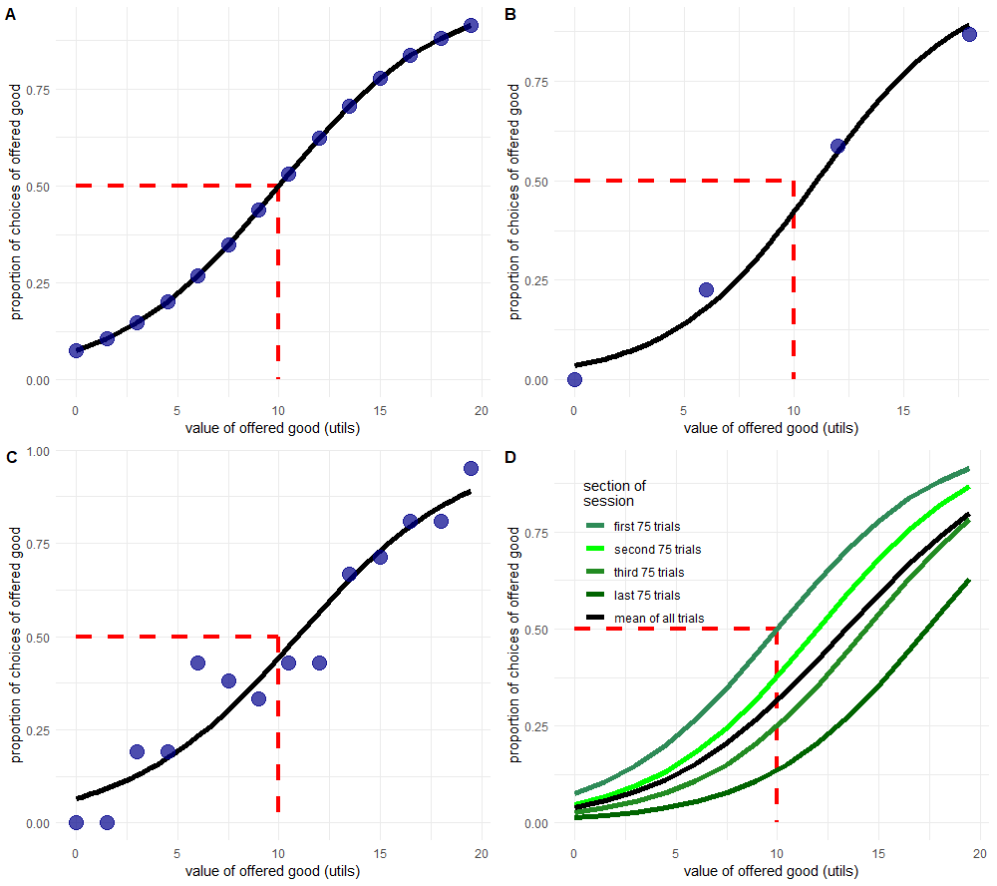
Figures 2.1a-d): The repeated binary choice paradigm has multiple undesirable features. All four figures show a simulated indifference curve (black) of hypothetical choices between a sure 10 utils and an offered good whose utility varies from 0 – 20 utils. We assume that the ‘true’ indifference point of a participant is when they must choose between the sure 10 utils and an offered 10 utils (dashed red line at 50% proportion of choices). Figure 2.1a) shows average choices (blue circles) which follow a perfect logistic distribution, though with an indifference point that is not directly sampled by the offered choices. Figures 2.1b) and 2.1c) show the constraint of 300 trials (a reasonable session for a trained non-human primate) where a researcher is faced with a trade-off between maximising accuracy by reducing the number of distinct choices (2.1b) or precision by reducing the number of choices made at each distinct offered choice (2.1c). Figure 2.1d) shows a hypothetical effect of satiety on the choices of a participant, where the value of the offered good decreases by 15% relative to the sure 10 utils after each block of 75 trials.

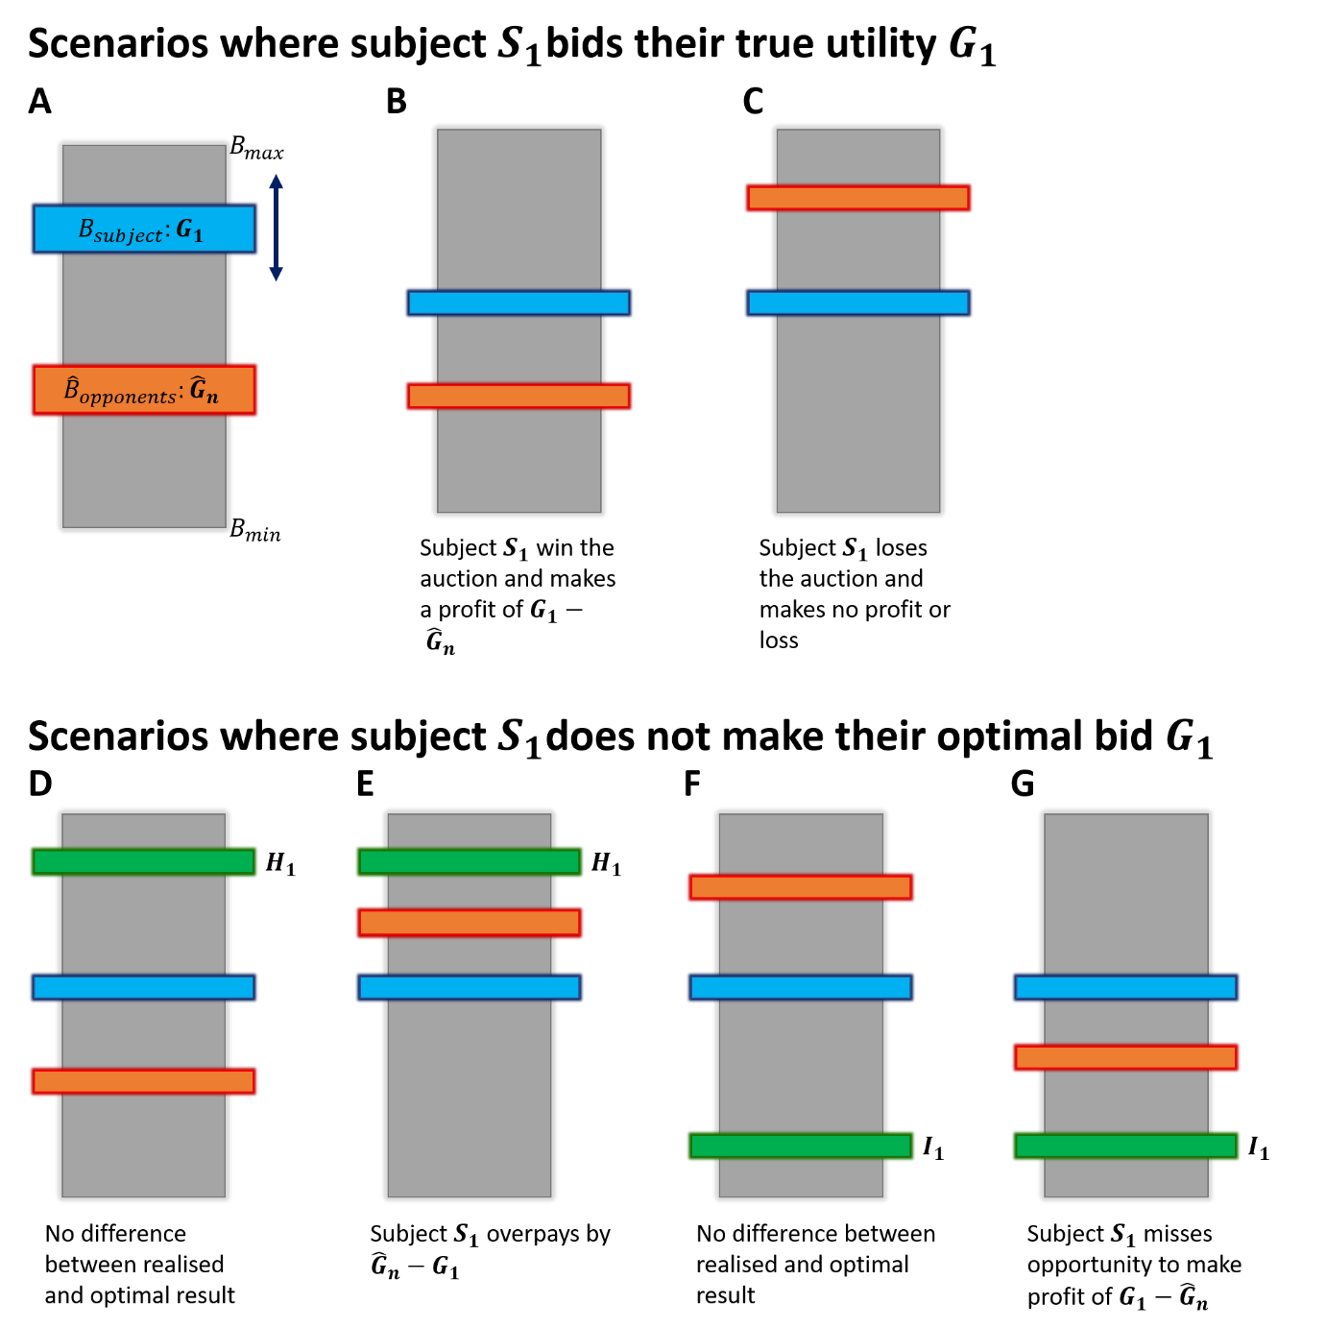
Figures 2.2a-g): The optimal strategy in a sealed-second price auction such as the BDM is to bid one’s true utility. In a hypothetical bidding range between $B_{min}$and $B_{max}$ (represented here as a grey bar, for comparison with the task we present to monkeys in chapter 3), a subject $S_{1}$has a utility for an auctioned good that is equal to $G_{1}$ (blue bar in a) and in subsequent panels). A subject can place their bid anywhere along the bidding range, but optimally should bid their utility for the auctioned good. In b) the subject’s bid is equal to $G_{1}$which is higher than the highest opposing bid ${\hat{G}}_{n}$(orange bar), so the subject wins the auction and pays the ‘second-price’ (${\hat{G}}_{n}$). In c) the subject makes the same, optimal bid of $G_{1}$but this is lower than the largest opposing bid, so the subject does not win the auctioned good but keeps their entire endowment. In d-g) the subject deviates from their optimal bid of $G_{1}$(blue bar as previously) to raise their bid ($H_{1}$, d-e)), or lower their bid ($I_{1}$, f-g)), represented by a green bar. In d) raising one’s bid has no effect on the outcome, but in e) we can see that this means risking overpaying for the good when $H_{1}>{\hat{G}}_{n}>G_{1}$. In f-g) the subject decides instead to lower their bid to $I_{1}$(green bar again), which has no effect on the outcome when the subject loses the auction, but gives rise to the possibility of missing out on profit when $G_{1}>{\hat{G}}_{n}>I_{1}$.

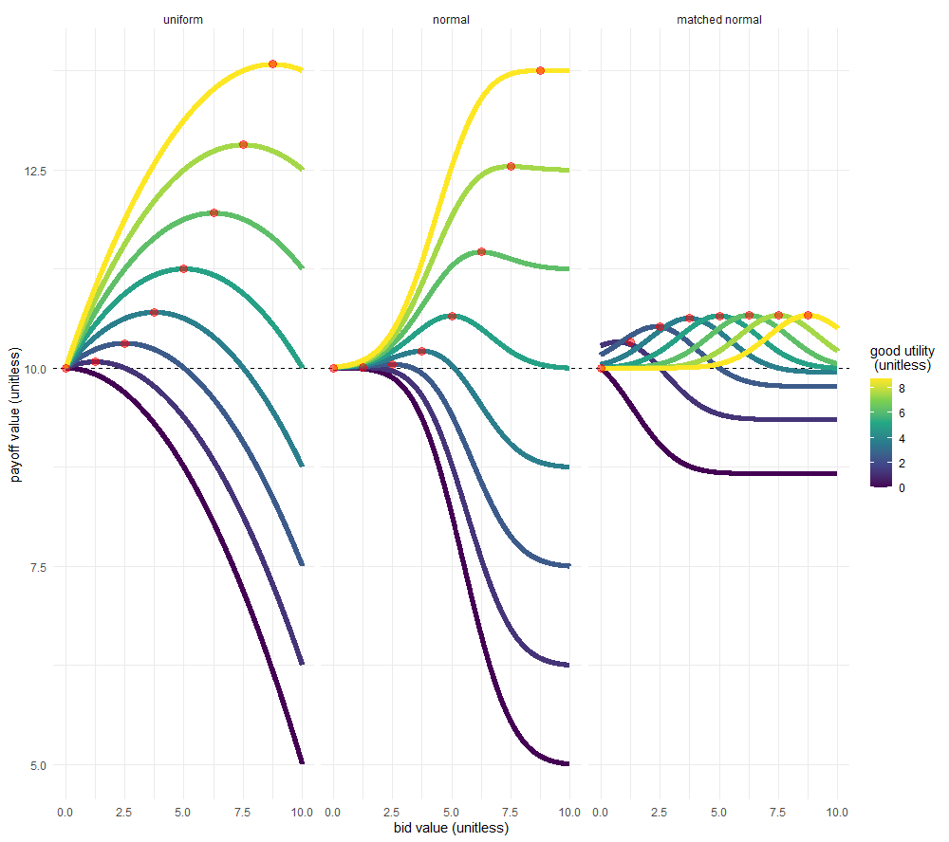
Figure 2.3: The expected payoff for a BDM auction given an initial endowment of 10 utils. Expected payoff is calculated analytically and is the mean total utility received at the end of a trial from a potentially won good and what remains of the initial endowment. Colours of lines indicate the hypothetical known utility of a good and payoff is shown for a range of bids (x axis) and distribution of computer bids. ‘Uniform’ computer bids follow a flat probability density function where the computer is equally likely to make any bid. ‘Normal’ computer bids follow a normal distribution with a mean of 5 (the mean of the endowed bidding range) and a standard deviation of 5/3 (one third of the mean of the endowed bidding range). ‘Matched normal’ computer bids are normally distributed with the same standard deviation but with a mean centred on the hypothetical known utility of a good. In practice a computer following this distribution would use the learnt mean of a monkeys bid for an offered good. Red circles indicate the maximum possible payoff per situation and are found when a participant’s bid is equal to the utility of the good. The dashed black line is at 10 utils, indicating the utility a participant would gain if they could simply keep their endowment and not participate in the auction.

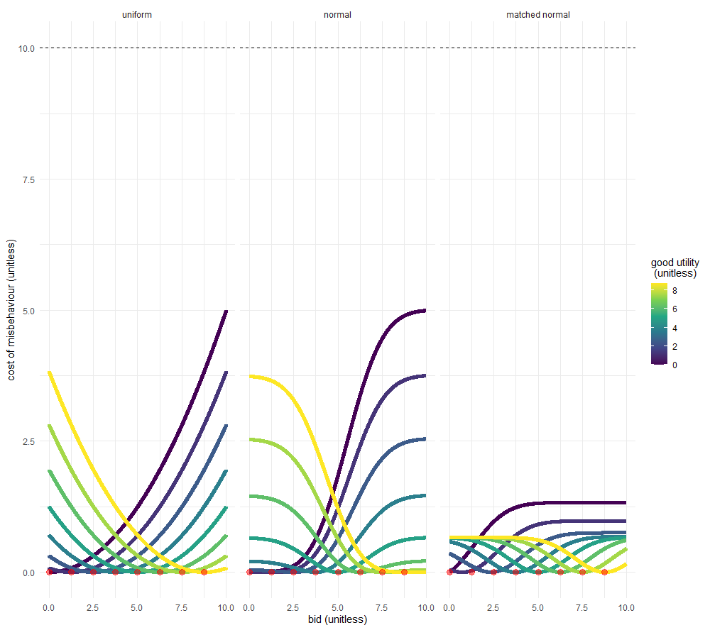
Figure 2.4: The expected cost of misbehaviour in a BDM auction given an initial endowment of 10 utils. Expected cost of misbehaviour is calculated analytically and represents the difference between the expected payoff from a trial given the participants bid, and the expected payoff of a trial where the participant bids optimally (bid == utility). Red circles indicate the cost of misbehaviour for a hyper-rational bidder who always bids their utility and show an expected cost of misbehaviour equal to zero. Colours of lines indicate the hypothetical known utility of a good and payoff is shown for a range of bids (x axis) and distribution of computer bids. ‘Uniform’ computer bids follow a flat probability density function where the computer is equally likely to make any bid. ‘Normal’ computer bids follow a normal distribution with a mean of 5 (the mean of the endowed bidding range) and a standard deviation of 5/3 (one third of the mean of the endowed bidding range). ‘Matched normal’ computer bids are normally distributed with the same standard deviation but with a mean centred on the hypothetical known utility of a good. In practice a computer following this distribution would use the learnt mean of a monkeys bid for an offered good. The dashed black line is at 10 utils, indicating the maximum possible misbehaviour of a participant who refuses to interact with the task and does not get to keep their ‘endowment’.

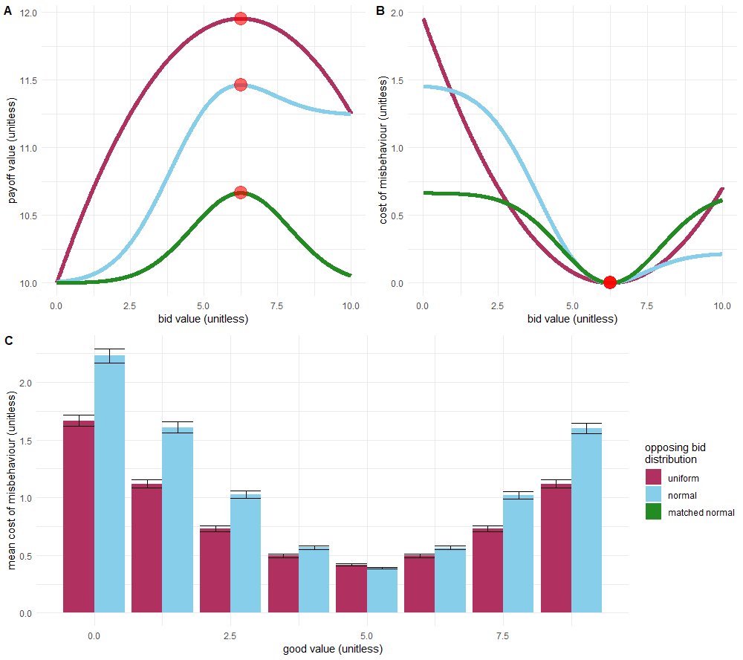
Figures 2.5a-c): How the distribution of computer bids defines the shape of the payoff and cost curves for a good of known utility. In a) and b) a good of known utility of 6.25 utils and show the expected payoff from a BDM auction where a participant is endowed with a budget of 10 utils. Payoffs and cost of misbehaviour are calculated as in figures 2.3 and 2.4. Red circles indicate the maximum payoffs (a) and minimum expected cost of misbehaviour (b). These are observed where the participant bids the exact value of the offered good (6.25 utils). Expected payoff and cost of misbehaviour curves are shown for the three different distributions of computer bids described in figures 2.3 and 2.4. In c) the mean cost of misbehaviour for a monkey which bids uniformly randomly across the endowment budget range is shown for a range of offered good utilities. Colours of bars indicate the opposing computer bid distribution and error bars represent the standard error of the mean. The ‘matched normal’ distribution of bids is not shown in c) as it requires a separate distribution for each given utility of an offered good.

Appendix 2.1- Derivations of payoff and expected cost of misbehaviour on a BDM auction trial

For a more formal proof of the incentive-compatibility of the BDM task, we present a proof, originally adapted from Milgrom & Weber, 1982 in Al-Mohammad & Schultz, 2019. Terms have been edited slightly to reflect their usage in this thesis, but the proof otherwise remains the same.

We assume that any participant has smooth, continuous, and differentiable utility function. An example is shown in figure 2.6, where the red lines shows the expected utility of hypothetical participants for bids increasing along the x axis. The black straight lines show the differentiation of this utility function with respect to bid at certain points along this curve.

We know that the expected utility a participant has is the expected utility of winning the auction multiplied by the probability of winning the auction, plus the expected utility of losing the auction multiplied by the chance of losing the auction.

Equation 2.6
$$υ_{i}\left(\overline{P}\right)=p_{win}⋅υ_{i}\left(\overline{P}|win\right) + (1 - p_{win})⋅υ_{i}\left(\overline{P}|loss\right)$$

In the main text of Chapter 2, and in appendix 2.3 we discuss the closed form solutions to this expected utility when participants make bids against one computer randomly drawing its bid from a uniform distribution. Here we consider a participant bidding in a ‘life-like’ auction where a participant bids against any number of other bidders with unknown utility functions of their own.

This participant places a bid, $B_{subject}$, which determines whether they win an auction against any number of other bids $B_{opps}$, where the maximum of these, ${\hat{B}}_{opps}$ determines the price paid in the event of the participant winning the auction. The probability of winning or losing any auction trial is therefore a cumulative distribution function of the opposing bids, $f$($B_{subject}$) bounded by the minimum possible bid, $B_{min}$, and the subjects bid.

Equation 2.7
$$υ_{i}\left(\overline{P}\right)=\int_{B_{min}}^{B_{subject}}{υ_{i}\left(\overline{P}|win\right)f({\hat{B}}_{opps})d{\hat{B}}_{opps}+ \int_{B_{subject}}^{B_{max}}{υ_{i}\left(\overline{P}|loss\right)f({\hat{B}}_{opps})d{\hat{B}}_{opps}}}$$

As we are considering auctions as commonly understood in the marketplace (and not as carried out in economic/psychological/neuroscientific contexts), we assume that the utility $U\left(\overline{P}|loss\right)$ is zero; the participant neither wins, nor pays anything for an auctioned good.

$$υ_{i}\left(\overline{P}\right)=\int_{B_{min}}^{B_{subject}}{υ_{i}\left(\overline{P}|win\right)f({\hat{B}}_{opps})d{\hat{B}}_{opps}+ \int_{B_{subject}}^{B_{max}}{0 f({\hat{B}}_{opps})d{\hat{B}}_{opps}}}$$

$$υ_{i}\left(\overline{P}\right)=\int_{B_{min}}^{B_{subject}}{υ_{i}\left(\overline{P}|win\right)f({\hat{B}}_{opps})d{\hat{B}}_{opps}}$$

The expected utility of the payoff, given that the participant wins the auction is equal to the utility of the won good ($G$), minus the payment for the good

$$υ_{i}\left(\overline{P}\right)=\int_{B_{min}}^{B_{subject}}{υ_{i}\left(G - {\hat{B}}_{opps}\right)f({\hat{B}}_{opps})d{\hat{B}}_{opps}}$$

The maximum utility to a participant, $U\left(\overline{P}\right)$, occurs when the first derivative of their expected utility with respect to their own bid $B_{subject}$ is zero. At exactly this point, the change to their utility as they change their bid is zero. Moving their bid to either side of this point causes the change to utility with respect to the bid to become negative.

Equation 2.8
$$\frac{dυ_{i}\left(\overline{P}\right)}{dB_{subject}}=υ_{i}\left(G - B_{subject}\right)f(B_{subject}) = 0$$

It is clear that this equation is satisfied when the brackets of the utility function are equal to zero, that is, when the value of the good$G$ in units of the budget is equal to $B_{subject}$. In other words, this maxima is found when the utility of a good is exactly matched by the utility of the budget bid by a participant; a subject maximises utility by bidding exactly their utility for a good.

For a graphical representation of this proof, see figure 2.3 where the change in payoff value (in utils) is flat with respect to the bid, at the point where the bid is equal to the utility of the auctioned good (red circles).

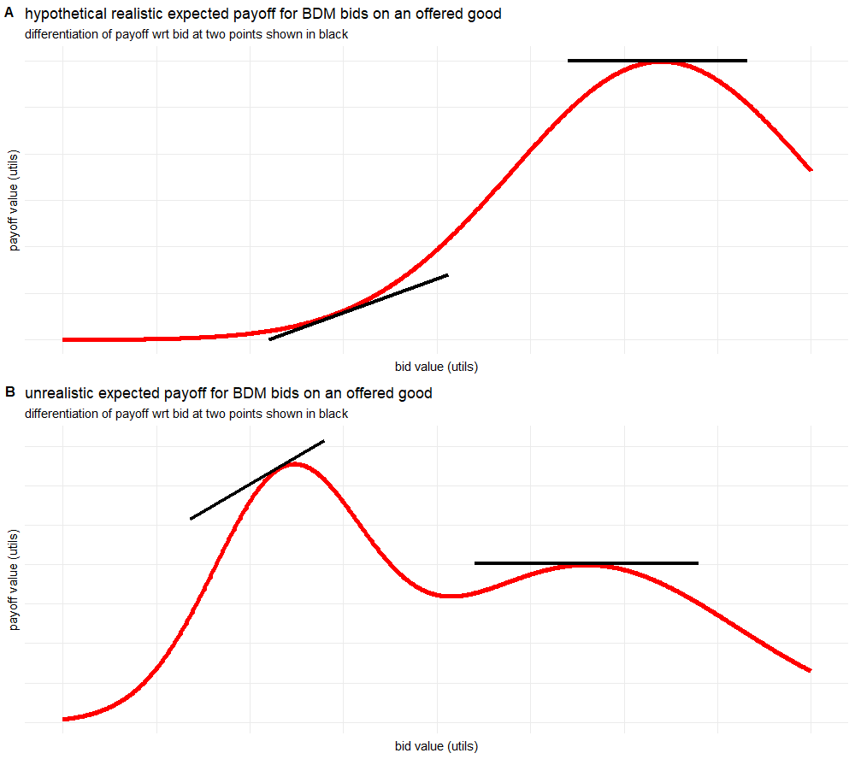
Figures 2.6a-b): Examples of smooth, continuous, differentiable utility functions for expected payoff vs. bid. In a) a realistic utility function for the simple BDM paradigm used in this thesis is shown. This is directly comparable to those found in figure 2.3, especially those for the uniform distribution. Differentiation of the curve is shown in black lines at two points, one at a maxima (the optimal bid as shown in the derivation in this appendix), and one which is not at an optimal bid. In b) we present a hypothetical utility curve for some more complicated paradigm (or indeed a participant who does not understand the paradigm presented). This is not a utility curve we would expect to encounter in the scope of this thesis, but is used to make the point that the proof above will still find local maxima or minima for a subjects utility function. Again, the derivative of the curve is shown at two points, including at one local maxima. Curves are for illustrative purposes and so are valueless across both axes.

Appendix 2.3- Derivations of payoff and expected cost of misbehaviour on a BDM auction trial

For any economic decision making task the payoff is equal to the magnitude of potential outcomes, multiplied by the probability of that outcome occurring (equation 1.2). In any auction task there are only two outcomes: winning the auctioned good, or not. As the BDM is a second price auction, a ‘win’ occurs when the participant makes the highest bid, and the outcome is that they receive the auctioned good and pay the second highest bid out of their budget. The expected utility of a payout $υ_{i}(P)$ can therefore be expressed as:

Equation 2.9
$$υ_{i}\left(\overline{P}\right)=p_{win}⋅\left(υ_{i}\left(G\right)+\left(Budget-{\overline{B}}_{computer|win}\right)\right) + (1 - p_{win})⋅Budget$$

Where a good $G$, of some utility in terms of the budget is auctioned and receives bids, $B$.

We use a BDM task as commonly reported in the economics literature where there is one opponent bidder- a computer who makes random bids with an equal, uniform probability across the entire bidding range. The probability of a participant winning any auction trial is therefore equal to their bid as a fraction of the total bidding range.

$$υ_{i}\left(\overline{P}\right)=\frac{B_{subject}}{Budget}⋅\left(υ_{i}\left(G\right)+\left(Budget-{\overline{B}}_{computer|win}\right)\right) + (1 - \frac{B_{subject}}{Budget})⋅Budget$$
In the BDM paradigm, both subjects and the random computer bid are drawn from a range from 0 to the total of the Budget, so the maximum bid is exactly equal to the Budget for any trial:
$$υ_{i}\left(\overline{P}\right)=\frac{B_{subject}}{B_{max}}⋅\left(υ_{i}\left(G\right)+\left(B_{max}-{\overline{B}}_{computer|win}\right)\right) + (1 - \frac{B_{subject}}{B_{max}})⋅B_{max}$$

The expected computer bid given that the computer has bid less than $B_{subject}$ is a random bid drawn uniformly from the range of 0-$B_{subject}$. The average computer bid on a trial that the subject wins is therefore half of $B_{subject}$:
$$υ_{i}\left(\overline{P}\right)=\frac{B_{subject}}{B_{max}}⋅\left(υ_{i}\left(G\right)+\left(B_{max}-\frac{B_{subject}}{2}\right)\right) + (1 - \frac{B_{subject}}{B_{max}})⋅B_{max}$$

We can now multiply out the brackets to reduce this equation to:
Equation 2.10
$$υ_{i}\left(\overline{P}\right)= \frac{υ_{i}\left(G\right){⋅B}_{subject}}{B_{max}} +B_{subject}- \frac{{B_{subject}}^{2}}{2B_{max}} +(B_{max} - B_{subject})$$

$$υ_{i}\left(\overline{P}\right)= \frac{υ_{i}\left(G\right){⋅B}_{subject}}{B_{max}} - \frac{{B_{subject}}^{2}}{{2B}_{max}} +B_{max}$$

The BDM is incentive compatible for each trial, therefore on each trial a rational participant should seek to maximise the utility of their expected payout by bidding exactly their utility for the good $G$. I.e. we assume for any trial that $υ_{i}(G) = B_{subject}$.
$${υ_{i}\left(\overline{P}\right)}_{max}= \frac{B_{subject}{⋅B}_{subject}}{B_{max}} - \frac{{B_{subject}}^{2}}{{2B}_{max}} +B_{max}$$
$${υ_{i}\left(\overline{P}\right)}_{max}= \frac{{B_{subject}}^{2}}{B_{max}} - \frac{{B_{subject}}^{2}}{{2B}_{max}} +B_{max}$$
$${υ_{i}\left(\overline{P}\right)}_{max}= \frac{{B_{subject}}^{2}}{{2B}_{max}} +B_{max}$$

As mentioned, $B_{subject}$ is in the range 0-$B_{max}$. We can therefore $B_{subject}$ express in terms of $B_{max}$ for the ideal situation for any subject (a highly valued good to be auctioned when $υ_{i}(G) = B_{subject}≥B_{max}$), or the worst case (an unvalued good when $υ_{i}(G) = B_{subject} = 0$).

For any trial we can therefore express the expected utility of the payoff for a monkey to be:
Equation 2.1110
$${υ_{i}\left(\overline{P}\right)}_{max}= \left\{\begin{aligned}\frac{3}{2} B_{max}, if υ_{i}(G) = B_{subject} ≥ B_{max} \\ B_{max}, if υ_{i}(G) = B_{subject} = 0 \\ \frac{{B_{subject}}^{2}}{{2B}_{max}} +B_{max}, otherwise\end{aligned}\right.$$

From this result, we can trivially derive the expected cost of misbehaviour- the difference between the maximum expected payoff of a trial and the post-bid expected payoff of a trial. As misbehaviour will only affect the potential profit of a trial, for simplicity’s sake we only consider the difference between the utilities of expected profit ($\overline{π}$). The expected change in payout between when the participant bids their utility ($υ_{i}(G) = B_{subject}$) and when they do not ($υ_{i}(G) ≠ B_{subject}$).

Equation 2.112
$$υ_{i}\left(\overline{π}\right)=\frac{B_{subject}}{B_{max}}⋅\left(υ_{i}\left(G\right) - \frac{B_{subject}}{2}\right)$$

$$υ_{i}(ECM)= {υ_{i}\left(\overline{π}\right)}_{max} - υ_{i}\left(\overline{π}|B_{subject}\right)$$

For when the participant actually misbehaves this can also be written as

$$υ_{i}(ECM)= υ_{i}\left(\overline{π}|B_{subject} = υ_{i}(G)\right)- υ_{i}\left(\overline{π}|B_{subject} = φ_{i}(G)\right)$$

Where $φ_{i}(G)$ is the utility function for a good $G$ which incorporates some error, deviating the bid from the optimal value.

Equation 2.13
$$υ_{i}(ECM) = \frac{{υ_{i}(G)}^{2}}{{2B}_{max}} - \left(\frac{υ_{i}\left(G\right) ⋅φ_{i}(G)}{B_{max}} - \frac{φ_{i}{(G)}^{2}}{{2B}_{max}}\right)$$

$$υ_{i}(ECM)= \frac{{υ_{i}(G)}^{2}}{2} + \frac{{φ_{i}(G)}^{2}}{2} - υ_{i}\left(G\right) ⋅φ_{i}(G)$$

$$υ_{i}(ECM)= \frac{{(υ_{i}\left(G\right) - φ_{i}(G))}^{2}}{2}$$
If we express the difference between $υ_{i}\left(G\right)$ and $φ_{i}(G)$ as some error $ε$, we can then rewrite this as
Equation 2.14
$$υ_{i}(ECM)= \frac{ε^{2}}{2}$$

Therefore, the actual utility of a good, U(G), has no effect per se on the cost of misbehaviour to the participant. Instead, it is only the deviation from this utility which affects the disutility of suboptimal bidding.

For fuller discussions of deriving the payoff and cost of misbehaviour for the BDM, extending this appendix to multiple bidders and more complex distributions of computer bid, see Lusk et al., 2007.

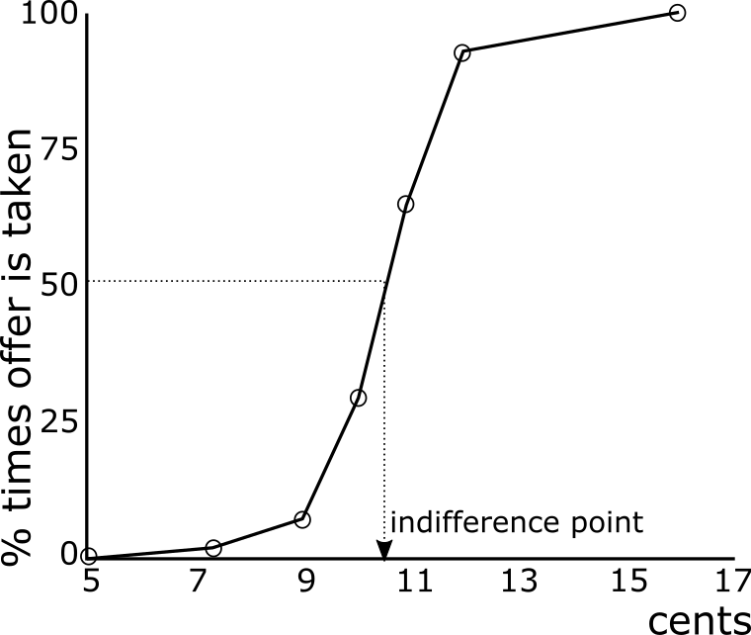
Figure 2.7) In empirical studies of utility it is not uncommon to find indifference points at unobserved choices. Redrawn from Mosteller and Nogee, 1957, in which subjects were offered the chance to make a bet with a cost to enter of 5₵. The utility curve for a single subject here (figure 2 in the original paper) shows the percentage of times the bet is made for fixed odds. The assumed indifference point of ~10.5₵ in this case is never directly tested with an offer, highlighting a weakness of the binary choice paradigm.

To do:
- check form of beta regression equations and rum model – emailed phil about RUM and most of the way there. Beta regression Im doing some reading. I’m 99% sure I’m doing it correctly.
- Work out where/ how to put tables – you might see me refer to tables of e.g. beta regression coefficients. I’ll put these in I’m not trying to work out the best way to get LaTeX to play with word. Worst case I’ll just do them manually in word.
- Finish two appendices – 1 on the training of the monkeys, showing some results over time/ the bid targeting task. 2 on the exclusion criteria for trials. This is very basic, it’s just trials with impossibly small reaction times, too long bidding times (>3 standard deviations from mean), and also removes sessions with less than 60 completed trials.
- Change figures to svg and relabel axes to make bigger – easy stuff to do one weekend
- Stats test between bundle choice estimate and distribution of bdm bids – t test? Have enquired with people who know more about statistics than me
Synopsis:
Chapter that details the behavioural results of the BDM (and binary choice) tasks.
Comes after into (chapter 1) and theoretical treatment of the bdm (chapter 2).
Main goal is to prove that a) monkeys can do the BDM, therefore it’s worth studying the ephys of monkeys doing the bdm and b) explore why and how they make their bids (to a limited extent- I don’t see the thesis as a behavioural thesis though clearly we have some interesting behavioural data!).
I think the text needs a bit of work still but can always be edited later. Stuff like adjustments to make figures clearer etc. are always appreciated but again not a huge concern for me atm. I think the main thing is if there are any analyses/figures/etc. wanted in this chapter that I haven’t added. Actually anylsing and producing and writing up new figures isn’t much work at all but thinking up a new figure is.
Text in bold and red are notes for me to change things.

Chapter 3 – Non-Human Primate Behaviour on the BDM Task
In the second chapter of this thesis, we described a second-price auction task in which participants reveal their utility for any good on a single trial basis. We concluded the chapter discussing the budding neuroscientific literature of human functional imaging studies employing the BDM. Needless to say, it is a far simpler task to train a human (even one laying in an MRI machine) to perform second-price auctions than a model organism. This chapter details the task design, training, and behavioural results of two adult rhesus macaques on a task consisting of repeated BDM auction trials using liquid budgets and rewards.
Materials and Methods
Below we discuss the task design, equipment required, and model non-human primates used to gather data during the project, attempting to provide the reasoning behind any decision. All items discussed can be assumed to be consistent throughout the various experiments in the remainder of this thesis, unless otherwise specified.
Task Design
The epochs of the BDM tasks are displayed in figure 1. Animals sat in front of a task screen (figure 1a) were presented with a cue indicating the beginning of a trial at time 0. After a fixed delay of 1.2 seconds, a large fractal was displayed on the left-hand side of the task screen (figure 1b). This fractal indicated the offered good on any single auction trial, corresponding to a fixed amount of blackcurrant juice reward. The magnitude of juice represented by the fractal was learnt via repeated experience over multiple sessions using the same offered goods. During this period, the monkey was required to be bother touching the joystick and to keep it ‘centered’ i.e. in a vertical upright position. If either of these requirements were violated, the monkey ‘failed’ the trial and received neither juice reward nor ‘budget’ water and incurred a time penalty of the time remaining on the trial plus two extra seconds.
Another 1.2 seconds after the display of the good to be offered in the trial, a large, black and white, hatched bar was presented on the right-hand side of the screen, crossed by an orthogonal, thinner purple bar. The black and white bar represented the bidding range from 0% (minimum bid, bottom of the bar) to 100% (maximum bid, top of the bar) of the budget liquid. This bar can be thought of as analogous to those presented in figure 2 of the previous chapter.
The purple bar crossing the ‘budget bar’ represents the monkey bid and appears at a random location on the vertical axis of the budget bar. Such ‘random starts’ of the bid position were found to give rise to consistent inter-session mean bids in the original training of the monkeys (Al-Mohammad, 2017). During this epoch, the monkey has four seconds within which to place their bid vertically using the up/down axis of the joystick. Bids were considered ‘placed’ when there had been no movement of the bidding indicator (see equation 3.1) within the last second. This placement period of 1 second was shortened for monkey V to 700ms to improve behaviour. Past this point, any movement of the joystick had no effect on the task. To ensure attention to the task and encourage swift decision making, if no movement was detected within the first second of possible bidding, the monkey failed the trial and incurred the same penalty two second + time remaining penalty described above until the trial was repeated with the same offered good.
After the four seconds bidding epoch finishes, a second, green bar appears representing the computer bid, drawn randomly as described in chapter 2 of this thesis. As with any BDM auction tasks, the monkey ‘wins’ the auction if it’s bid is greater than that of the computer and loses if it is not. If the monkey has won the trial, it is also signalled by the segment of the budget bar below the computer’s bid flipping horizontally, to indicate the budget that has been paid by the monkey.
1.5 seconds after the result of the trial is revealed the monkey is rewarded with juice in the case that it has won the trial. A further 1.5 seconds later, whatever remains of the monkey’s water budget is delivered to the monkey. In between trials, a variable 2.5-3.5 second blank inter-trial-interval is interleaved between trials. This summary of a single trial of the BDM task is illustrated in figure 1c.
All the behavioural data shown here are from sessions completed by the two monkeys over July 2019-November 2020. We limit our analysis to behavioural data obtained during the neuronal recording phase of the task during which the magnitudes of juice offered to the monkeys, and the magnitude of the water budget, were held constant.
Equipment
Monkey’s were seated in a (Crist Instruments) inside of a darkened, sound-reducing booth for the duration of the task sessions to reduce distractions. While within the booth, monkeys and their interaction with the task were monitored using two CCTV cameras.
Attached to the front of the chair was a joystick (custom-made, Biotronix workshop, Department of Psychology, University of Cambridge) which the monkey could reach through a window in the front panel of the chair. The joystick permitted movement across two dimensions (left/right, and up/down) which changed the resistance, and therefore voltage, across the joystick circuit. This change is voltage is used for control of stimuli that indicated the monkey’s bid (BDM task) or choice (a binary choice task described later). The joystick was also touch-sensitive to record whether the monkey was holding the joystick at any time, emitting a binary voltage signal. Joystick position and touch data were digitised to the computer via a National Instruments Data Acquisition Card (PCI-6229). Movement of stimuli controlled by the joystick was defined by
Equation 3.1
$$x_{t+Δt} = \left\{\begin{aligned}x_{t}+GV_{t} if {|V}_{t}|>V_{τ} \\ x_{t } if |V_{t}|<V_{τ}\end{aligned}\right.$$

The position of an object controlled by the joystick remains at position ($x_{t}$) if the absolute change in voltage ($V$) produced by deflection of the joystick at time $t$ is less than a voltage threshold ($V_{τ}$). Otherwise, it is updated to the original position plus the change in voltage across the joystick circuit multiplied by a gain constant $G$. The maximum speed of the bidding indicator is capped at 46% of the total bidding range per second for both monkeys. The thresholds and gains for each joystick vary slightly, so is regularly tested on the task by the human experimenters for consistency.
Stimuli were presented to the monkeys on a computer monitor placed 70cm in front of the monkeys at head height. These stimuli were produced and displayed using a custom-built software suite (MATisse; Hickman, 2017), utilising the Psychophysics Toolbox (Kleiner et al., 2007) for MATLAB (MATLAB, 2017). Computers were run using the Windows 10 operating system. Juice and water delivery to the animals was mediated via gravity and the opening of solenoid valves (SCB262C068; ASCO).
Data Analysis
All analysis presented here was done in R 4.0.2 (‘Taking Off Again’; R Core Team, 2020) on a 64 bit windows machine. Notebooks for analysis are published by the author (DoctoRate; Hickman 2020). Graphics were made using the ggplot2 package (Wickham, 2016) and the vast majority of munging was carried out using tidyverse grammar (Wickham et al., 2019).
Wilcoxon and Spearman’s rank tests were carried out using functions from the inbuilt stats package. K-means clustering of joystick movement was also done using a function from this package. Beta regressions were carried out using functions from the betareg package (Cribari-Neto & Zeileis, 2010), after the distribution of monkey’s bids were fitted using the fitdistrplus package (Delignette-Muller & Dutang, 2015) and checked using the gamlss packages (Stasinopoulos & Rigby, 2007). Models were selected primarily based off minimising the Akaike information criteria (Akaike, 1974) using the formula
$$AIC = 2k - 2ln(\hat{L})$$
Where k (the number of parameters) for the beta distribution selected is 2 and $\hat{L}$ represents the maximum value for the model’s likelihood function.
Random utility models were fitted in R using the mlogit package which is described and explained in Train, 2009.
Animals
All experiments and data in this thesis were gathered from two adult rhesus macaques (Maccaca mulatta), referred to as monkey U and monkey V. Both monkeys had been trained on a similar BDM auction task previously (referred to as 'Monkey A' and 'Monkey B' in Al-Mohammad & Schultz, 2019), though due to time between projects, differing needs of the experiments (e.g. head-fixing of monkeys), and subtle changes to the task, both were retrained in the period October 2017-July 2018. Monkeys had both been previously trained on the auction tasks presented here and an equivalent binary-choice ‘bundle choice’ task. For more details of the training see Al-Mohammad & Schultz, 2019 and appendix 3.1.
Both primates were born in captivity at the Medical Research Council’s Centre for Macaques at Porton Down in the United Kingdom (monkey U: 2010-02-10, monkey V: 2011-06-08) and were housed within the departmental facilities. Both were group-housed at various times prior to and during the duration of this project, but due to separate incidents were singularly housed for much of the time this data was recorded. The weights of each monkey recorded weekly for the duration of project is shown in figure 2.
Rhesus macaques are the most widely distributed non-human primate species, being found across most of continental Asia (Singh et al., 2020). They are the most commonly used non-human primate animal model in the neuroscientific literature (Capitanio & Emborg, 2008) due to their dexterity and ability to reproduce complex decisions, such as in economic decision-making tasks (Ferrari-Toniolo et al., 2020; Fiorillo et al., 2003; Grabenhorst et al., 2012; Padoa-Schioppa & Assad, 2006).
To incentivise participation in the tasks, primates were fluid restricted for 6 days per week (from Saturday evening until Friday afternoon), during which time the majority of liquid available to the monkeys was earned through behavioural tasks. For the remainder of the week, primates had unrestricted access to fluid, and were also given unrestricted access on any days where they were not worked on the task, following any surgeries, and also for at least one full week every months.
Rhesus Macaques show Significant Rank Ordering by Offer Level
Over the course of these projects, the two monkeys faced at least 80,000 BDM trials each. We restrict our analysis to the sessions completed during the neuronal recording phase of the project, where offered goods were static and monkeys were consistently tested on the BDM. We also use objective selection criteria to remove trials where we have reason to believe either monkey was not sufficiently engaged with the task. These are discussed in appendix 3.2.
During the recording phase of the project, monkey U completed 233 sessions, averaging 130.6 trials per session (standard deviation: 34.3), whereas monkey V completed 174 BDM sessions and on average also completed 130.6 trials per session (standard deviation: 30.0). After the removal of trials as outlined in appendix 3.2, we are left with 163 and 142 sessions for monkey U and monkey V respectively, with an average of 115.9 and 114.3 trials completed in each session (figure 3.3c-e).
This is fewer trials than we had hoped for during recording from dopamine neurons; for a set of 3 fractals shown, we will have data from fewer than 40 bids made by the monkey. During the initial months of the project we aimed to train monkeys to complete at least 200 trials of the BDM for any behavioural testing session, which we frequently achieved (figure 3.3a-b). The reduction in the number of trials successfully completed by each monkey during the neuronal recording phase (figure 3.3e) is thought to be due to 3 factors: Primarily, a reduction in trials completed was seen in monkey U once we began head-fixation training in preparation for neuronal recording. Once recording, the identification of putative dopamine neurons takes time and the receipt of an unexpected liquid reward, both of which might reduce to desire of the monkey to later work on the task (see the opening of chapter 4 for more detail on the neuronal recording procedure).
Finally, the relatively low number of trials completed by the monkeys may have been in part due to the large liquid payout per trial. Total expected liquid received per trial is derived in chapter 2 and varies by bid (see figure 2.3), but for a minimum expected volume, a monkey who bids the maximum for the lowest magnitude of juice can anticipate half the bidding range (0.6ml) of water and the magnitude of juice reward. Even on the theoretical very ‘worst’ trials where both the monkey and computer bid near the maximum for this lowest juice magnitude offer, the monkeys will be certain to receive the juice reward (0.2ml for monkey U, 0.3ml for monkey V) which is commensurate with other studies of non-human primate decision making (Ferrari-Toniolo et al., 2020; Pastor-Bernier et al., 2017) plus a negligible amount of the remaining water budget.
In contrast, on particularly lucky trials where the monkey wins the high value fractal and only pays a negligible amount of their budget, the animal can receive 1.2ml of their water budget and the magnitude of juice offered (0.7ml for monkey U, 1.7ml for monkey V). As derived in chapter 2, the cost of misbehaviour is proportional to the utility (proportional to the magnitude) of the juice reward offer and the size of the water budget with which to bid. However, increasing the utility of these necessarily will decrease the time it takes for a monkey to become sated on liquid and thus decrease future performance. Striking a delicate balance in this trade-off between accurate behaviour per trial and number of trials is likely to be key to any future non-human auction experiments. As previously noted however, one of the key benefits of auction paradigms is that they reveal the utility of the organism for an offered good on each individual trial and so (in contrast to binary choices, see figure 2.1) there is no reduction in accuracy or resolution to the utility estimate from a reduced number of trials. Indeed, it may be the case that fewer trials with greater incentive for a subject to behave truthfully (larger signal-to-noise ration) generates the optimal statistical power for such experiments (Perugini et al., 2018).
Given that the only dimensions by which the offered goods varied was magnitude of liquid, we expected a monotonic relationship between the liquid volume and utility of offered goods to the monkey. As the animal’s optimal bid for any good is exactly equal to their utility for that good, we therefore expected a monotonic relationship between magnitude of offered juice and bids placed by the monkey. Figure 3.4a shows that over more than 15,000 bids each, monkeys show such a behaviour, with the population of bids significantly differing by the magnitude of the offered juice on a trial (‘reward offer level’), tested using a Wilcoxon signed-rank test (Bonferroni-corrected p-values < 0.0001). Effect sizes for the reward level on all bids were reasonable (0.35-0.74) and are reported in table 3.1. On a session-by-session basis, the mean bid per reward level was rank ordered in all but 3 of 305 sessions (161/163 for monkey U and 141/142 for monkey V) with the distributions of mean bid per session shown in figure 3.4b. A Wilcoxon signed-rank test showed significance in the distributions of these mean bids per session (Bonferroni-corrected p-values < 0.0001) and greater effect size than for the pooled bids (0.61-0.86; table 3.4).
We also tested whether intra-session bids we significantly different between reward levels using a Wilcoxon signed-rank test. Uncorrected p-values showed statistical significance at p < 0.05 between the highest magnitude reward level and the lowest in almost all sessions completed by each monkey (0.988 for monkey U, 1.0 for monkey V; figure 3.4c) and also between the middle reward level and the lowest (0.957 for monkey U, 0.986 for monkey V). Fewer sessions showed such significant differences in the distribution of monkey bids between the highest and medium reward magnitudes for both monkeys (0.81 for monkey U, 0.852 for monkey V), an effect that can also be clearly seen in the distribution of bids in figures 3.4a and 3.4b.
There are two explanations of this effect we find convincing. Firstly, the monkey’s bids are artificially limited: they cannot bid above the entirety of the water budget. In addition, the data for figure 3.4 we have removed trials where the monkey has bid at the bottom or the top of the budget. This limited bidding range naturally compresses the bidding space. It is possible, though unlikely, that comparing the true (i.e. budget unlimited) distribution of bids, this effect would disappear.
Secondly, this may be an effect of the marginal utility of juice. In chapter 1 we introduce the concept of the St Petersburg paradox and its solution that an increase of monetary value (amount of juice) has a greater utility to a poor man than a rich one. For each linear increase in juice volume we offer the monkey, we might expect there to be less and less utility added to the offer and thus a deacceleration of bids.
Given this non-linearity in the rise of marginal utility, we also investigated the rank-ordering of bids within single sessions using a Spearman’s rank correlation test. Spearman’s rank allows us to investigate the extent to which there is a monotonic relationship between the reward offer and the bid without assuming linearity in this relationship. In figure 3.4d we show that monkeys maintain a reasonably steady ρ between 0.5 and 0.75 with averages indicated by dashed lines at 0.632 (monkey U) and 0.672 (monkey V). This is slightly lower than previously reported figures (Al-Mohammad & Schultz, 2019), likely due to the behavioural effects of head-fixed recording and the reduced number of trials per session.
Monkeys show two distinct patterns of bidding behaviour
Monkeys interact with the task via the vertical movement of a bidding indicator which is controlled by moving a joystick towards or away from them. This movement takes place entirely within the ‘bidding’ epoch of the task (figure 3.1) and can be separated into 3 separate stages:
- At the start of the bidding epoch the budget bar appears, crossed by bidding indicator bar that appears at a point on the budget that is randomly drawn from a uniform distribution. The monkey must first react to the start of the epoch and the position of the bidding bar before moving the joystick. This reaction time will be variable across monkeys; in the BDM, our monkeys seem to have a reaction time at around 500ms (figure a2.1). We observe little effect of the reward level or the monkey’s bid (i.e. the utility of the offer) on the reaction time (figure a2.2 and table a2.1).
- Monkeys then move the joystick towards or away from them to adjust their bid to the desired level. The time from the start of the epoch to this point is referred to as the “bid place time” in figure 3.5a, and this time minus the reaction time is referred to as the “time spent moving joystick” in figure 3.5b. Both monkeys had easily enough time in the bidding phase to make bids, with monkey U taking an average of 2254ms (standard deviation of 360ms) and monkey V taking an average of 2463ms (standard deviation of 451ms) to place bids. With roughly 500ms reaction times each, monkey U spent an average of 1735ms (standard deviation of 348ms) and monkey V an average of 1930ms (standard deviation of 455ms) moving the joystick to reach their desired bid level.
- Once satisfied with their bid, monkeys must then hold the bidding bar at a constant level for either 1 second (monkey U) or 700ms (monkey V) before the end of the bidding epoch.
Given the random position of the starts, we had expected that the time spent moving the bidding bar by each monkey to correlate strongly with the difference between the starting bid level and the final bid made. However, in figure 3.5b its possible to see that this isn’t the whole story: there is the hint at two distributions (especially for monkey U) of joystick moving times.
We investigated the bidding activity of the monkeys in figures 3.6 and 3.7 showing the time quantities plotted in figure 3.5 against two movement quantities. “Total bidding movement” refers to the gross bidding movement of the monkey, whereas “net bidding movement” refers to only the difference between the final and the starting bids. To save space, both of these values have been plotted as their modular values. For instance, if the monkey moved their bid down 10% of the total bidding range before moving their bid up 5% towards its initial starting position, the net bidding movement would be 5% while the total bidding movement would be 15%. Figure 3.6 shows the relationship between time spent bidding and bidding movements coloured by the reward level, and 3.7 shows the same relationships coloured by the final monkey bid.
For both monkeys, the time to place bid and the total bidding movement were strongly correlated as expected (linear model R² of 0.60 and 0.72 for Monkeys U and V respectively, p < 0.0001). The speed of the bid indicator bar is limited so to move further takes more time. However, it is also clear from the net bidding plots that there are distinct clusters of bidding activity: a ‘slower’ cluster comprised of different reward levels and final bids with little correlation between net movement and movement time, and at least one other cluster that where a relationship exists between net movement and movement time (see bottom left panels).
The coordinates from the bottom left panels are used to train a k-means clustering algorithm. Cluster number is informed using the ‘elbow-method’ using the within cluster sum of squares per number of clusters to find an inflection point where additional clusters provide little extra variance explained (figure 3.8a). Using this and our priors we settled on three clusters which are identified per monkey using a k-means algorithm (figure 3.8b). Cluster numbers have been modified to be consistent between monkeys and net bidding movement has been plotted as its true value (c.f. figures 3.6 and 3.7 where the modular value is used).
Three clear clusters can be seen per monkey. In two clusters, the monkey moves their bid quickly towards a desired value. In cluster 1 (purple) where the monkey moves the bar efficiently down the budget towards a final bid and cluster 3 (green) where the monkey does the opposite, moving a bidding bar up towards its final value. In cluster 2, the monkey does neither. The net bidding movement tends to be smaller but take longer than in the other two clusters.
This mystery is resolved in plot 3.9 where the individual trials movements are shown in multiple plots arranged by reward level and starting bid decile. Movements of the bidding bar are coloured by cluster as in figure 3.8. Both monkeys show similar bidding behaviour, quickly moving the joystick down or up to final bids that are further from the initial starting bid (purple cluster 1, top left and green cluster 3, bottom right of each panel). When the starting bid of a trial is closer to the monkey’s preferred final bid however, they tend to make large movements either up (monkey U) or down (monkey V) towards the extreme of the budget bar before returning the bid to its final position near where it started. This may be because to make a bid the monkey is required to move the bidding indicator bar from its initial position. It may also be the case that, although both monkeys are able to precisely target bids when forced to (see appendix 3.1), it is easier to make larger movements than finer ones. Instead of a fiddly small adjustment of the joystick, monkeys may save frustration by making larger movements of the joystick. If so, it may be interesting for future studies to see if and how this affects the accuracy of the monkey’s bids. As previously mentioned, it may be beneficial for any further work on animals performing the BDM to gather more accurate data from fewer trials with a greater cost of misbehaviour which should punish any inaccurate behaviour.
Figure 3.9 also shows the mean monkey bid per reward level (dotted line) and per reward level and starting bid tenth (dashed line). The effect of the starting bid on the monkey’s bid for an offered reward can be seen in the deviation of these two lines across different deciles of starting bid. This relationship is further explored in figure 3.10 where a clear effect of the bid starting at the monkey’s mean bid (dashed line) for a reward level can be seen. There is a discontinuity of monkey’s final bids at the point where the starting bid is roughly equal to the population mean of a monkey’s final bid for a given juice reward. In figure 3.10b) its possible to see how monkeys go from slightly bidding above their mean bid for an offered reward at the starting bid decile below this mean bid, to slightly underbidding as the starting bid is raised into the next decile.
We might have expected the inverse relationship to this (that monkeys bid higher when the starting bid is high and vice versa) given the potential effort costs of moving the joystick to change the cursor position (Burrell, 2019). It seems in this project that the speed of movement possible and the lack of resistance on the joystick seems to have negated this; the bidding itself requires little effort from the monkeys.
Modelling monkey’s final bids
Given that both the reward level offered, and the initial location of the bidding bar affect the monkey’s final bid, we wanted to quantify the relative effect sizes of these and of other variables of importance. In total we selected 5 variables that were assumed to have relevance for a monkeys bids, the reward level and the starting bid, along with the total liquid (water and juice) in ml that each monkey had received up until a trial on any day, the randomly drawn computer bid on the previous trial, and whether or not the monkey won the previous trial. The distributions of each of these variables, colour by reward level) is shown in figure 3.11 where no variables show a strong co-varying relationship other than the computer bid and result of the previous trial.
To regress these variables against the monkey’s bid on any trial, a beta distribution regression was carried out with the form:
Equation 3.2
$$monkey's bid | monkey \sim β_{1}(reward level) + β_{2}(starting bid) + β_{3}(total liquid) + β_{4}(last trial computer bid) + β_{5}(last trial monkey win) + ε$$
A beta regression model was chosen as the monkey’s bids fall in the range $(0,1)$. To confirm the choice of model, we also fitted a range of distributions to the monkey’s bids, which showed a beta distribution fit to have the lowest Akaike information criteria (AIC) and largest log likelihood. Tables for the tests of distributions are shown in figure 3.11c and the parameters for the optimal fitted beta distribution are shown in figure3.11d. In figures 3.12a-c the empirically observed monkey bids and compared to these fitted beta distributions for each monkey. Quantile-quantile (Q-Q), CDF distribution, and theoretical vs actual proportion (P-P) plots are shown for both of these models. In each model, but especially for monkey V, observed points show a clear relationship with the theoretical predicted points, strongly suggesting that these beta distributions capture some of the pattern of bidding, and that a beta regression is a rational statistical choice.
Before performing regressions, all variables except monkey bid (which is naturally constrained to the range $(0,1)$) were rescaled using the formula
Equation 3.3
$$A = (a-a_{min}) / (a_{max}-a_{min})$$
Where a variable a is transformed into the rescaled variable A.
All beta regressions carried out used a log link-function. Our main focus in this chapter is to show the relative influence of various features of the data rather than their absolute predicted effect. Therefore we do not provide the absolute effects of a change by 1 unit of any unscaled feature $a$, though this can be calculated thus:
Equation3. 4
$$Δ\hat{y}= \frac{e^{(β_{0} + β_{a})}}{1 + e^{(β_{0} + β_{a})} }-\frac{e^{β_{0}}}{1 + e^{β_{0}}}$$
The two beta regressions produced by equation 3.2 are plotted in figure 3.13a (monkey U McFadden pseudo-R² = 0.316; monkey V McFadden pseudo-R² = 0.374) showing the dominant effect of the reward level offered on the monkey’s bid (monkey U: $β_{1}$ = 1.49±0.019, Z-score = 77.5, p < 0.0001; monkey V: $β_{1}$ = 1.72±0.018, Z-score = 97.7, p < 0.0001). This is to be expected given the results already presented in figure 3.4. For both monkeys, the higher the reward level (i.e. the magnitude of juice offered), the greater the expected bid.
Both monkeys also show a negative coefficient for the starting bid position (monkey U: $β_{2}$ = -0.074±0.025, Z-score = -3.0, p = 0.0029; monkey V: $β_{2}$ = -0.326±0.024, Z-score = -13.9, p < 0.0001) indicating that when the starting bid was higher, the monkey’s final bid tended to be lower. We discussed the reasons for counterintuitive finding in the previous section and in figures 3.5-3.10.
The results of the last trial had a subtle but statistically significant effect for both monkeys with the randomly drawn computer bid on the last trial (monkey U: $β_{3}$ = 0.235±0.031, Z-score = 7.7, p < 0.0001; monkey V: $β_{3}$ = 0.144±0.031, Z-score = 4.7, p < 0.0001 ) and if the monkey won the last trial (monkey U: $β_{4}$= 0.189±0.017, Z-score = 10.9, p < 0.0001 ; monkey V: $β_{4}$ = 0.094±0.018, Z-score = 5.3, p < 0.0001 ) tending to cause an increase in subsequent bid. The intuition behind the former effect is simple: a high randomly drawn bid might signal to the monkey that the distribution of bids it is facing has changed, especially if there have been multiple above average opposing bids in the recent past. Outside of the laboratory setting, opponent’s bids within an auction signal information about the true worth of an auctioned good (Milgrom & Weber, 1982); we review the literature on how a rational participant should incorporate other bidder’s values in appendix 1.1.
That the monkeys tending to bid higher than otherwise expected if they won the last trial is more difficult to rationalise. We might have expected the reverse phenomena to occur, that monkeys who win an auction trial would decrease their subsequent bid in line with findings about ‘hot hand’ effects in psychology (Gilovich et al., 1985). This effect observes that people who succeed at a task with certain, relatively fixed, probability believe that they will then have a greater chance of succeeding in the subsequent attempt (e.g. sportsmen who make a difficult shot will believe they will also make the next, similarly difficult, shot they make), even when attempts are independent. Participants in first-price auctions might believe that they have a higher chance of winning subsequent auctions and thus shade their bid to lower costs incurred in the event of a win. In theory the BDM has no such advantage as the dominant strategy is always to bid one’s true value (see chapter 2).
When regressions are performed grouped by monkey and date (figure3.13b and figure 3.13c), the dominance of the reward level on bid is clear is to see. Data is smoothed to the mean coefficient estimate of the last 5 sessions in figure 3.13c where reward juice offer is clearly separable from other variables of interest. This parameter had the greatest positive coefficient in 137/163 sessions for monkey U and 111/142 sessions for monkey V.
The total amount of liquid a monkey has received has a much more variable, though generally prominent, and positive, aggregate effect on bids. The high variance in this parameters estimated coefficient might be because, although the amount of liquid the monkey receives in task is carefully recorded, this is not exactly equal to their level of liquid deprivation. For example, liquids given to the monkey to incentivise their leaving the cage or whilst their craniotomy chamber is cleaned prior to recording is imprecise and at the whim of the experimenter (though of course we tried to keep this consistent across days and sessions where possible), and monkeys may be more or less liquid deprived due to factors entirely outside of the experiments control, for instance the intensity of sunlight into their housing area, or energy expended since the last session.
The results of the last trial were mostly insignificant on a single session level with only a fraction of total sessions showing significance at (uncorrected for multiple comparisons) p < 0.05. For monkey U only 11/163 sessions showed a statistically significant regressor for the computer bid on the last trial but with a low average coefficient (mean $β_{3}$ of significant sessions = 0.154), and a further 11/163 sessions had a significant relationship between monkey bid and whether or not the monkey won the last trial (again with a low average relationship, $β_{4}$ = -0.018). Monkey V showed similar results with 11/142 sessions showing a significant relationship between the monkey’s bid and the previous computer bid and 13/142 showing a significant relationship between the monkey’s bid and the result of the last trial (for significant sessions, mean $β_{3}$ = 0.076, mean $β_{4}$ = -0.025).
Finally, there was evidence for systematic starting bid effect on the monkey’s final bid for monkey V across multiple sessions, with all but one session revealing a negative estimate for the relationship between starting bid and final bid. For monkey U, the effect of the starting bid on their eventual bid for an offer was more variable across the year spent recording data (figure 3.13c).
Single fractal sessions
To control for the dominant effect of reward level and to remove any framing effects, we also recorded from the two monkeys facing only one reward level per session. Monkeys were repeatedly shown the medium level reward with the same representative fractal and juice amount offered as when that fractal was present with the two other (higher and lower) reward levels (i.e. 0.45ml for monkey U and 1.0ml for monkey V). Otherwise the task remained unchanged and as in figure 3.1.
Every bid made by the primates is plotted as a boxplot in figure 3.14a. Though a Wilcoxon test for mean ranks showed significant differences (p < 0.0001 for monkey V, p = 0.004 for monkey U), visual inspection of the distributions led us to believe that this significance arises from overpowering of the tests. Testing using Cohen’s d statistic confirmed this returning a ‘small’ difference (0.4666) for monkey V and a ‘negligible’ difference (0.0771) for monkey U. Plotting the mean session bids for the medium reward level showed visually similar results (figure 3.14b). Due to the aggregation of data, the difference in medians was only significant for monkey V (p < 0.0001, Cohen’s d 1.0449). These differences could be due to task independence effects (e.g. without the framing of the lower and higher value rewards offered, monkey’s bids might change), but seems likely to at least in part be a temporal effect. In figure 3.14c the mean monkey bid for the middle reward level is plotted over time. Sessions where only one reward level was offered are again plotted in block colour in comparison to semi-transparent plotting of sessions where all 3 fractals were offered to the monkey (plotted for the last month before switching of tasks). Though the population mean bids for each context are not negligibly different (dotted and dashed lines), the mean bids for each monkey continue roughly where they ended for session in which 3 fractals were shown. Differences computed by a Wilcoxon test were not significant (p = 0.716) for mean medium fractal bids made by monkey U and Cohen’s d statistic was again negligible (0.0237).
As before, the distribution of bids were fitted to a beta distribution, showing a good agreement between theoretical and empirical observations (figure 3.15). A beta regression of the same form as equation 3.2 was used to investigate the various coefficients of features in our data, except for the removal of the first independent term, the reward juice offer, which was equal across the dataset.
Equation 3.5
$$monkey's bid | monkey | medium reward only \sim β_{1}(starting bid) + β_{2}(total liquid) + β_{3}(last trial computer bid) + β_{4}(last trial monkey win) + ε$$
The estimates for the four selected coefficients for a beta regression of all bids split by monkey are shown in figure 3.16a. As with the regression for all three reward levels, only the starting bid and the total liquid received seem to have a prominent effect. For monkey U, the results on the last trial were significant at p < 0.05 (last trial win = 0.0003, last trial computer bid = 0.0364) though with reasonably low coefficient estimates (0.172±0.048 and 0.175±0.084 respectively). There was no noticeable effect of the total liquid acquired by the monkey within the session on his bids (p = 0.486, coefficient estimate = -0.054±0.077). Only the starting bid seemed to significantly influence the bids of monkey U in this context (p < 0.0001, coefficient estimate = -0.649±0.055).
For monkey V, the total liquid received was by far the dominant feature with an estimate of 1.47±0.066 (p < 0.0001). Though the estimates other parameters showed significance (last trial win: p < 0.0001, estimate = 0.165±0.040; last trial computer bid: p = 0.0368, estimate = 0.126±0.060; starting bid: p = 0.0004, estimate = 0.162±0.043), the estimated betas were comparatively low.
Similar results were seen when regressions were performed grouped by monkey and date (figure 3.16b). For monkey U only the starting bid (14/22) and total liquid (9/22) were significant regressors on a single session level. For monkey V, the total liquid the monkey had received in the task was significant for 21 of the total 22 sessions, whereas the starting bid (3/22), last trial computer bid (2/22), and last trial win (1/22) generally did not significantly influence bids. Interestingly, as with figure 3.13b, total liquid was by far the most variable feature between sessions, perhaps for the same reasons as hypothesised above. The estimates of coefficients from this regression and plotted over time in figure 3.16c. In comparison to figure 3.13c, these estimates are not smoothed over multiple sessions.
Comparison of behaviour between auction and binary choice paradigms
Given that both monkeys seemed capable of understanding and performing the BDM task, we were naturally interested in how the results of the BDM compared to those elicited from binary choice tasks. Monkeys were also trained on a similar task in which they could decide between a ‘bundle’ comprising of a juice reward offer and some amount of water, or 1.2ml of water (corresponding to the full budget of the BDM task; figure 3.17c). Amounts of juice in the reward bundle were signified by the same fractals as used in the BDM task and corresponded to the same volume and concentration of a juice (figure 3.17b). The water in the bundle varied between 0.12 and 1.2ml of water, in 0.12ml (i.e. 10% of the BDM bidding range) increments. The primates made choices on this task using the left/right axis of the joystick, that is, orthogonal to the movements made to select their bid in the BDM.
This task can be thought as mathematically (but perhaps not mechanically) identical to a BDM auction where the participant bids second. Instead of indicating the level of a bid, the subject simply has to say whether they want to bid above (choose bundle of juice and some water) or below (choose simply retaining the full ‘budget’ of water) a hypothetical computer’s bid. As the winner of any BDM auction pays the second price bidding anywhere above an imagined bid results in the same outcome: the bidder wins the offered good (juice) and pays the randomly drawn bid. Therefore, the water that is subtracted from a possible maximum of 1.2ml of water in a bundle can be thought of as such a pseudo-bid. To encourage this consistency in tasks, the stimuli representing the amounts of water offered were presented as similarly between this ‘bundle choice’ task and the BDM (figure3.17b), where a reversal of a hatching pattern indicated the water withheld from the monkey from the full 1.2ml budget. In addition, the epoch times and the hardware used were also kept identical between tasks.
The only extra requirement for monkeys during this task was that the bid had to be placed (using the same criteria as for the BDM) at least 5% of the screen’s width away from the centre of the screen to signify the half of the screen containing the offer the monkey wished to select.
Data from this bundle choice task is filtered using the same methods as data from the BDM task (see appendix 3.2). In addition, the first sessions monkeys performed on this task were removed as these were the first occasions monkeys had performed such a binary choice task in many months. Two such sessions were removed for Monkey U (the first bundle choice sessions in October 2019 and in September 2020) and one was removed for Monkey V (the first bundle choice session in October 2020).
Monkeys were able to make bids using the joystick well within the time required (figure 3.18a), without a consistent ending location preferred for the marker. From figure 3.18a it is also clear that we were able to gather many more trials (n = 2267 from 23 sessions) from monkey U than from monkey V (n = 714 trials from 6 separate sessions). Shortly after starting this phase of the project, the cranial implant (see chapter 4) on monkey V unexpectedly failed and the animal had to be sacrificed per Home Office Project Licence guidelines. We analyse and discuss the results from monkey V alongside those from monkey U, though will caveat that the data from this monkey is much less complete.
The bid placement and reaction times of the monkeys did not vary significantly with the juice offered in a bundle on a two-way ANOVA test (Bonferroni-corrected p < 0.00625; bid placement time: monkey U: F = 0.478, p = 0.489, monkey V: F = 1.84, p = 0.175, reaction time: monkey U: F = 0.495, p = 0.482, monkey V: F = 5.52, p = 0.019). The bidding time for monkey V was significantly correlated with the water offered in a bundle (F = 25.2, p < 0.0001), though no other timing event was (bid placement time: monkey U: F = 0.578, p = 0.447, reaction time: monkey U: F = 3.84, p = 0.0502, monkey V: F = 0.266, p = 0.606). A linear model estimates the size of this bidding time effect on monkey V to be a change of roughly 170ms difference in bidding time across the entire range of bundle offers (coefficient estimate = 169.58±33.81, p < 0.0001), and so we are led to believe this is an effect of overpowered tests. For visual inspection of the distribution of reaction and bidding times by juice and water volumes offered in bundles, see figure 3.18b.
To compare the utility of the identical fractal stimuli indicating an equivalent volume of juice across the BDM auction task and bundle choice tasks, a psychometric curve of the probability of a monkey choosing any given bundle over the full budget volume of water was produced (figure 3.19). For either monkey, the total fraction that any bundle option was chosen is plotted against the amount of water the monkey had to sacrifice to choose that bundle. For instance, if a monkey choose a bundle of an amount of juice and 0.78ml of water, they had to sacrifice 0.42ml (1.2ml – 0.78ml) of extra water they would have received if they choose the ‘budget’ option.
Both monkeys show clear rank ordering in the average amount of water they are willing to forgo to select an amount of juice. The low reward level requires greater amounts of water to be present in a bundle for that bundle to be of equal average utility to the monkey as the 1.2ml of water present in the budget. The aggregate choice data was then fitted with a logistic function (solid lines). The amount of water a monkey would be willing to sacrifice for a given volume of juice with a 0.5 probability could be interpolated from this function, giving the equivalent of the BDM’s ‘willingness-to-pay’. As discussed in chapter 1 of this thesis, the is also referred to as the ‘indifference point’ of bundle task.
For monkey U, indifference points were roughly evenly spaced across the bidding range, with a low and approximately even standard error of the fit (low volume juice offer = 0.219±0.011ml, medium volume juice offer = 0.417±0.013ml, high volume juice offer = 0.680±0.020ml).
For monkey V, choice fractions were much more variable, with large and overlapping standard errors for bundles of equivalent water volumes. This was likely due to the lower number of trials carried out by monkey V before premature termination of the experiment, with the limited data collected representing the first bundle choice sessions the monkey had performed for over a year and since implantation of the craniotomy chamber. Nevertheless, we were able to calculate the following indifference points using the same method as for monkey U: low volume juice offer = 0.288±0.022ml, medium volume juice offer = 0.577±0.032ml, high volume juice offer = 1.264±0.208ml. Note the comparatively larger standard errors of these estimates than those for monkey U, and especially for the higher volume reward option, for which the indifference point minus the standard error of the mean is outside the tested range (>1).
We also used a logistic function to measure the effect of selected variables on monkey’s choices. Unlike for the BDM, we use the regression to predict the chance of a monkey picking the option presented on a certain side of the screen (the right sided option). The regression then gives us the estimates of the coefficients for the defined variables, plus an error term which roughly corresponds to the monkey’s bias in choosing options presented on one side of the screen over those presented on the other. The side that bundles appear on is semi-random but is balanced over multiple sessions so monkeys will have faced the same bundle choices on either side of the screen in roughly equal proportions. Both monkeys made choices using their right arms which have asymmetric biomechanical efforts, which are known to influence choices in humans (Cos et al., 2011). Our logistic regression on all trials completed by the monkeys took the following form:
Equation 3.6
$$p(choose right option) | monkey \sim β_{0}+ β_{1}(juice offered) + β_{2}(bundle water offered) + β_{3}(last trial chose right) + β_{4}(last trial chose bundle) + ε$$
Where the juice and water offers refer to the difference between the liquids offered on the right side of the screen compared to the left. The variables for the last trial are both binary variables indicating if the monkey chose the right side of the screen or the bundle on the last trial. $β_{0}$ refers to the intercept of the regression which corresponds to the monkey’s side bias as discussed. The results of this regression over all trials is shown in figure 3.20a.
By far the dominant features for monkey’s choices were the amounts of liquid offered (p < 0.0001, monkey U: $β_{1}$ = 22.7±0.313, $β_{2}$ = 24.1±0.259; monkey V: $β_{1}$ = 12.8±0.388, $β_{2}$ = 12.1±0.540). By contrast, the choices made on the last trial had a negligible relationship with the monkey’s subsequent choices (chose right last trial: monkey U: p = 0.994, $β_{3}$ = -0.0001±0.124; monkey V: p = 0.410, $β_{3}$ = 0.221±0.269; chose bundle last trial: monkey U: p = 0.445, $β_{4}$ = -0.094±0.123; monkey V: p = 0.129, $β_{4}$ = -0.417±0.274).
Monkey U was negligibly right-biased (p = 0.080, $β_{0}$ = 0.192±0.110), whereas monkey V showed a significant, though small left bias (p < 0.0001, $β_{0}$ = -1.21±0.260). Performing a regression of the same form as equation 3.6, but grouping by monkey and session date paints a more modest picture of this side bias. Only 3 of the 23 sessions performed by monkey U had a significant within-session side bias, and only 3 of the 6 bundle-choice sessions for monkey V showed a left-sided bias. These minor biases seemed to diminish over time (figure 3.20c) which may reflect the monkey’s adjustment to the new task context after over a year of training solely on the BDM task.
As recording dopaminergic neuron activity during the BDM task was the main focus of this project, training on the bundle-choice task was sparse. In figure 3.20c we plot the regression coefficient estimates by session number rather than date as for monkey U sessions took place in October-November 2019 and September-October 2020. These two blocks of sessions are delineated with a dotted line. Thought the juice and water offers are by far the dominant feature in both blocks of sessions, it is perhaps interesting that $β_{2}$ is generally larger than $β_{1}$in sessions completed in 2019, but the reverse is true for the sessions completed a year later. This may reflect small changes in monkeys juice preference over long periods of experimentation.
I may do some random utility modelling in here. I don’t think it’s strictly necessary for our hypotheses but we have the data so it would be nice to properly model the utility the monkey’s receive per unit of water. This is currently in progress but I don’t think it makes any substantial difference to the main hypothesis of the thesis or chapter.
Plot 3 – random utility model?
Plot 4 – satiety shift of utility curve
Comparing the indifference points elicited by the bundle choice task to the mean willingness-to-pay (WTP) per session for each reward level shows a potentially interesting effect of task on reward evaluation behaviour. For both monkeys, behavioural reports of utility for a given volume of juice was generally lower in the bundle choice task STATS TEST – T-TEST?. Previous research into monkey’s behaviour on the BDM task found no significant differences in these WTP estimates (Al-Mohammad & Schultz, 2019), however, such divergence might not be unexpected. Behavioural economic research into human performance of equivalent tasks finds divergence in the WTP derived from non-hypothetical auction and choice experiments, though these experiments consistently report a higher WTP elicited from choice experiments than from auctions (Banerji et al., 2013; Hamukwala et al., 2019; Lusk & Schroeder, 2006). Due to the nature of non-hypothetical choices made by human participants, these studies compare the mean WTP of multiple subjects for a given auction and choice set in comparison to ours, in which single monkeys make many economic decisions.
Our data is limited by the scope of this project, and by the early termination of one of the monkeys, but we strongly feel such potential divergences of WTP estimates warrant further investigation. Ideally, monkeys trained on interleaved auction and choice trials could account for the trade off in human studies between the number of individual WTP estimates for an auction/choice, the hypothetical nature of many such choices, and the pooling of WTP estimates between individuals. Furthermore, if such findings provide support that preferences are constructed ad punctum in the experimental context which they are presented (Slovic, 1995), what then is the implication for the neuronal processes which abstract the value of stimuli away from (e.g.) the fractal presented? If the dopaminergic neurons of the midbrain are a ‘reward retina’ (Schultz, 2009), is the utility of a good reflected in the activity of these neurons also task dependent, and if not, where do such effects arise?
Nevertheless, the differences in WTP elicited between tasks in this study are relatively minor. The differences in WTP may arise simply due to task dependent effects, e.g. the relative complexity of the BDM. In such auction tasks, the monkey can only find an optimal strategy by exploring the bidspace and comparing their predicted and experienced utility on a trial-by-trial basis. This is in stark contrast to the bundle choice task where the monkeys received exactly what they chose.
To compare these experienced utilities, we take the WTP as estimated from the bundle choice task as a ‘ground truth’ of the value of each reward volume in terms of water. We define the potential ‘optimal’ utility a monkey could experience as the utility they receive (in common currency units of water) if they bid this amount on every single trial across the ~1 year span we report auction task data from (figure 3.23b). The fraction of this optimal utility a monkey actually experienced on a session by session basis is plotted in brown per reward level. Median experienced utility tends to match this potential optimal utility well (Monkey U: lowest reward level: 98.8%, medium reward level: 98.3%, highest reward level: 98.5%; monkey V: lowest reward level: 98.4%, medium reward level: 98.9%, highest reward level: 94.5%).
Per trial, the difference in utility experienced by the monkeys from their BDM bids, compared to what they would have experienced if they always bid the estimated WTP from the bundle choice was small. Had monkeys bid their fitted choice WTP on every single BDM trial, they would have received the equivalent utility of 1.342±0.030ml (monkey U) and 1.616±0.031ml (monkey V; falling to 1.344±0.020ml when excluding the highest reward level) of water per trial on average. This difference in received utility per trial reflects the difference in valuation of the offered juice volumes. In comparison, monkey’s actual bids resulted in the receipt of an average of 1.317±0.038ml (monkey U) and 1.562±0.032ml (monkey V, 1.323±0.023 when excluding the highest reward level) water utils worth. The difference between optimal and realised utility per trial is therefore only a fraction of that of a single millilitre of water. Monkey U lost out on an average of 0.025±0.013ml utils worth of water per trial compared to his WTP as estimated by the bundle choice task, and monkey V 0.053±0.021ml (removing the highest reward level trials gives similar results to monkey U, 0.020±0.08ml per trial).
This experienced utility is also compared to a hypothetical random bidder (purple bars, figure 3.23b). Such a randomly bidding monkey would have experienced significantly less utility per trial (one-way ANOVA, monkey U: F_{2,18892} = 951.6, p < 0.001; monkey V: F_{2,11105} = 428.3, p < 0.0001), though still would only have missed out on a relatively small water-volume utilities worth per trial (monkey U: 0.067±0.008ml, monkey V: 0.055±0.007ml). The small incentive per trial for monkeys to bid their true utility for an offered good reflects the shallow cost of misbehaviour function, a known limitation of the BDM as presented in this project (see chapter 2).
The comparison of monkey’s behaviour on the BDM and bundle choice tasks suggests that both are feasible mechanisms to elicit utility reports from animals. Having validated the BDM auction task in macaques, we spend the next chapter discussing the activity of recorded single putative dopaminergic neurons from the animal’s midbrains during this task. We expect that the activity of these neurons to reflect the utility calculations the monkeys must perform in order to maximise their returns of liquids during auctions trials (Stauffer et al., 2014), and therefore, to be able to correlate this utility-dependent response with the monkey’s bidding choices on a single trial level.

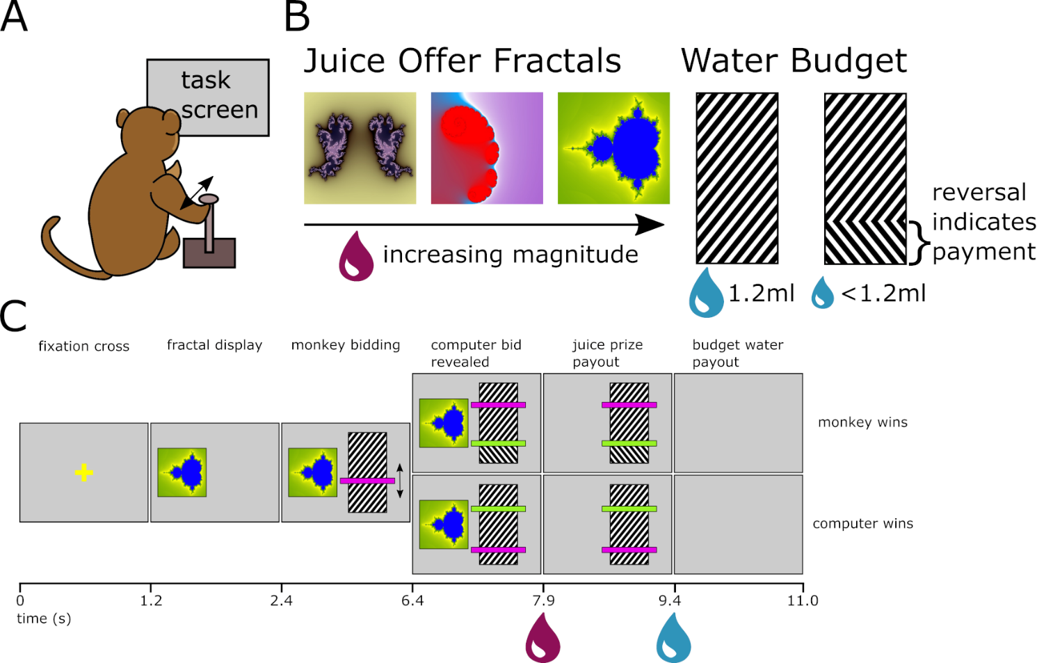
Figure 3.1a-c) The components of the BDM task used in this thesis. A) The monkey uses a joystick to interact with the task presented on a computer screen at head height 70cm from itself. To manipulate their bid the monkey moves the joystick towards or away from them (‘up/down’). B) the payouts of any trial of the task are defined by the juice offer fractal (indicating a certain magnitude of blackcurrant juice of constant concentration) to be bid for, and the water budget. A ‘full’ budget represents 1.2ml of water. Any payment a monkey makes on a winning auction trial is subtracted from this and indicating by a reversal of hatching. C) The epochs of the BDM task as seen by the monkey (not to scale; task does not include arrows in ‘monkey bidding’ epoch). Times are in seconds and indicate the change of the display and the delivery of liquids to the monkey. When the computer bid is revealed trials are fall into ‘monkey wins’ and ‘computer wins’ categories. Where the monkey’s bid (purple) is higher than the random computer bid (green), the monkey wins and pays for the juice offer. In comparison, when the monkey’s bid is lower than the computer’s bid the monkey retains the full 1.2ml water budget but does not receive any juice. After each trial, a random 2.5-3.5 second intertrial interval is interleaved.

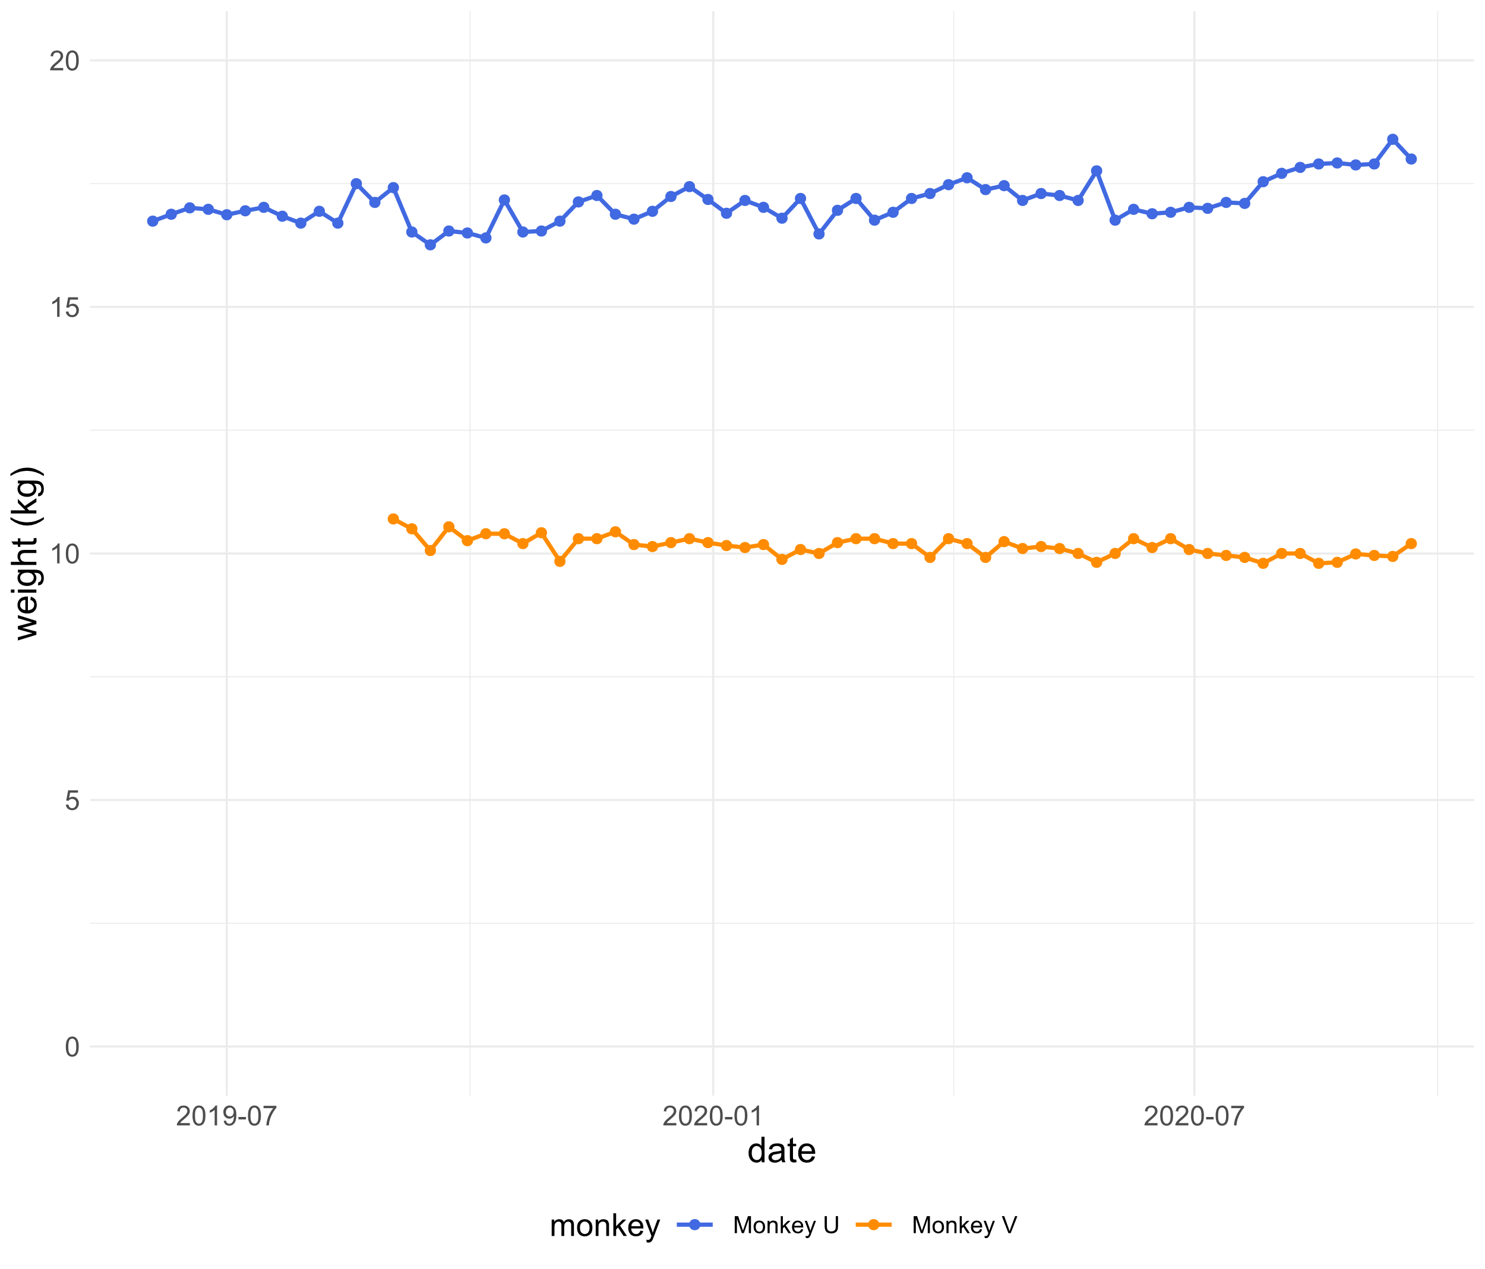
Figure 3.2 The weights of the two monkeys over the recording phase of the project. Monkeys were weighed prior to task performance on a weekly basis. The weights of the two monkeys remained steady of the entirety of the project. Monkey U was relatively large and heavy and monkey V relatively small and skinny, but both were within the normal physiological range for Macaca mulatta primates. The weights of the monkeys were used to calculate the liquid supplement given to each after experiments to maintain a minimum level of liquid deprivation.
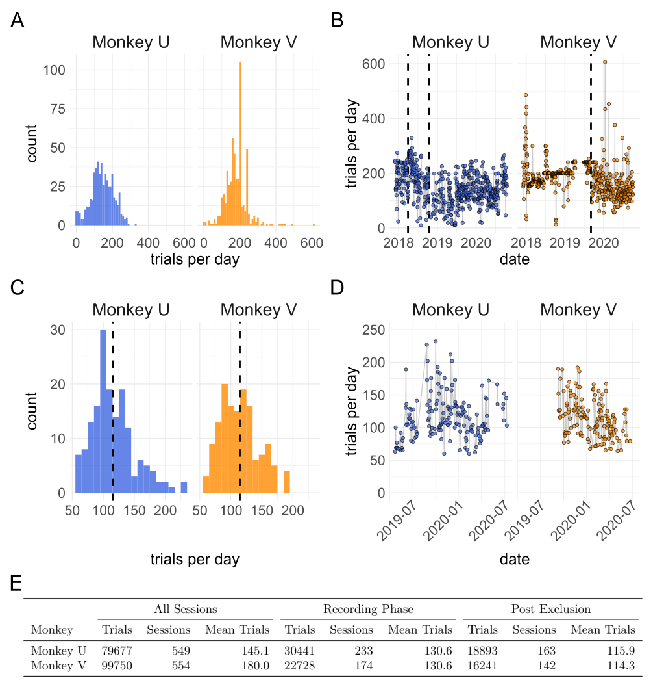
Figure 3.3a-e) Performance of two monkeys on the BDM task over the duration of this project. Two monkeys (‘U’ and ‘V’) were trained on the BDM (see Al-Mohammad & Schultz, 2019 and appendix 3.1). Once trained, monkeys performed BDM in 5 sessions per week completing a range of trials per session (A). ‘Complete’ trials indicate that monkeys successfully made bids which were compared against a randomly drawn computer bid and paid out. Incomplete trials resulted in an error timeout and no receipt of juice or water budget. Peaks for both monkeys occur at 200 and 240 trials where sessions were halted by the experimenter to maintain behaviour on subsequent sessions. B) During the initial retraining phase of the project, which aimed for monkeys to complete at least 200 trials per session which they regularly achieved. Dashed lines for Monkey U refer firstly (April 2018) to the initiation of head fixed training and later (October 2018) to the surgical implantation of a recording chamber. The single dashed line for Monkey V (September 2019) refers to the surgical implantation of headbars and a recording chamber after which the monkey was immediately trained to perform auctions while head-fixed. C) BDM trials from the neuronal recording phase of the project were filtered to exclude trials and sessions using a priori criteria (appendix 3.2) resulting in a smaller number of sessions and trials per session. Dashed line indicated mean number of trials (115.9 for Monkey U and 114.3 for Monkey V). D) shows how the number of ‘good’ BDM trials per session varies over time during this phase. In E) the number of trials and sessions are shown for the whole of the project (‘All Sessions’), the neuronal recording phase of ~1 year per monkey (‘Recording Phase’) and of filtered ‘good’ trials completed during the recording phase filtered as in appendix 3.2 (‘Post Exclusion’).
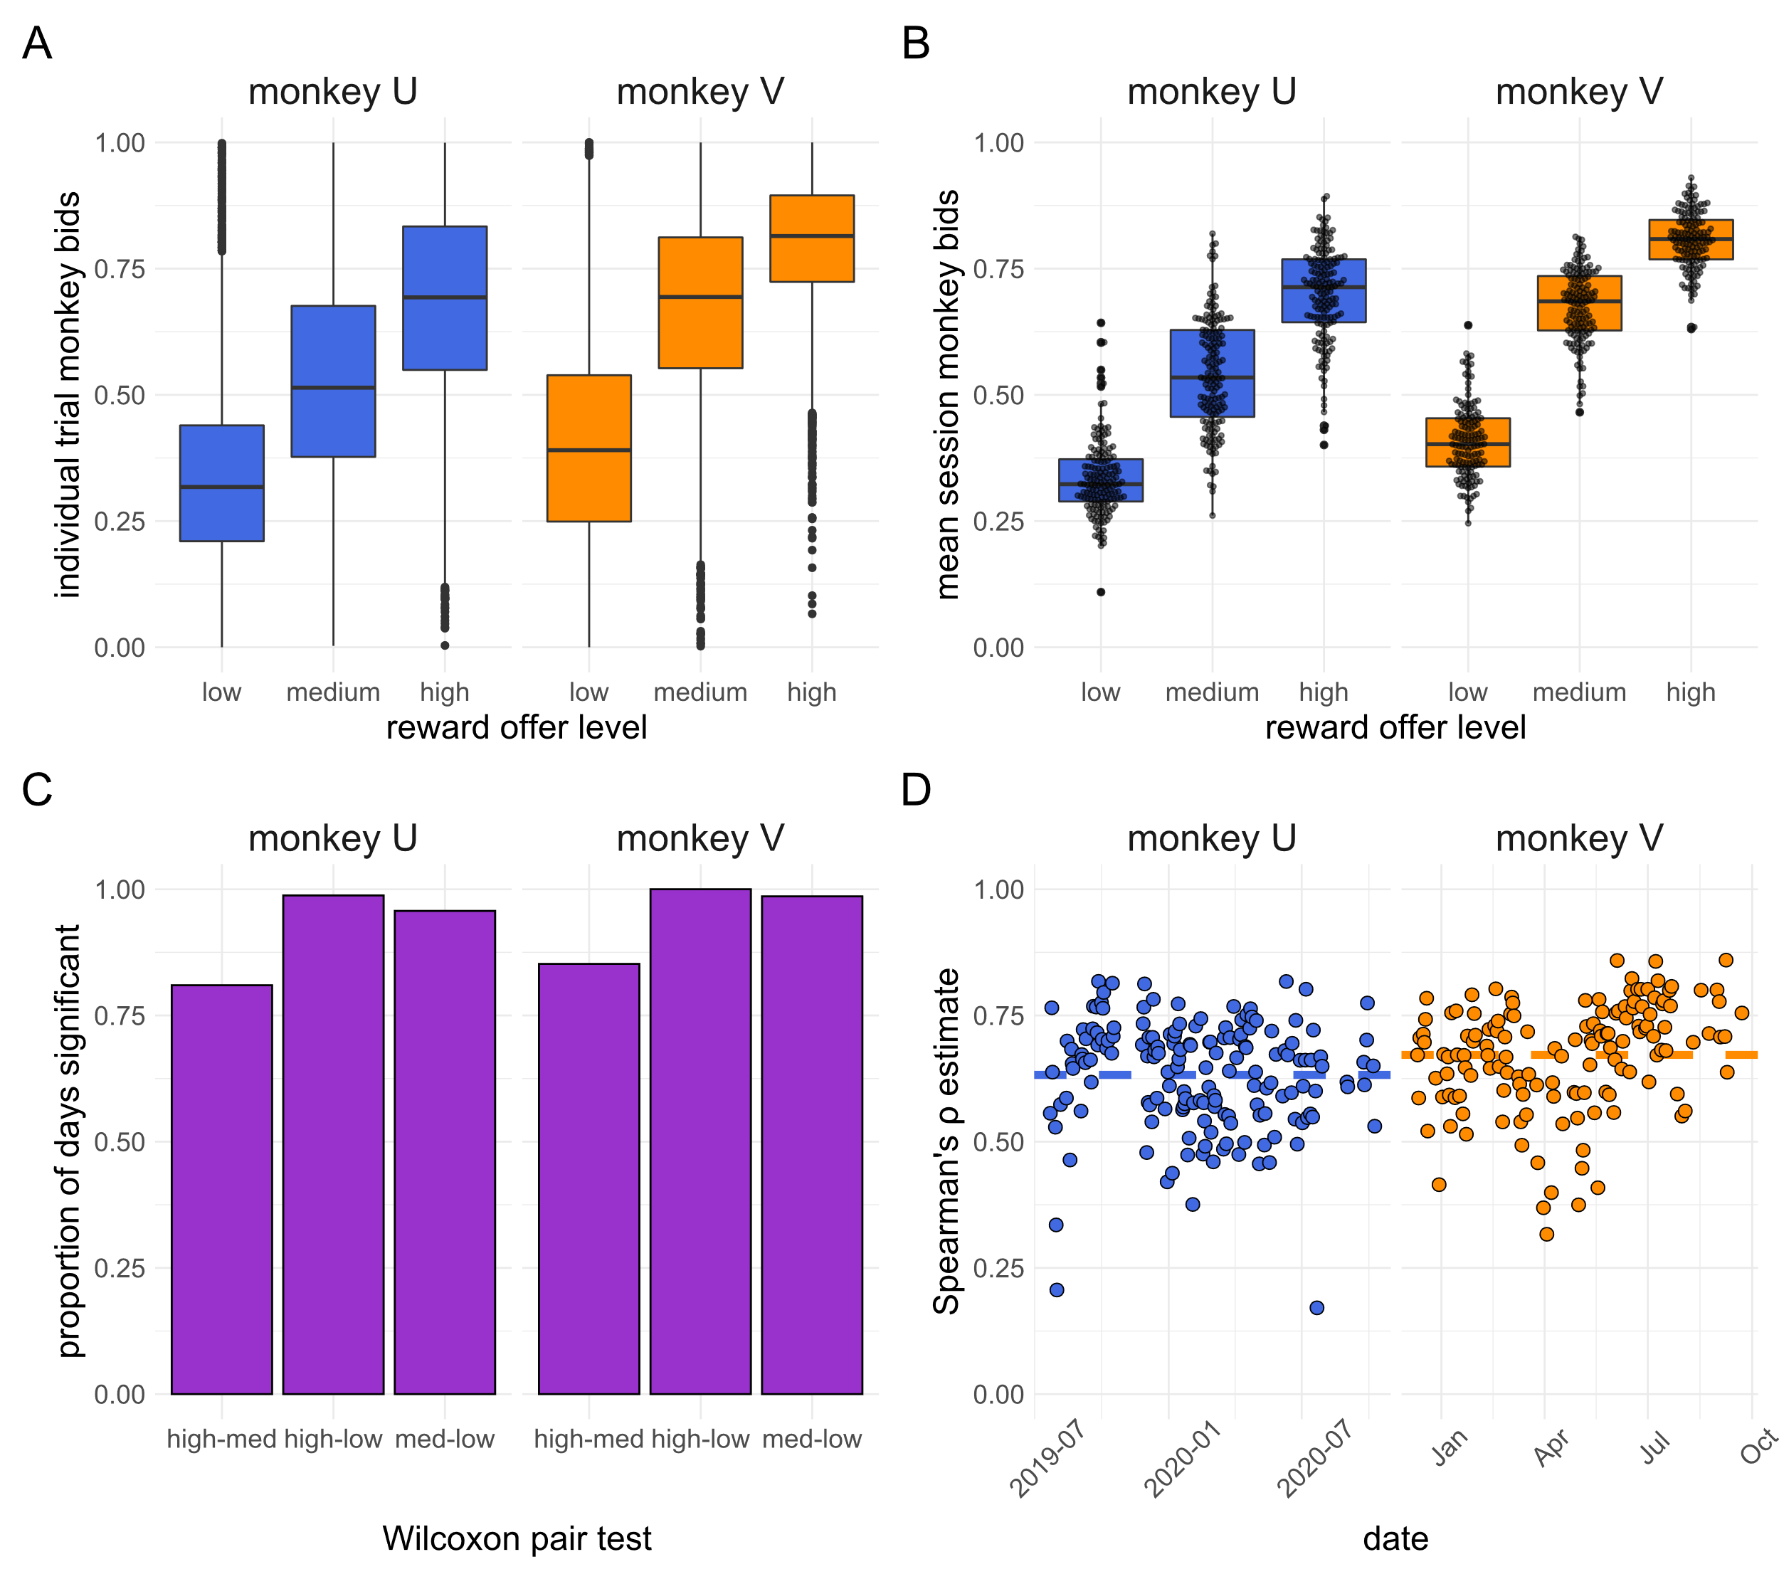
Figure 3.4a-d) Monkeys show rank ordered bidding on the BDM auction task. A) boxplots of each individual bid made by either monkey during the recording phase, post exclusion (n = 18893 for Monkey U; 16241 for Monkey V). Bids are separated by monkey and by the level of the reward offer into ‘high’, ‘medium’, and ‘low’ categories whose magnitude varied by monkey but were consistent across the entire phase (0.2, 0.45, 0.7ml Monkey U; 0.3, 1.0, 1.7ml Monkey V). B) boxplots of the mean bid per reward level per session (n = 163 for Monkey U; 142 for Monkey V) for each monkey. Individual mean session bids are overlaid in a beeswarm. Stars for plots A and B indicate significance for all corrected pairwise Wilcoxon comparisons p < 0.0001. C) the proportion of individual sessions for which a one-sided Wilcoxon test (uncorrected) between all bids made by a monkey showed significant differences (p < 0.05) in the level of the bid. X axis shows reward offer levels tested between, ‘low’, ‘med’ (medium), and ‘high’. D) Estimate of the Spearman’s ρ between the reward offer level and the monkey’s bids per date. Dashed lines indicate mean Spearman’s ρ over the entire period (0.632 for Monkey U; 0.672 for Monkey V).

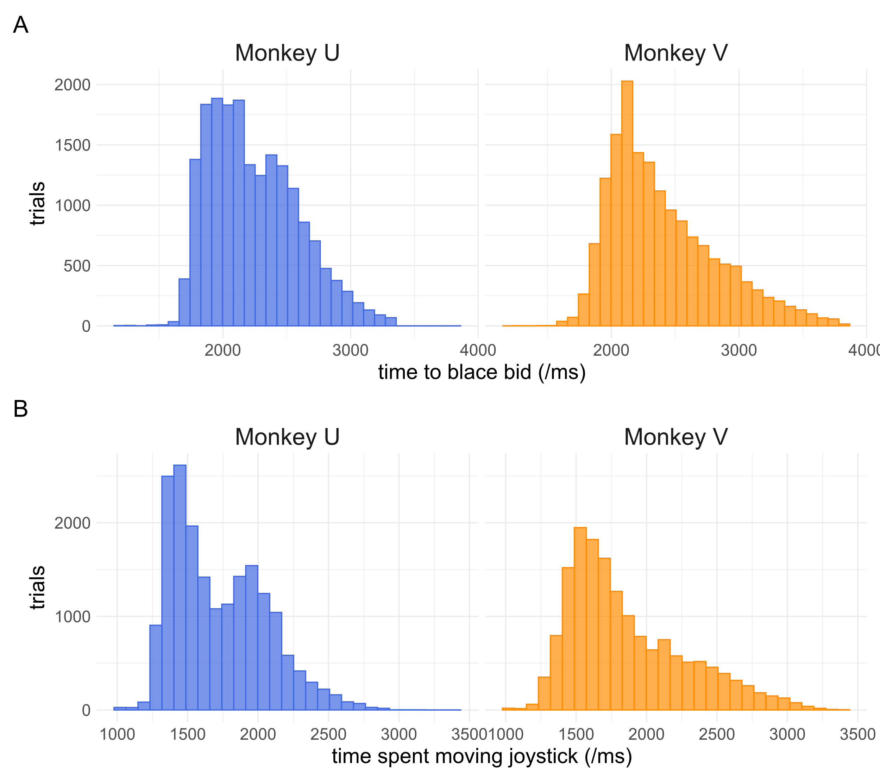
CHANGE COUNT TO TRIAL COUNT ON FIGS INC 3.3 Figure 3.5a-b) Monkey joystick behaviour while completing the BDM task. Trained monkeys were able to quickly move bids to their preferred locations. A) The total time spent moving a bid from the beginning of the bidding epoch. Monkey U was slightly faster to make bids in general. This graph does not include the time the joystick had to be held still to ‘place’ bids (see methods). Note the slightly longer tail for Monkey V whose ‘placement time’ was reduced from 1 second to 700ms. When considering the total time spent moving the joystick (i.e. from the first movement of the bidding indicator to the last) monkeys, especially Monkey U, show behaviour that seems to fall more into two populations of ‘fast’ and ‘slow’ bids (B).

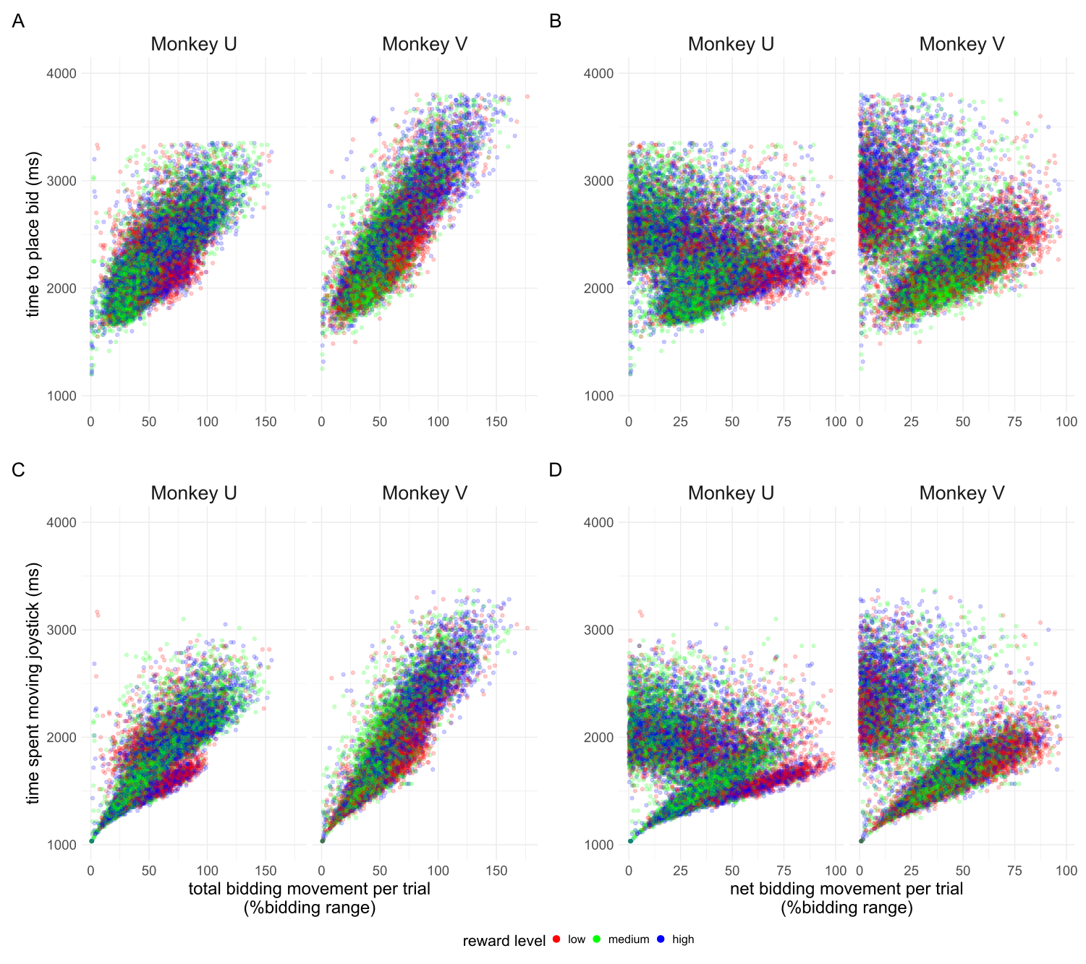
Figure 3.6 Distinct clusters of bidding activity can be seen when studying the relationship between the time spent moving the joystick and the net bidding movement per trial. For each monkey, the time to place bid and time spent moving the joystick (see figure 3.5) are plotted against the gross (total) bidding movement or the net bidding movement. Both x axis are plotted as modular values. Points are coloured by the reward level offered in the trial. Both monkeys show similar patterns of strong correlation between time to place bids and total bidding movement, and clusters of patterns between time spent moving the joystick and net bidding movement.

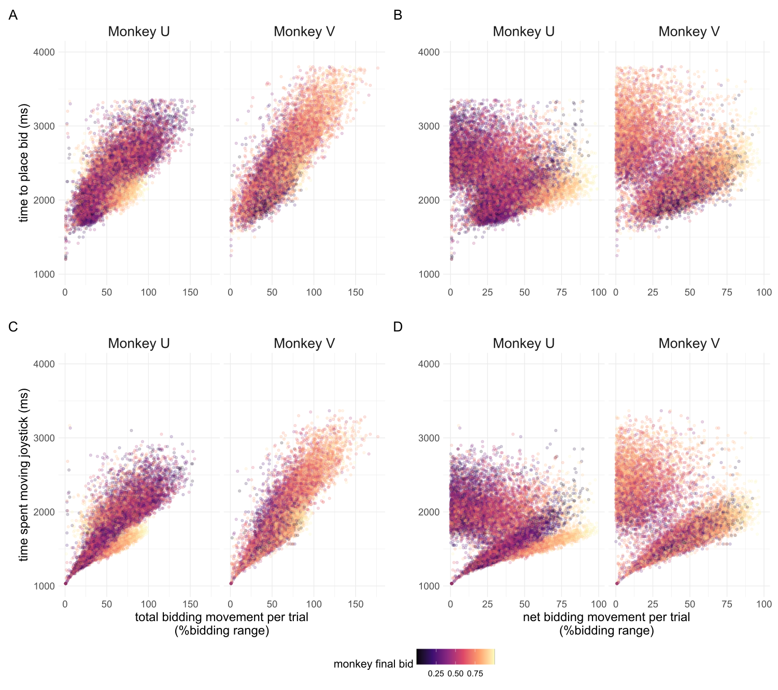
Figure 3.7 Distinct clusters of bidding activity can be seen when studying the relationship between the time spent moving the joystick and the net bidding movement per trial. Points plotted as in figure 3.6 but are coloured by the monkey’s final bid from low (yellow) to high (purple).

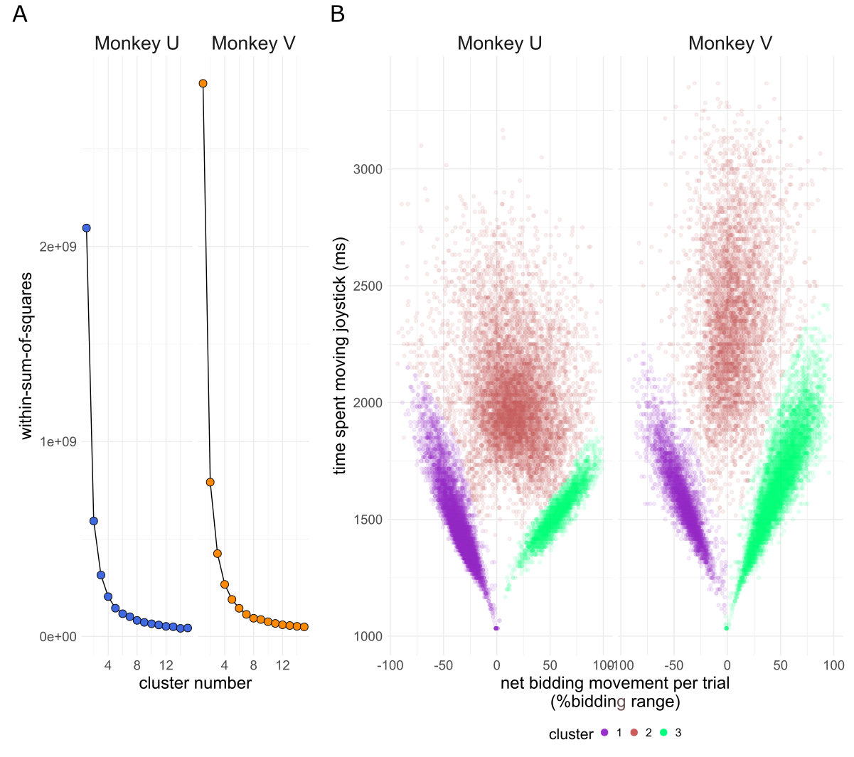
Figure 3.8a-b) Clustering of monkey bidding behaviour. A) Bidding behaviour using the time spent moving the joystick and net bidding movement (see figures 3.6 and 3.7) as coordinates is used to train a k-means clustering algorithm. Within cluster sum of squares is used to identify an elbow in the variance explained by the addition of clusters which confirms the priors of 3 clusters in the data. B) Individual bids are shown as in figures 3.6 and 3.7, coloured by their cluster as determined using k-means clustering. Clusters numbers have been rearranged for consistency between monkeys.
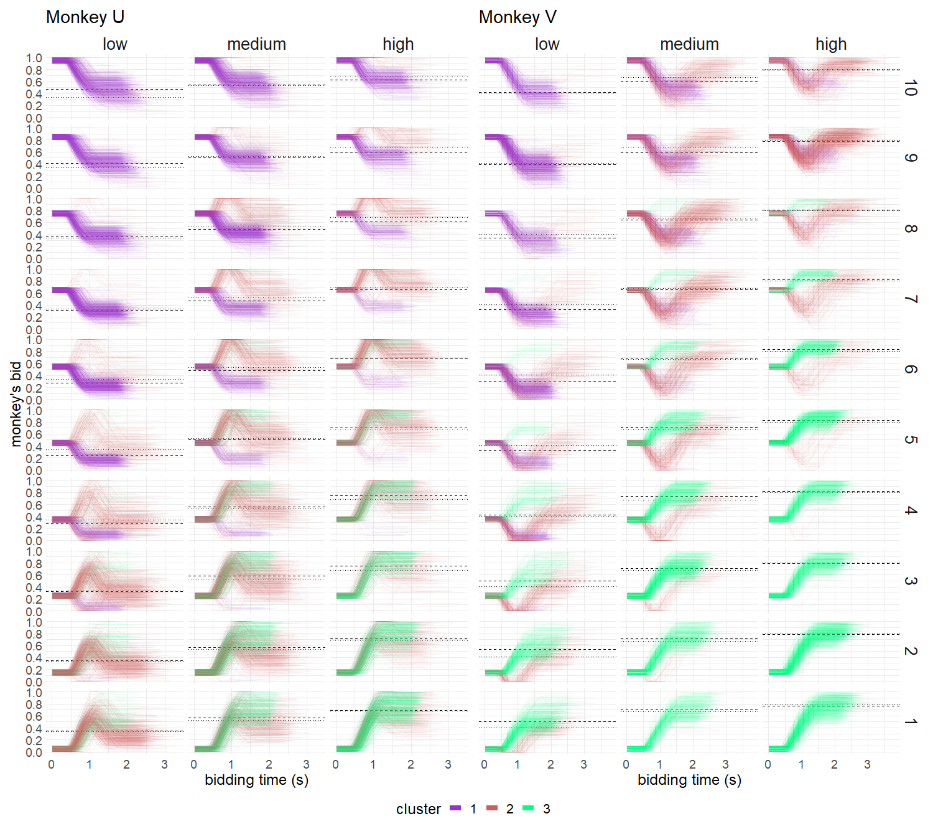
Figure 3.9 Individual bids made by monkeys coloured by cluster. Clusters from figure 3.8 are imposed on traces of the bidding indicator bars movement over time. Trials per monkey are spit by reward level offered and by the starting bid decile, where 1 is the lowest (bid starting in 0-10% of the budget bar). Dotted lines indicate the mean monkey bid per reward level, compared to dashed lines which indicate mean monkey bid per reward level and starting bid decile.

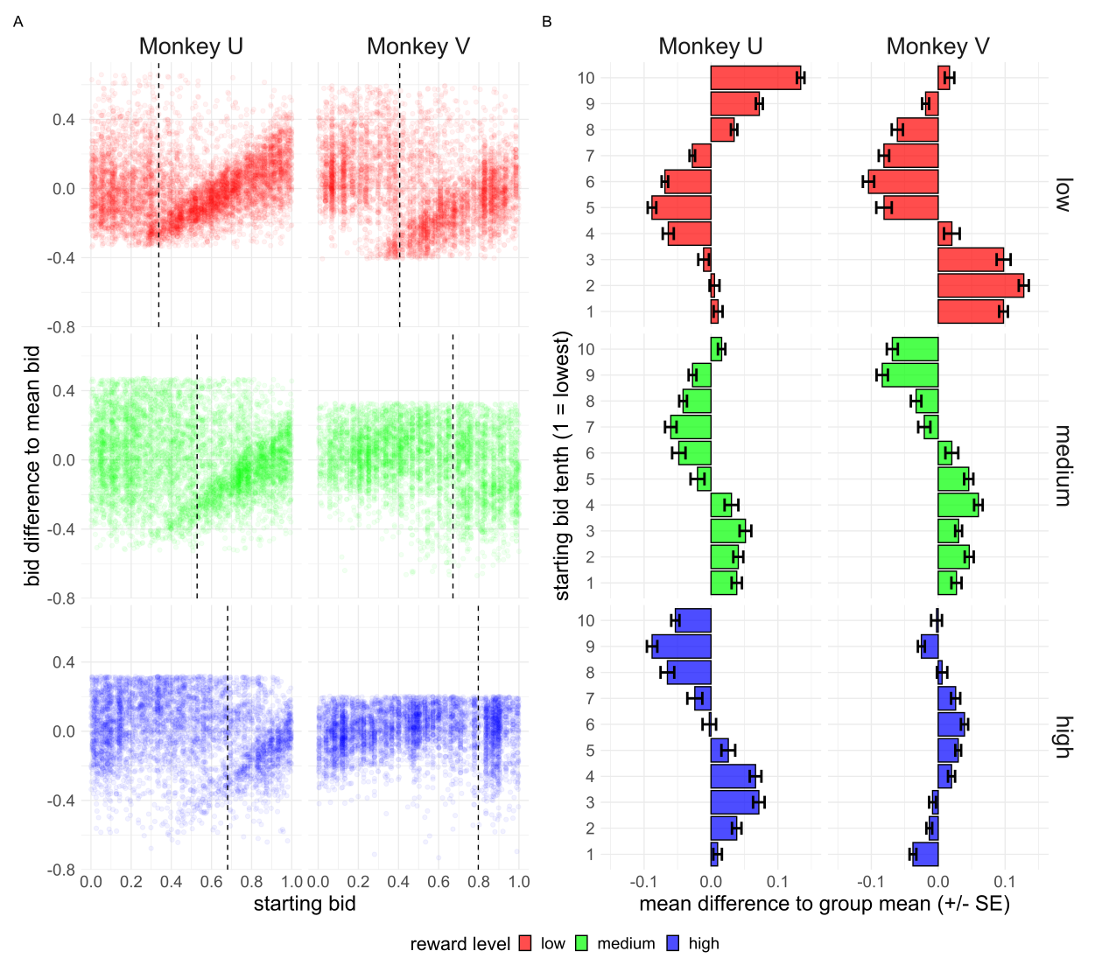
Figure 3.10a-b) The effect of the randomly drawn starting bid on the monkey’s final bid. A) The difference of a monkey’s final bid to the mean final bid per reward level is shown against the randomly drawn starting bid of the trial. The mean bid per reward level is also indicated via a vertical dashed line. B) The difference between the mean bid per reward level and starting bid decile is compared to the mean bid per reward level. I.e. the mean effect of the starting decile on the monkey’s final bid. Negative values indicate that the starting bid decile leads the monkey to bid lower than would be expect, and vice versa. Error bars are standard error of the mean.

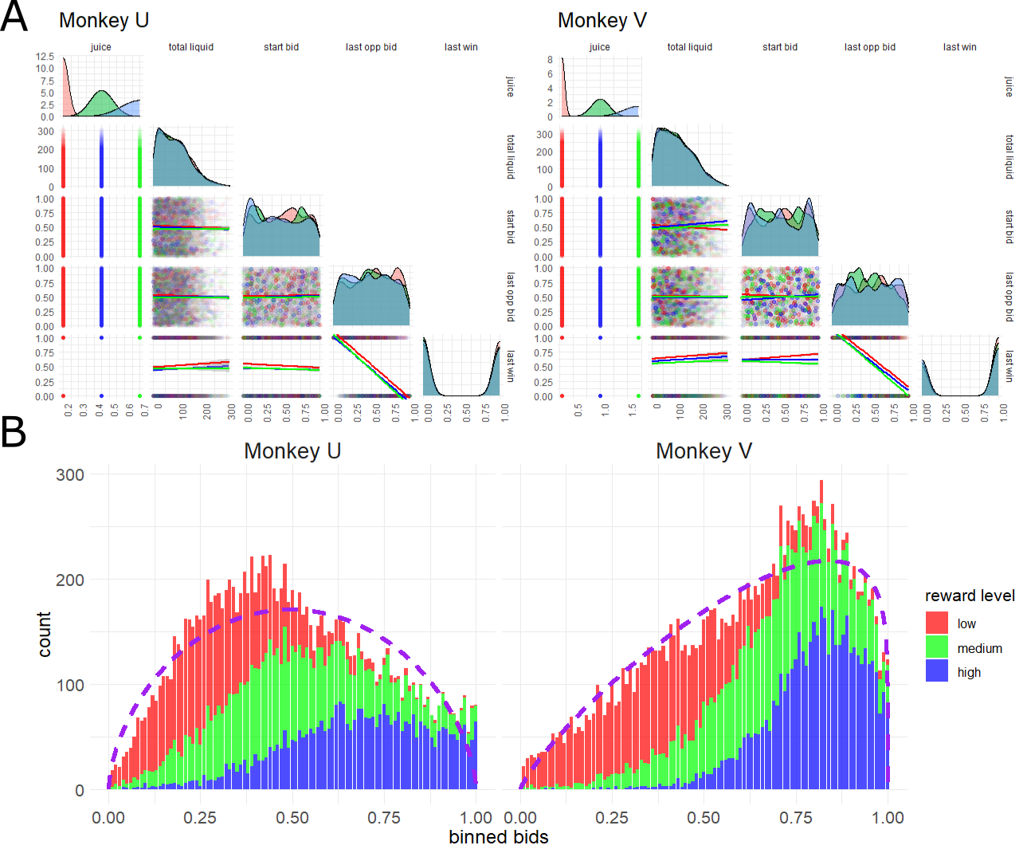
Figure 3.11a-b) The distribution of independent and dependent variables selected for the BDM task. In a) the distributions (diagonal) of each selected independent variable is shown coloured by reward level (red = lowest magnitude juice, green = middle, blue = highest). ‘juice’ refers to the ml of juice offered at each level; ‘total liquid’ is the total ml of liquid the monkey has received that day; ‘start bid’ is the randomly drawn starting bid of the trial; ‘last opp bid’ refers to the randomly drawn computer bid on the last trial; ‘last win’ is a binary variable indicating if the monkey won (1) or lost (0) the last trial. Note, variable names have been changed here compared to figure 3.12 in the interest of space. No variables show strong co-correlation (dots and best fit linear model plots) except for the last computer bid and whether the monkey won the last trial, as would be expected. B) the distribution of monkey bids coloured by the reward level as in a) is bound in the range (0,1), i.e. between 0 and 1 not inclusive. The two monkeys show a clearly different distribution in bids due to the different amounts of liquid offered and the monkeys private utility functions. Dashed purple lines indicates the fit of a beta distribution to the monkey’s bidding data.

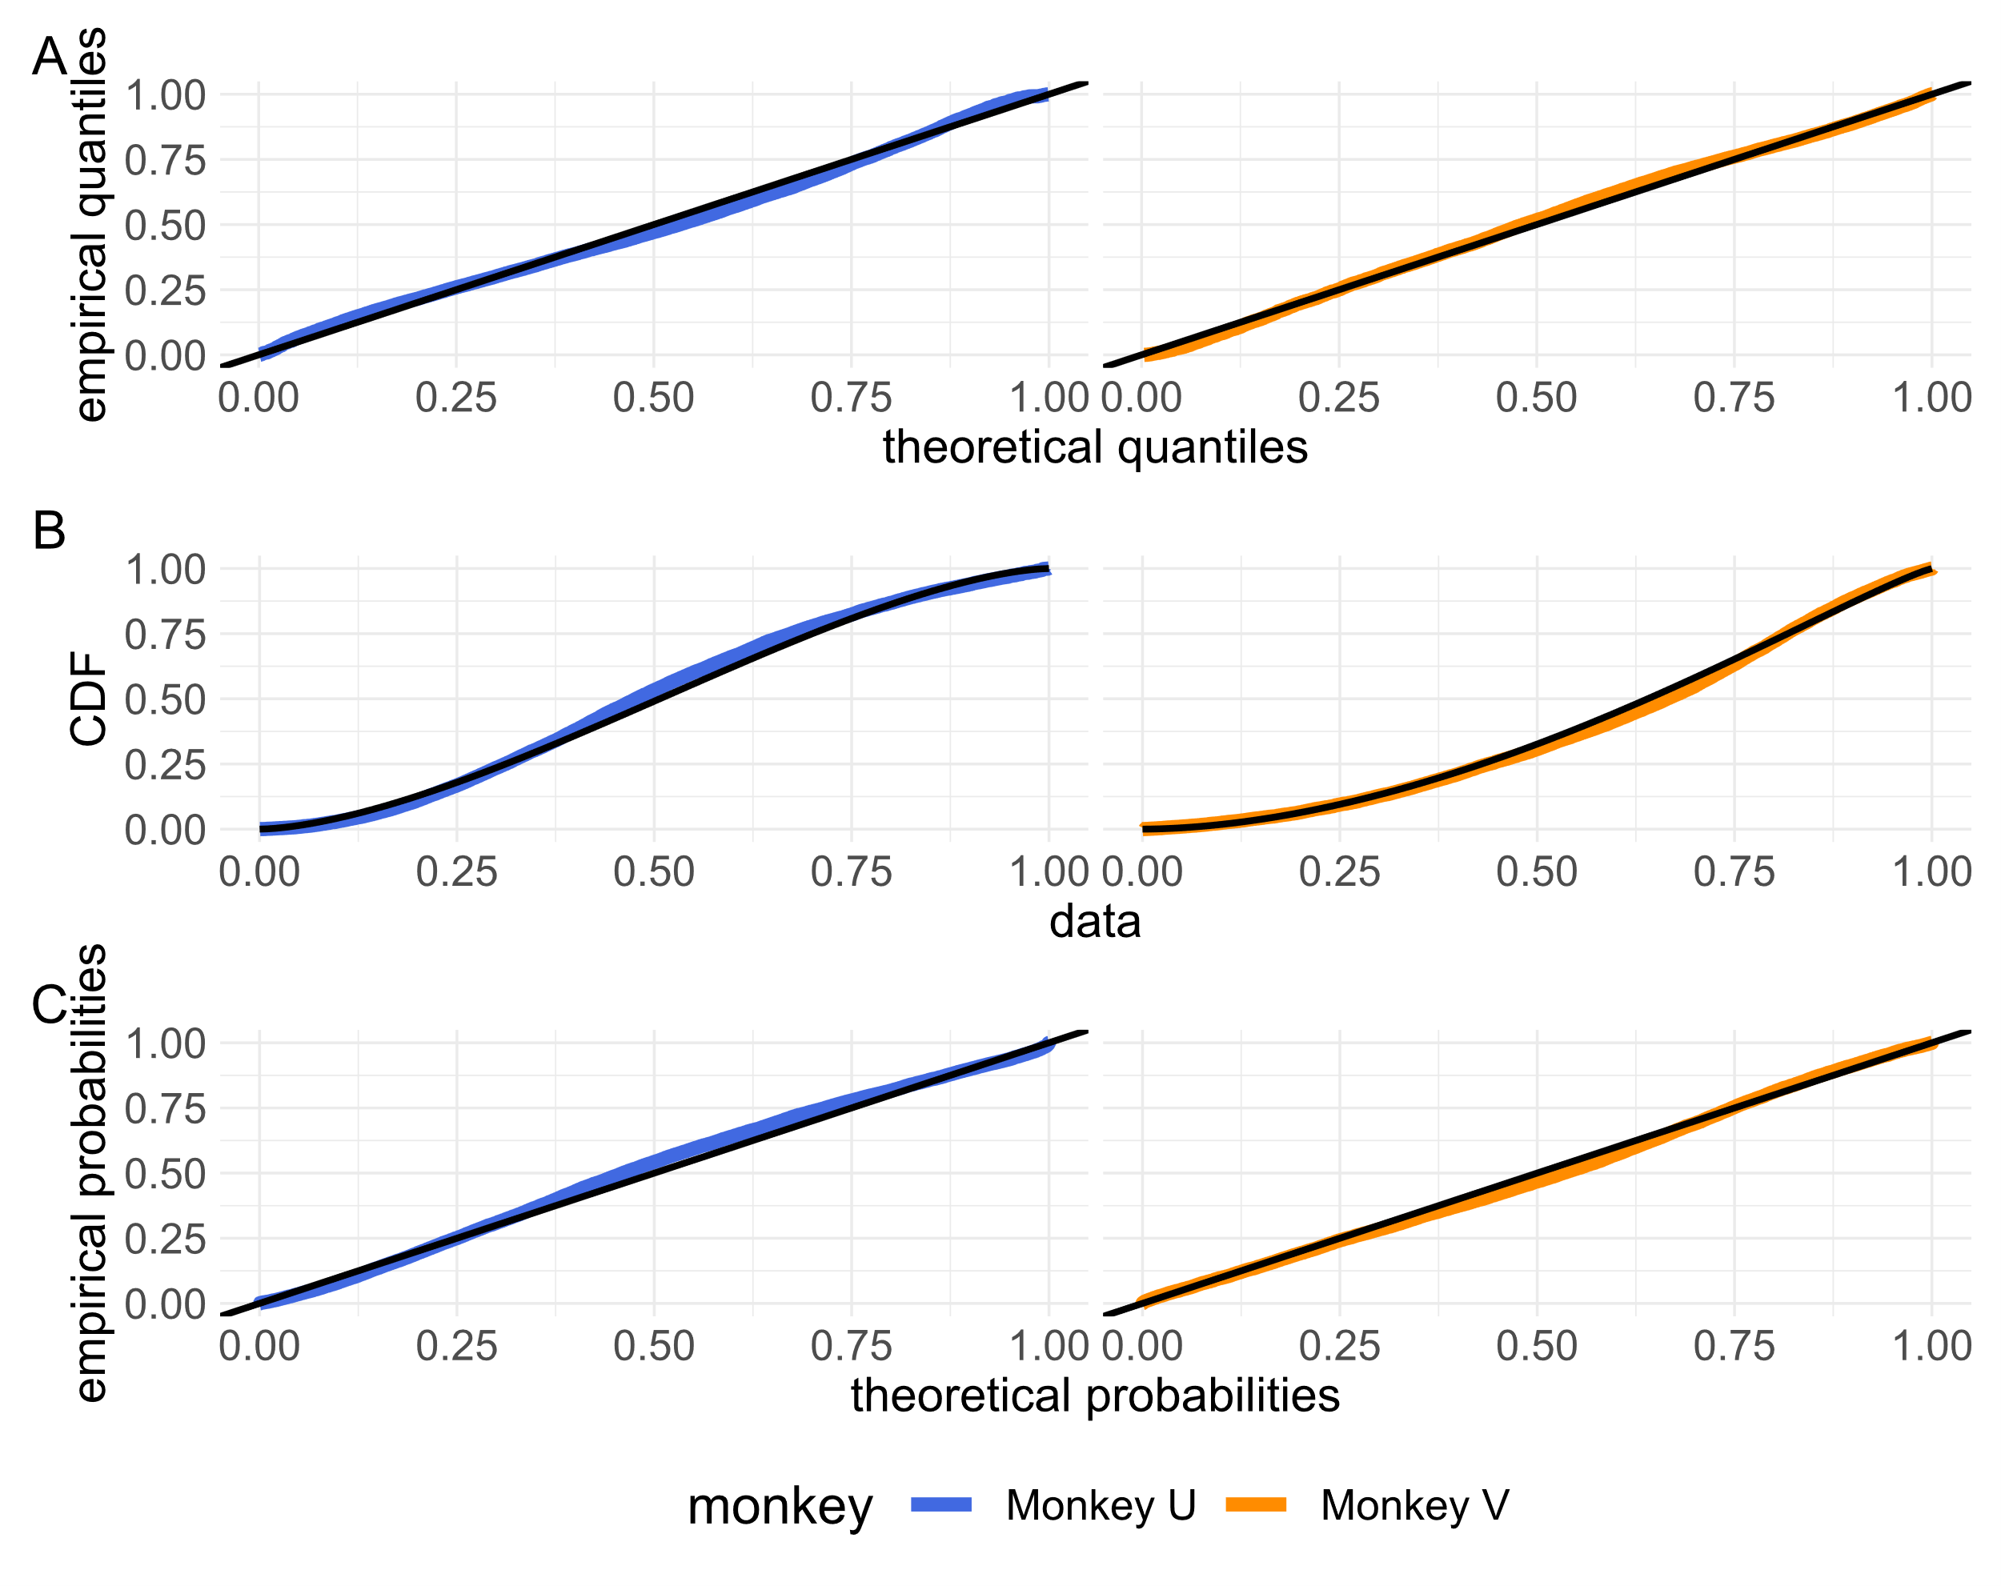
Figure 3.12a-c) Agreement between the distribution of monkey bids and the fitted beta distributions. A) Quantile-quantile plots of monkey’s bids against the fitted beta distributions of figure 3.11b) (parameters in table 3.11c). Perfect fit is shown as a black line along x=y. B) The cumulative distribution function (CDF) of observed (colour) and theoretical (black) points are plotted next to each other. C) Probability-probability plots of the CDF of observed and theoretically beta distributed monkey’s bids plotted against each other. For all plots, colour refers to monkey whose bids are plotted. All plots show good agreement between empirically observed bids and those expected given the fitted beta distributions (i.e. where the coloured lines fall reasonably along black lines).
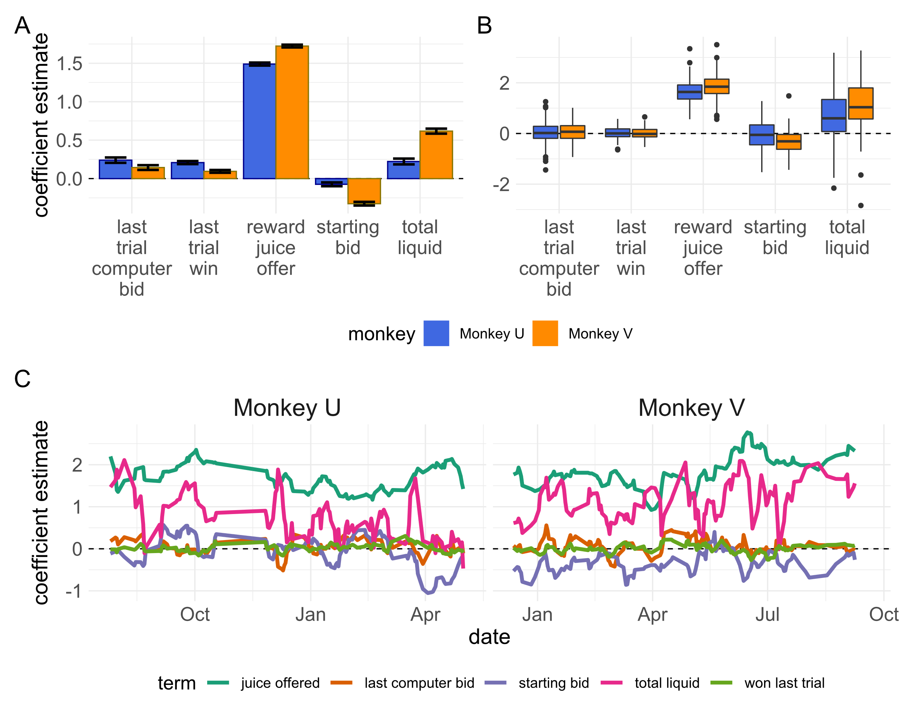
Figure 3.13a-c) results of beta distribution regressions on relevant task variables. A) Coefficient estimates for a regression of relevant task variables against monkey bids for all trials separated by monkey. Error bars represent +/- standard error. For both monkeys, the reward level offered was the dominant variable in guiding monkey’s bids as expected. Both monkeys also showed an inverse relationship with the starting bid (though much more so for monkey V). Monkey V also showed a much greater effect of aggregate bid increasing as the monkey received more liquid over successive trials (i.e. was sated). B) Coefficient estimates for identical regressions grouped by both monkey and session date. Boxplots show similar findings as the single regression carried out in a). In every session, reward level was a significant variable in determining monkey’s bid. The total liquid received shows the greatest variability in effect over multiple sessions. In c) regression coefficients from b) are plotted by date, showing the relationship over time. Lines are smoothed by taking the mean coefficient estimate over the last 5 sessions.

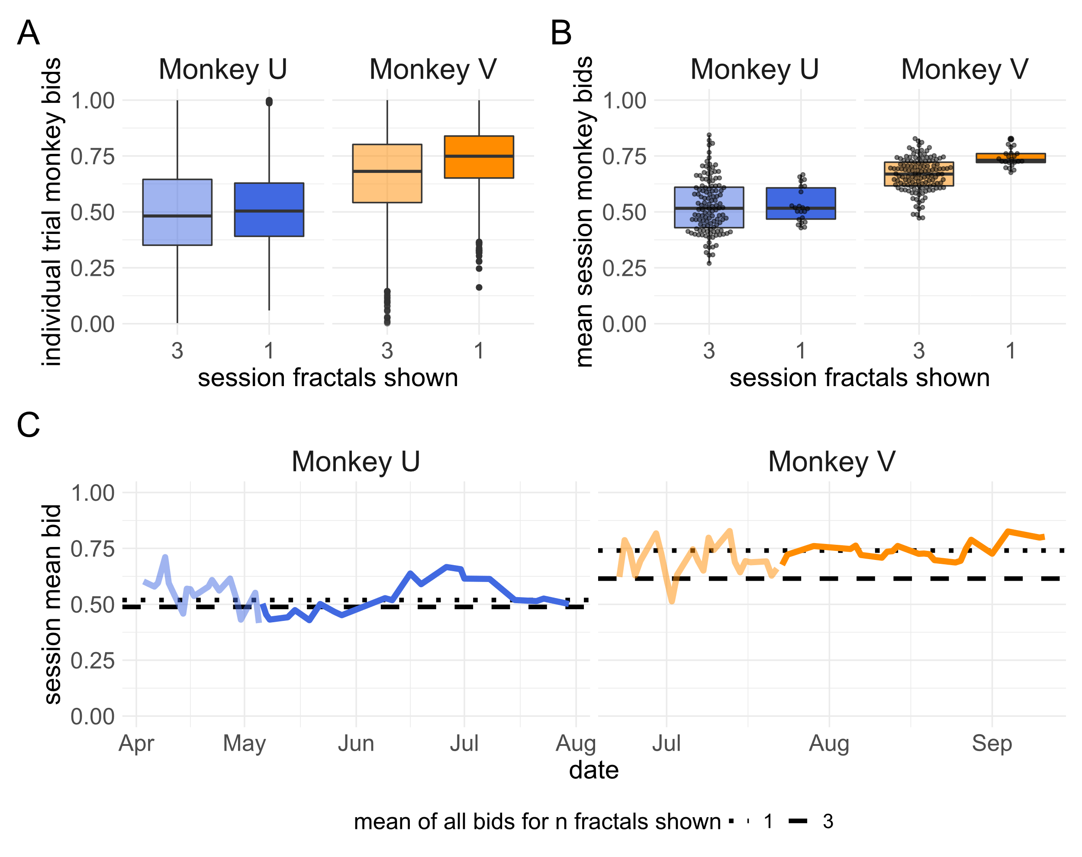
Figure 3.14a-c) The distribution of monkey’s bids when only the medium reward level fractal is show. A) the distribution of monkey bids from n = 2228 (monkey U) and 2724 (monkey V) trials on sessions where only the medium fractal was shown (opaque boxplot). These are compared to the distribution of all bids made for only the medium fractal in sessions where all 3 reward levels were presented to the monkey (n = 4665 for monkey U, n = 4628 for monkey V) in the semi-transparent boxplot. B) the mean session bid for the medium reward level fractal is shown for sessions where only the medium reward level fractal is offered to the monkey (n = 22 for both monkeys) is compared to the mean session bid for the medium reward level fractal in sessions where all 3 are shown to the monkey (n = 163 for monkey U and 142 for monkey V). The mean bid for each of these 22 sessions per monkey is shown over time in c) (opaque line). The mean bid for the medium reward level fractal on sessions with 3 presented fractals for the month prior to changing the task is shown in the semi-transparent line. Note: the reward juice volumes associated with the middle fractal are different between monkeys (0.45ml for monkey U, 1.0ml for monkey V) but the same between conditions.

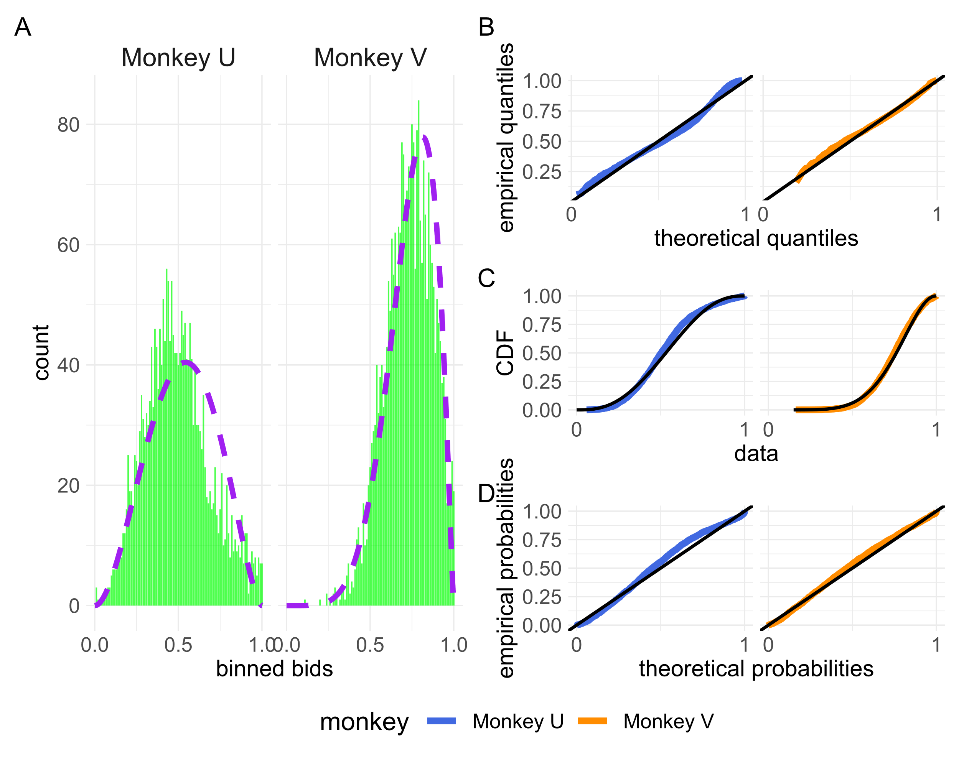
Figure 3.15 the distribution of monkey bids for sessions where only the medium reward level fractal is presented. A) binned bids are shown in a figure equivalent to 3.11b for the two monkeys over the 22 sessions where only the middle fractal was shown. A beta distribution (purple) was fitted to each monkey’s bids. For monkey U this fitted distribution took the form α = 2.97, β = 2.65. For monkey V the fitted distribution took the form α = 6.49, β = 2.25. B-D) empirical vs theoretical observations from the distribution of monkey’s bids and the fitted beta distributions are plotted as in figure 3.12. Again, both theoretical distributions captured much of the observed distribution of bids.

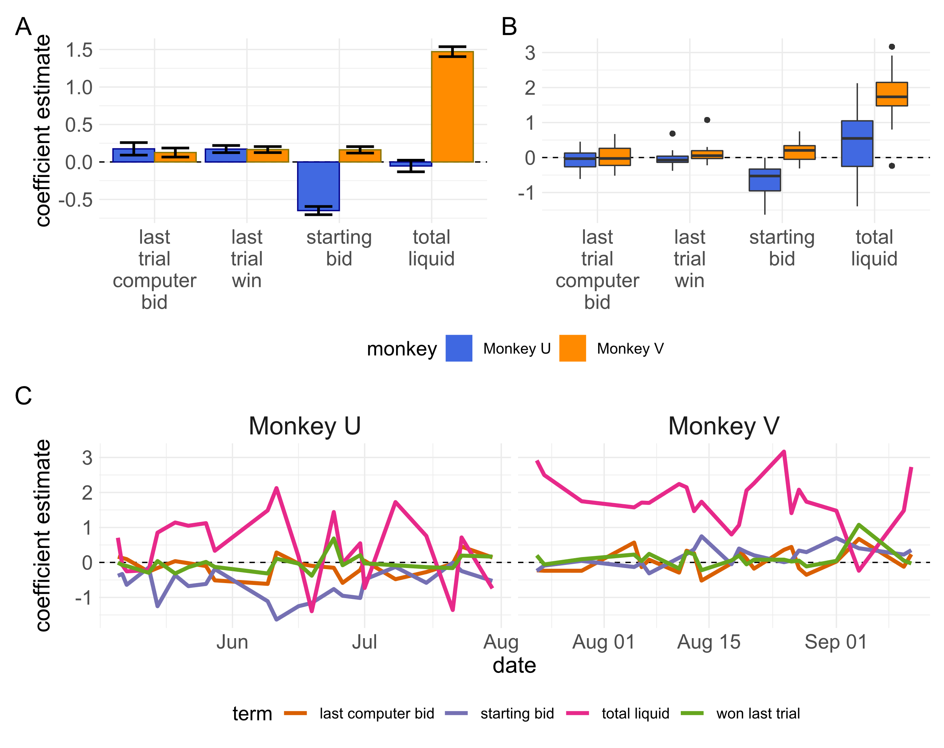
Figure 3.16a-c) results of beta distribution regressions on relevant task variables for sessions where only the medium reward level fractal is presented to each monkey. Regressions are identical to those performed for figure 3.13 except for the exclusion of the now invariant reward juice offered feature. In c) estimated coefficients are plotted per session date and not smoothed as in figure 3.13c).

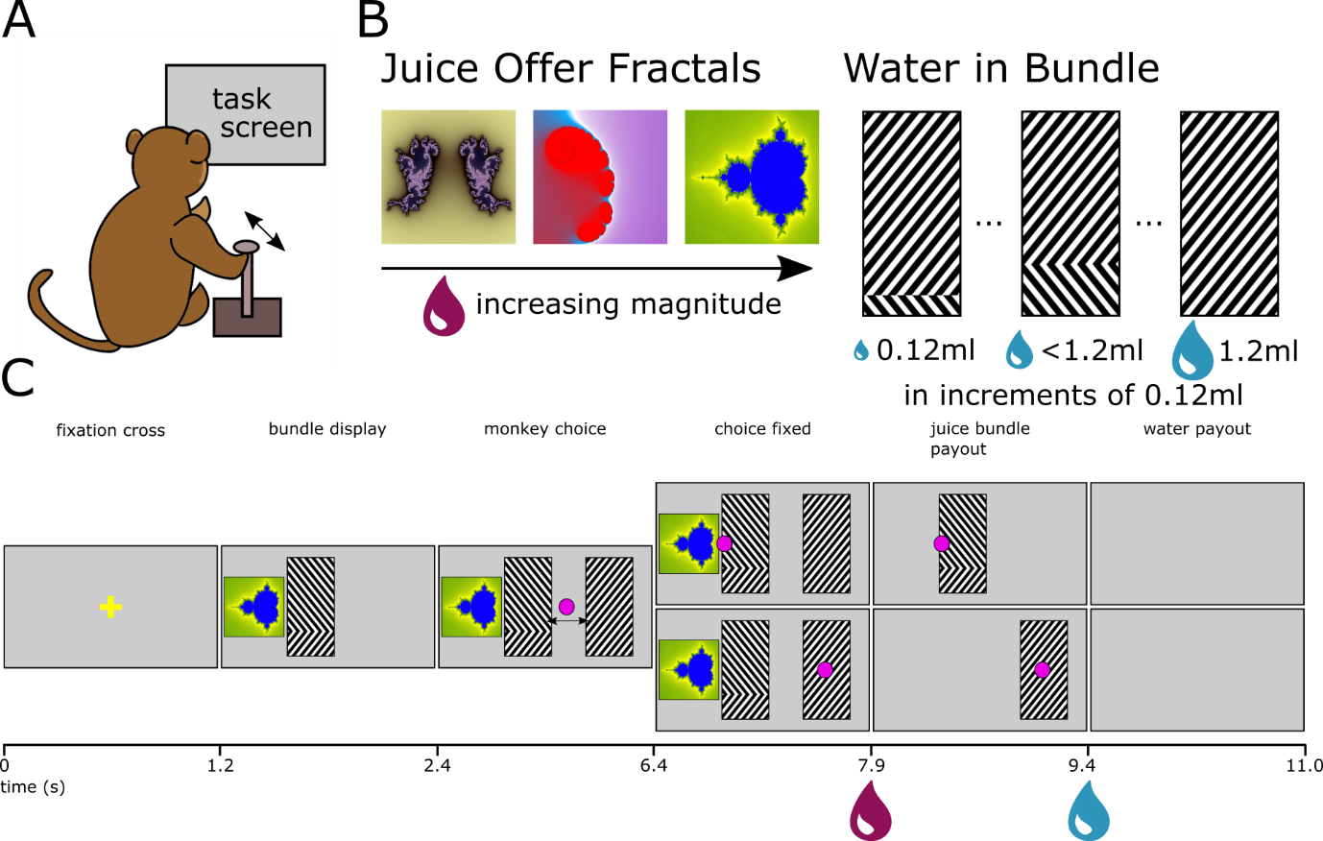
Figure 3.17a-c) The bundle choice task is equivalent to a second-price auction where the monkey bids second. A) monkeys in the same experimental set up as the BDM make choices using the left/right axis of the same joystick. B) task components are the same as presented in the BDM task. Fractals used to signify a juice reward offer are the same and correspond to the same volumes of juice as in the BDM. Amounts of water are indicated by a grating pattern as in the BDM. For every trial, a choice is presented between a juice reward and some amount of water, or a full 1.2ml of water. Bundles can be comprised of between 0.12ml and 1.2ml or water in 0.12ml increments. C) The full task progression is presented (c.f. figure 3.1). Times between epochs are the same as in the BDM and liquids are delivered to the monkey at the same points in either task.

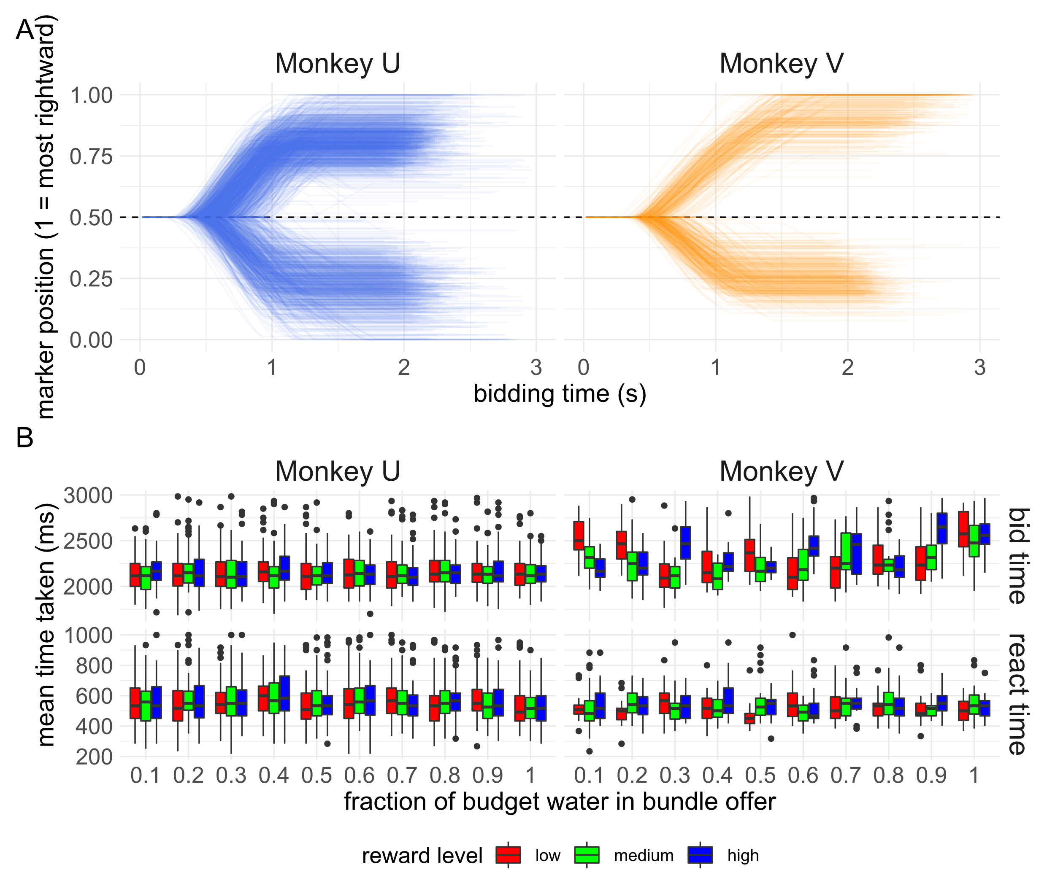
Figure 3.18a-b) Monkeys were able to quickly and reliably make choices in the bundle choice task. A) traces of the relative marker position during all bundle-choice trials for both monkeys. The markers starts each trial in the centre of the screen (0.5) and monkeys can either move it to the right (towards 1.0) or the left (towards 0 on the plot). Both monkeys were able to quickly move the marker to well within the required area of bidding (>5% of the screen’s width distance from the initial, centred, position). Monkey U performed 2267 trials over 23 sessions. Monkey V performed 714 trials over 6 sessions. B) Median reaction times (‘react time’) and time to place choices (‘choice time’) did not vary by either the level of juice (colours) or the amount of water offered (x axis) of the bundle for Monkey U. For Monkey V, the time spent bidding was significantly correlated with the amount of water offered in the bundle, though with a small effect size.

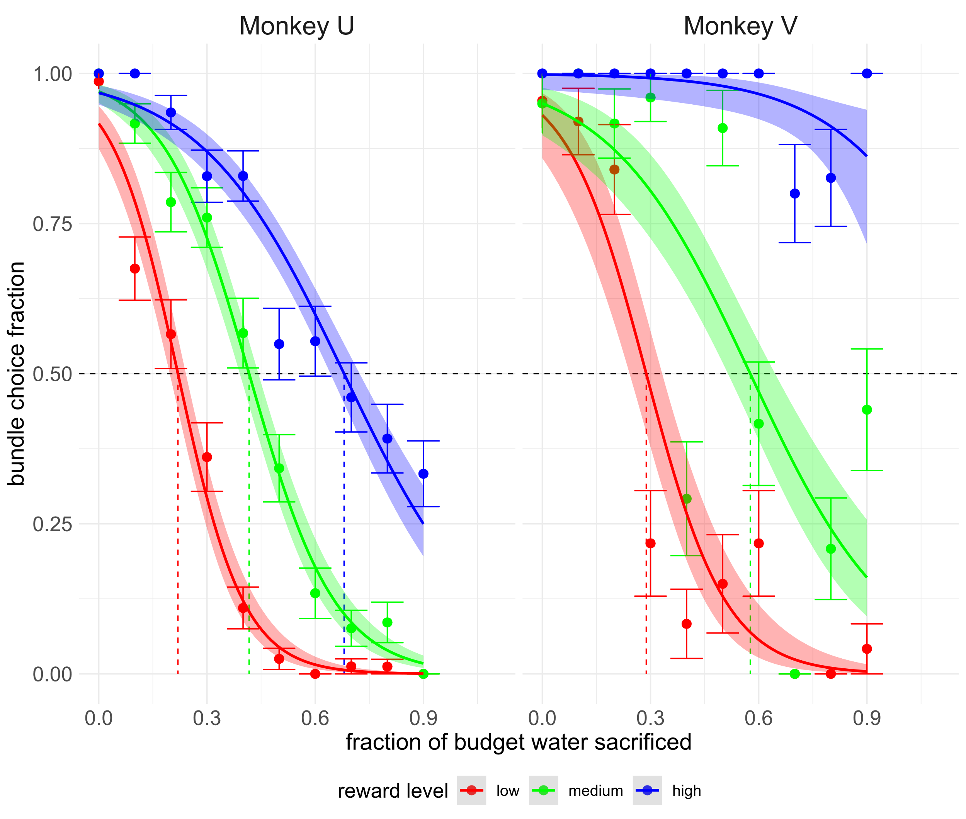
Figure 3.19 Monkeys showed rank-ordered indifference points on the bundle choice task. The fraction (±standard error of mean) of times the monkey chooses the bundle when offered an amount of juice and water is calculated, where 1 indicates that the monkey always chooses that bundle over the budget offer of 1.2ml of water. A logistic function is then fitted to the monkey’s choices (lines) indicating the estimated number of times a monkey would pick a hypothetical bundle of reward level plus some fraction of 1.2ml of water. Shaded area indicates standard error of the mean of this function. The monkey’s willingness-to-pay for a particular bundle in terms of water is then assumed to be the point on the x axis that this psychometric function crosses the 0.5 mark. See chapter 1 and figure 1.1 for more on this ‘indifference point’. Dashed lines coloured by the reward level indicate the indifference points from bundles offered to monkeys.

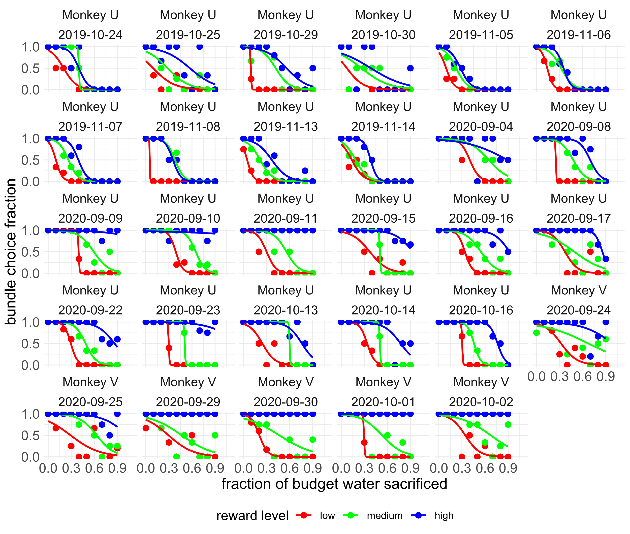
Figure 3.20 Monkeys binary choice data presents a noisier picture. All binary choice sessions per monkey included in analysis are plotted as in figure 3.19 (indifference lines and standard error of mean on the logistic fit have been removed in the interest of clarity). The stochasticity of fits is clear and due to the limited number of trials completed by monkeys (Monkey U: mean trials per session = 98.6, standard deviation of trials per session = 33.9, Monkey V: mean trials = 119, standard deviation = 18.9). There are 30 categories of juice and bundle water that can be offered to the monkeys so over ~100 trials, an animal might only see a bundle offer a limited number of times.

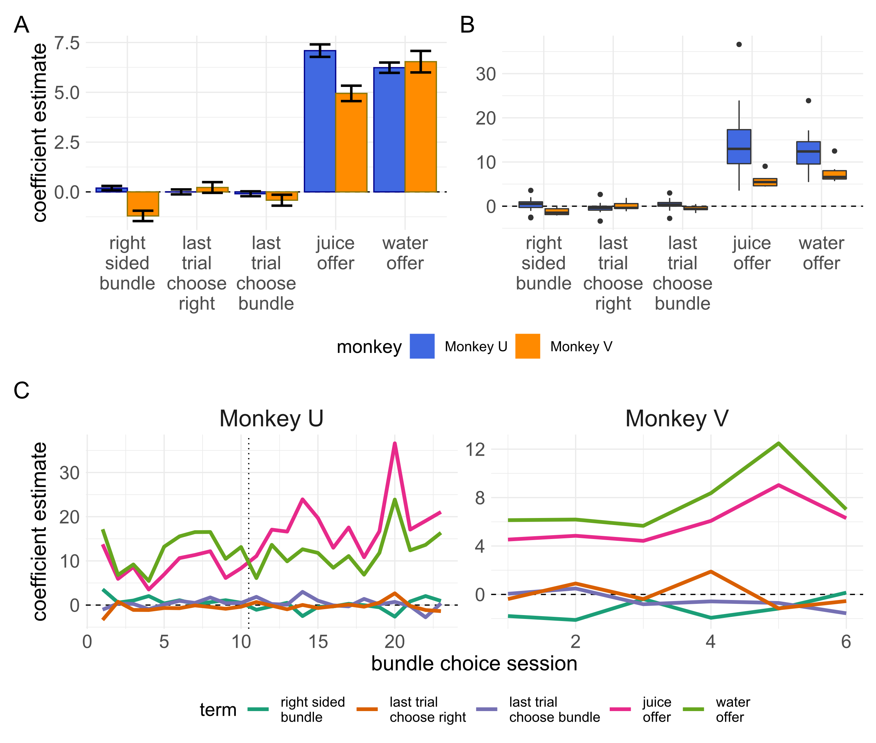
Figure 3.21a-c) the results of a logistic regression on monkey’s choices on the bundle choice task. A) Coefficient estimates for a regression of relevant task variables against monkey choices for all trials separated by monkey. Error bars represent +/- standard error. Both monkeys show similar dominance of the difference in juice and water offered in the bundle when deciding between bundles or a full ‘budget’ of water. Though significant, the coefficient estimates for the results on the last trial were negligibly small. As the regression is on the probability of choosing the right-sided option, the intercept corresponds to the bias in the monkeys choice of sides and has been relabelled here. Monkey U showed a small but consistent right-sided bias whereas monkey V showed a larger left-sided bias. B) Coefficient estimates for identical regressions grouped by both monkey and session date. Boxplots show similar findings as the single regression carried out in a). In every session, the features that best predicted the monkey’s choice on a trial were the offers of water and juice in the bundle. In c) regression coefficients from b) are plotted by session number ordered by date, showing the relationship over time. Session number rather than date is used as for monkey U there were large periods between the sessions on the bundle choice task due to the focus on gathering data from monkeys performing BDM auctions. The split in session date is shown using a dotted line for monkey U. Sessions before the line take place in October-November 2019, and sessions after take place in September-October 2020. For monkey V, all sessions take place in September-October 2020.

RANDOM UTILITY MODEL FIGURE – IN PROGRESS

FIGURE 3.22
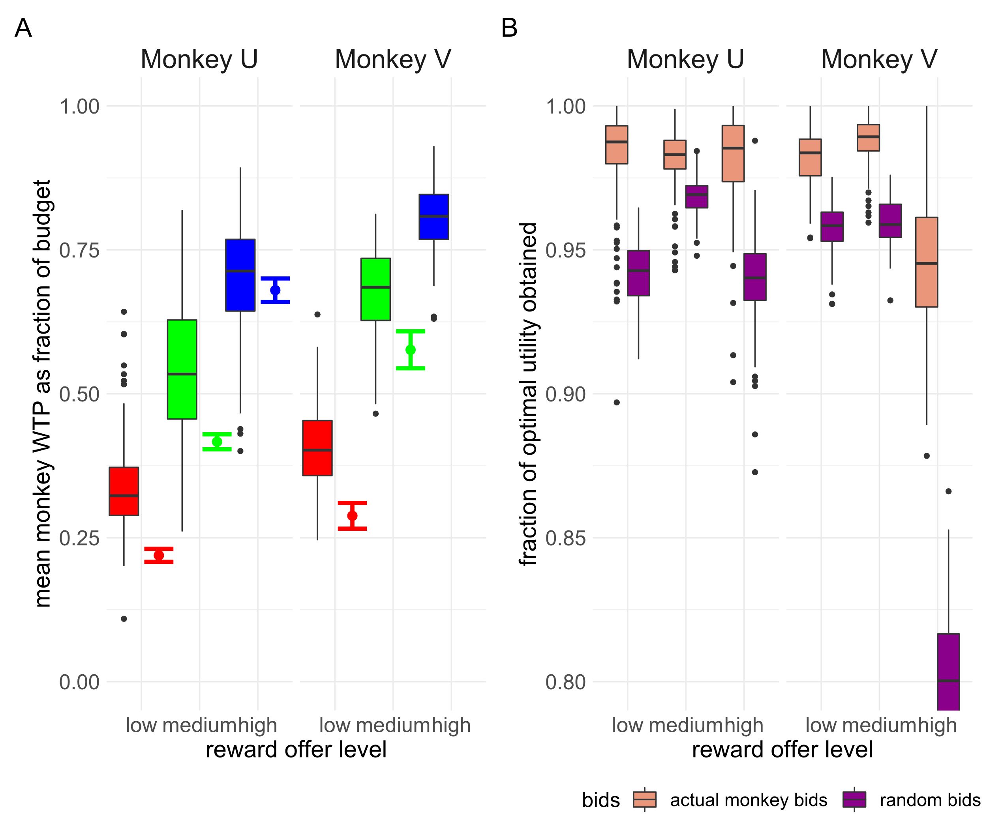
Figure 3.23a-b) Monkeys bids on the BDM compared to indifference points elicited from the bundle choice task. A) Mean monkey bids per BDM session are plotted as boxplots as in figure 3.14b, coloured by reward level. The bundle choice indifference points for the same reward levels as plotted in figure 3.19 ± the standard error of the fitted binomial function are shown to the right of each of these boxplots. Both are expressed as a fraction of the budget monkeys are willing to forgo in order to obtain juice reward, where 1 indicated willingness to miss out 1.2ml of water. The binomial fit for the largest juice volume for monkey V is above the range of the graph. B) Taking these indifference points as the utility of the juice in terms of units of water, we calculate the total utility available to a hyper rational monkey that always bid this value (1.0). The total utility actually obtained by monkeys per session in terms of water is then calculated and shown per reward level (brown boxplots) as a fraction of this ‘optimal utility’. This is compared to hypothetical utility the monkeys would have experienced if their bids were drawn at random following a uniform distribution across the possible bidding range (purple boxplots).

Neither literally how neurons calculate and compare utilities, nor philosophically how a 1500g piece of meat manages to hold its own against intelligently designed computer programs. As an essay beloved by the author puts it (Bisson, 1990): "We probed [humans]. They're meat all the way through." "[They don’t have a brain?]" "Oh, there is a brain all right. It's just that the brain is made out of meat!" "So... what does the thinking?" "You're not understanding, are you? The brain does the thinking. The meat." "Thinking meat! You're asking me to believe in thinking meat!"
The examples used here are mostly to make a rhetorical point to introduce the idea of external unitary scales of decisions, and the lack thereof in economic decision-making. The point could well be made that all perceptual decisions are a subset of economic decisions. For a brief discussion on economic decision-making as psychophysics see appendix 1.1 and Luce, 1959.
Of course, this only considers value-in-use, rather value-in-exchange for the purposes of a simplified, illustrative example. We also skip over the idea that it is the marginal utility rather than the utility per se that causes the starving man to value food highly for the purposes of our point. See White, 2002 for a critical take on this common economic fable which goes beyond the scope of this thesis.
A medieval unit of currency. 20 ducats would have been a substantial sum on the order of hundreds/thousands of dollars in today’s currency. A more recent recreation of the St Petersburg Paradox reveals that modern undergraduates place a median value on the game of $1.50 (Hayden & Platt, 2009) though this uses a modified version where a participant wins $$2^{n-1}$ i.e. half what they would win in the version presented here.
In modern terminology the concavity of the utility function forms Gossen’s First Law, also known as the ‘law of diminishing marginal utility’, described by the 19th century economist (Gossen, 1983).
Sometimes von Neumann-Morgenstern expected utility is differentiated from this equation as $${EU}_{i,n}= p(x_{n})⋅{U_{i}(x}_{n})$$ For the purposes of this thesis, we consider the differences unimportant.
Throughout this thesis we refer to experimental paradigms where a subject indicates a choice between two goods, or bundles, as a ‘binary choice task’. 3 such binary choices are illustrated in figure 1a-c). This is compared in chapter 2 to an auction task in which a subject indicates a value they would be willing to pay for a good/bundle in terms of another other good.
Especially in the ICS literature it is difficult to anthropomorphise the rats as receiving ‘pleasure’ from the self-stimulation. Even when studying physiological markers which correlate with pleasure in humans, it is not clear to us that any model organism necessarily has a positive emotional valence associated with their choices/behaviour in neuroeconomic studies. Throughout this chapter we use words such as ‘pleasure’ and ‘reward’ while detailing the progression of neuroscience into economic decision-making, building up to studies which instead correlate neuronal activity with the more formal, neutral, term ‘utility’. Throughout the rest of the thesis we ascribe an animal’s motivations to maximising this neutral quantity of utility. For a brief review of ‘wanting’ vs ‘liking’ motivations in organisms making behavioural choices, see appendix 1.2.
For a colloquial explanation of the signal: dopamine neurons typically have a tonic firing rate of ~5Hz (imagine a fast bass drum beat). For a view of what 'firing' means see Figure 4.1 showing the average trace of a 'spike' from a representative dopaminergic neuron we recorded in this project. Upon delivery of an unexpected reward midbrain dopamine neurons produce a very brief 'drumroll' of the same spikes with a much shorter latency between. The increase in firing rate described happens within this 'drumroll' before the neuron returns to its 'resting' tonic frequency.
'Aversive' stimuli can create an initial positive increase in dopaminergic firing rate thought to be mediated by a 'saliency' signal (Schultz, 2016). This saliency signalling of dopaminergic occurs earlier (within the first 120ms of stimulus presentation) and is correlated with the perceptual intensity of the stimulus (e.g. brightness, loudness), the novelty of the stimulus (though novelty alone is not sufficient to generate it; Tobler et al., 2005), and whether it shares characteristics (e.g. modality) of other conditioned stimuli for rewards (Day et al., 2007).
A simplification. Dopamine release is not a simple linear function of dopaminergic cell firing rate (Mohebi et al., 2019). Indeed, dopamine release may not even fully necessitate anything upstream of the dopaminergic varicosities as cholinergic stimulation in the striatum seems to be able to shunt release of dopamine (Mohebi & Berke, 2020).
This thesis was written in the autumn of 2020; the implications for taking findings from behavioural economics seriously should be obvious.
We consider that behavioural/experimental/neuroeconomics is still in it’s infancy and if we ever do find a Grand Unified Microeconomic Theory it will not be for many years
Amos Tversky died in 1996
We only consider situations in which organisms choose between 2 options here for brevity. Of course, these tasks can be extended to choices between as many alternatives as an experimenter sees fit. Indeed, these might better capture the ethological choices made by organisms.
A simple game of this type can be modelled with two suitors where the 'winner' of the more beautiful bride offered has to pay the second price to the loser (second prices pop up in the most unexpected places!). This auction paradigm can be shown (Baye et al., 2012) to lead to similar results as Bhattacharyya & Lipman, 1995 that traders who know they are following symmetric strategies might both have a positive expected value of their mixed strategy even as they understand that only one of them can actually make a profit on a trade. Because trades and bridal prices are unbounded, each player's expected utility is not integrable with respect to the joint distribution of possible mixed strategies, and no Nash equilibrium can be found.
The second Caesar of the 'Year of Five Emperors' (not to be confused with the 'Year of Four Emperors' [69AD], nor the 'Year of the Six Emperors' [238AD]).
The Bank of England only began gilt auctions in 1987 (“The Gilt-Edged Market : Auctions,” 1987).
Bazerman and Samuelson empirically tested this winner’s curse in first price auctions, getting MBA graduate students to bet on the value of a jar filled with nickels. On average, winning bids are roughly 25% greater than the value of the coins being bid for (Bazerman & Samuelson, 1983).
As with much of microeconomics, this finding has a few assumptions which can be violated. Maskin and Riley showed that theoretically this ordinal ranking of auction mechanisms can be reversed if bidders are risk-averse (Maskin & Riley, 1984).
In one particularly famous case, a group of dentists won the rights to spectrum in Cape Cod, Masachussettes which they then sold onto Southwestern Bell Telecommunications for $41million profit (McMillan, 2009).
There is evidence for dopamine’s role in guiding reinforcement in fruit flies (Waddell, 2013) and sea slugs (Reyes et al., 2005) though these are unlikely to be true homologues of the primate reward system. Instead, it is probably likely that conserved dopaminergic systems represent a path of least resistance for the evolution of reward circuits (Barron et al., 2010).
We refer to both the medial prefrontal cortex (mPFC) and orbitofrontal cortex (OFC) as prefrontal cortices in this appendix despite these being anatomically distinct regions. We touch upon why different studies might find activation of one or the other when discussing the replication of BOLD signal activity correlation with bid in human experiments using the BDM and so will not here. A brief discussion can also be found in Padoa-Schioppa & Conen, 2017.
Though changes in BOLD signal have been found in both these regions during the same task, it is a simplification to conflate the roles of both these regions as we do to some extent here. Both macaque fMRI and single cell electrophysiology studies have found subtle differences in the neuronal activity of the prefrontal cortices and amygdala in Pavlovian (Saez et al., 2017) and credit-assignment (Chau et al., 2015) tasks.
See appendix 1.1 on Prospect theory which goes into further detail on the subjective treatment of probabilities in utility theories.
It is also possible that the player may simply not realise the correct value of their hand. Especially (but not limited to!) animal work it is impossible to perfectly verify if a subject understands a task so the simplicity of a task and its strategies is important to take into account.
See previous chapter on organism’s behaviour as utility maximising
We leave out the possibility that more of a good could contain disutility here. The current year however provides many examples that run counter to rigid economic thought. See Kubursi, 2020 for an example of negative prices for oil futures contracts.
This is also equivalent to tasks in which a good A and a good B are presented with probabilities x and y, which for the sake of brevity is also left out here.
See for instance the difference between being willing to pay more for a coffee on mornings where you had less sleep, and ‘choosing’ to buy a style of coffee you don’t like because you are too tired to communicate your choice to a barista. The idea behind stochastic choice theory is explained in greater detail in appendix 1.1.
Throughout this chapter, and the rest of the thesis, we will carry forward the assumption that any bid made is equal to the utility of the good to the primate making that bid. Of course, as with any behavioural paradigm this isn’t strictly 100% true even if the monkey had full information about the task (see Grether et al., 2007); a stricter definition would be that we expect the primates to bid their utility for the good, plus their utility for making the ‘correct’ bid plus some stochastic error (e.g. even well trained humans playing video games make joystick errors).
Though see previous section that in experimental paradigms the subject ‘gains’ the endowed budget in a lost auction trial.
Though see Hamukwala et al., 2019, which supposes that the complexity of the BDM means that even humans require extensive practice to produce reliable bidding.
Our monkeys cannot be told an induced value but should quickly learn the constant and certain value of an offered liquid good upon winning auctions.
A possibly counterintuitive idea. The expected computer bid before any bidding takes place is of course equal to half the maximum possible bid, however this is the expected computer bid given we know the subject won the auction. See the Monty Hall problem for a similar example.
Any good $G_{a}$ where $υ_{i}(G_{a})$ > B_{max} is indistinguishable from a good $G_{b}$ where $υ_{i}(b)$ == B_{max} and so the BDM paradigm is not a suitable task for such goods.
Though 16 bids are made in each of the ‘learning’ and ‘equibilibrium’ phases of the experiment, these are further split into four sets of 8 bids in the authors reporting.
See for instance, Dabney et al., 2020 on how the response activity of a single dopaminergic neuron is not simply a linear function of the magnitude of a reward. The more contexts (e.g. the greater distribution of reward magnitudes encountered) a neuron is recorded under, the greater the resolution of its scaling function. C.f. figure 4b) of Dabney et al., where the 7 magnitudes of possible reward mean (at most) fitting a scaling function to 3 or 4 (i.e. half of the) encountered reward magnitudes.
Mean bids were slightly, but not significantly higher in the sulpiride condition than in either the bromocriptine or placebo condition, raising the interesting possibility that it may be possible for interventions to affect bidding behaviour. It is perhaps confusing why a D2 antagonist (i.e. and inhibitory effect on an inhibitory signal) might affect behaviour in this way, though the authors make the point that it may simply be because application of sulpiride increases the variability of bids so they regress towards the mean of the budget range.
The main finding of this paper was the effect of treatment on the BOLD signal in the intraparietal sulcus, especially during the ‘late’ stage of valuation (more than half the time from stimulus presentation to setting one’s bid). Activity within this area has previously been implicated in decision making tasks with signals correlating with the gain a subject expects from a trial (Platt & Glimcher, 1999).
See chapter 1 of this thesis on the representation of utility in the brain and its associated appendices.
In rare cases it is possible to record electrophysiological signal from the human brain. See Zaghloul et al., 2009 for one such example, recording from the substantia nigra in patients undergoing deep-brain surgery for Parkinson’s disease.
This of course makes no difference, we are simply using the proof as formulated by Milgrom and Weber. In the BDM as discussed in the body of this thesis we assume there to be some utility just from receiving the endowment gifted to the participant at the start of each trial, but this utility should be ‘baked in’ to the participants expected payoff and so does not change the results, or implications, of the derivation here. It is actually probably untrue that the utility even of human’s buying and selling mineral rights (the example in Milgrom and Weber, 1982) is zero (see below).
This assumption is economically sound, but probably psychologically tenuous. Consider a child on Christmas Day who has spent the last six months expecting a specific gift and instead receives nothing.
Figure 2.6b) does in fact have a local minima at roughly the mid-point of the x-axis which contradicts this. A more stringent proof would state that this maxima is only a local maxima. For complicated utility functions that might arise (e.g.) as the BDM task is extended and extra round of bidding/payments/chance are incorporated this could become important. For the simple BDM paradigm in this thesis and in the lifelike auctions of Milgrom and Weber we assume a ‘simple’ utility curve with only one maxima as presented in figure 2.6a) and figure 2.3.
In the event of a loss the payoff is the same regardless of whether a participant paid attention- they receive the full endowment.
Efforts are made to make notebooks reproducible and code readable though due to time constraints results may vary. Contact the author for data and/or clarification of code.
Changes in the task consisted primarily of reducing the number of task epochs and shortening of the bidding epoch to shorten the overall task time and the removal of any stimuli not considered absolutely necessary for behaviour (e.g. changing of bidding bars to indicate the finalisation of bids, and the occlusion of the budget bar to indicate payment).
Imprecision due to data not included before the rewrite of the software for the task in the first two months of the project. Total trials numbers broken down by monkey, task, and completed are shown in figure 3e.
Not strictly true as it depends on the magnitudes of rewards but for both monkeys in this project the lowest magnitude fractal during the recording phase represented 0.2 and 0.3ml of juice respectively.
For a graphical example of distributions of utility (i.e. assumed bids for the BDM), see the appendix on Random Utility Theory in appendix 1.1 (figure a1.3).
Note- we do not include the intercepts of both regressions in figure 3.13. For Monkey U the intercept of the beta regression on all bids is -0.95992±0.03262 and for Monkey V the intercept is -0.49961±0.03053. By task design, the monkey’s bids are censored to 0 and the maximum of the bidding range (1). Though in theory a monkey could be motivated to bid at either extreme, such bidding tended to signal probable poor performance (see appendix 3.2) and so all such trials were excluded before analysis. For regressions including such data, typically a Tobit regression is preferred (Tobin, 1956). The negative intercepts from these regressions do not refer to the prediction of the monkey bids by the models when all selected variables are equal to 0. See equation 3.4. For the fitted regressions, such predictions are 0.183 for Monkey U and 0.295 for Monkey V.
See Cohen, 1992 for definition of effect size terminology.
Even if we expected the BDM and bundle choice tasks to give exactly equivalent WTP estimates, we would not expect the monkey to bid exactly the same value on every trial of the BDM. Utility is stochastic and indeed, one of the guiding ideas behind the experiments in this thesis is the limitation of aggregating choices over a whole session of discrete choice tasks versus trial-by-trial reports of utility from auction tasks. We compare the bids made to a hypothetical utility ‘ground truth’ from the bundle choice simply to show the limited difference the small changes in WTP make to the actual experience of the monkeys.

